Indigenous Champions Network Communique
  - Meeting Date: 11 December 2025
The Indigenous Champions Network (ICN) convened on 11 December 2025 at the Yarramundi Cultural Centre, Canberra, to advance whole-of-government transformation under Priority Reform 3 (PR3), with a strong focus on cultural safety, systemic reform, and leadership accountability across the Australian Public Service (APS).
Strategic Discussion – Priority Reform Roadmap
Members, supported by the ICN Chair and facilitator Geoff Richardson PSM, undertook a deep dive into the Priority Reform Roadmap & Immediate Actions, endorsed by the Secretaries Board in November 2025. The discussion focused on moving from intent to action and identifying levers for transformation within agencies.
Members acknowledged the importance of:
- Embedding cultural safety and structural change, not just incremental improvements.
- Strengthening governance and accountability mechanisms to ensure reforms are measurable and visible.
- Addressing systemic barriers such as short funding cycles and workforce certainty.
Strategic Discussion – ICN Priorities for 2026
Through collaborative discussions, members identified three collective priorities to guide ICN action in 2026:
- Data & Evidence: Capturing and sharing storytelling as data and lived experience research.
- Leadership & Accountability: Sharing sample KPIs from SES performance agreements and creating a library of accountability measures.
- Capability & Culture: Influencing APS employee census questions and designing evaluation mechanisms to measure cultural safety.
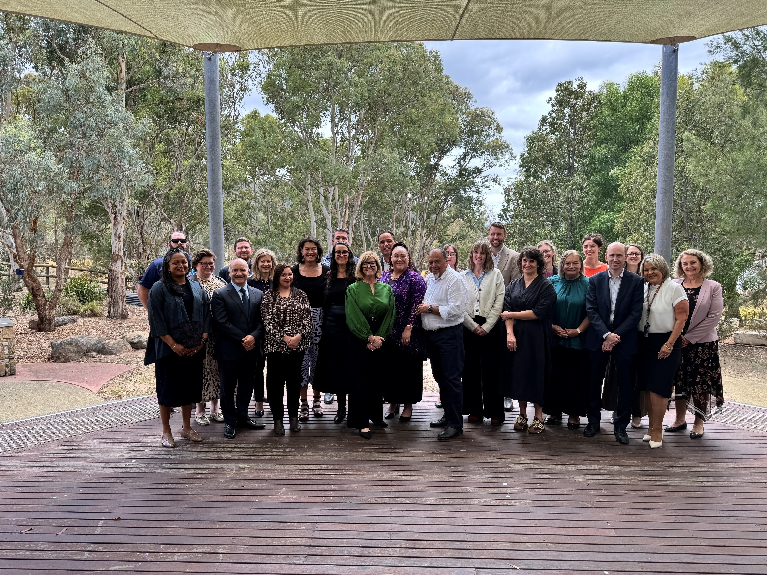
Next Meeting: Early 2026 (date to be confirmed).

