Action Planning Guide – Agency Edition

A guide to make the most of your APS Employee Census results and support agency-level action planning

Table of Contents
Action Planning Guide – Agency Edition 1
A guide to make the most of your APS Employee Census results and support agency-level action planning 1
1. The purpose of action planning 3
2. Using this guide 3
3. Create your action plan 3
3.1 Raise awareness of action planning initiatives 3
3.2 Exploring your Employee Census data 4
3.3 Celebrate your successes 5
3.4 Identify areas of opportunity 5
3.5 Develop a sequence of steps toward each goal 7
3.6 Construct your roadmap to success 8
4. Assess your goals 8
5. Safeguard your initiatives 9
6. Celebrate and share the success of your actions! 10
Appendix A - APS Employee Census reporting tools 11
Appendix B – Action Planning Template 14

1. The purpose of action planning
APS agencies that participate in the APS Employee Census are required to publicly release their Census agency-level report and an accompanying action plan. This release takes place in November and coincides with the tabling of the State of the Service Report in Parliament.
Your agency action plan will be a statement about what your organisation wants to achieve. It will assist the agency to focus on a desired end state and decide on the steps and required resources to achieve these outcomes.
Enriched and enabled workplaces have greater capability for high performance and improved outcomes for Australians. APS Employee Census results are a rich source of workplace information that can inform workplace initiatives. Action planning mobilises Employee Census results into activities that target specific aspects of the workplace to improve such things as resilience, flexibility, and performance.

2. Using this guide
This action planning guide is intended to be used in conjunction with the array of other Employee Census data and resources that include the Employee Census Dashboard, Highlights Reports, Flash Reports, Excel Heatmaps, and Employee Census Tip Sheets (see Appendix A). This guide will show you how to raise awareness around action planning, explore Employee Census data, identify areas to target, develop the sequence of steps needed to achieve outcomes and set safeguards to protect your agency’s goals. It will also ensure your goals are SMART, providing the best possible opportunity to deliver your agency’s desired outcomes.

3. Create your action plan

3.1 Raise awareness of action planning initiatives
Generate awareness by thanking employees
The first step in action planning is to let employees know that action planning is happening. Use agency communications to thank employees for their participation in the APS Employee Census. Without their valuable contribution, Employee Census results and insights would not be available. Take this opportunity to show employees the important role the Employee Census plays in developing initiatives in the agency. Tell employees when Employee Census results will be released and the action planning process will commence.
TIP
Thank employees for choosing to have their voice heard by the APS Employee Census and communicate how this contributes to APS wide initiatives.

This contribution will generate awareness and help employees understand the importance of the actions your agency’s plan will develop. This will in turn help to motivate greater participation in the actions your plan develops.
Distribute Employee Census results
At the first available opportunity, distribute Employee Census results to staff at all levels within your organisation. Communication that uses a combination of different methods is known to work best. Take advantage of email, intranet and posters, as well as all staff, group and team meetings. Encourage staff to explore Employee Census results.
TIP
Communicate Employee Census results to all staff within your agency with several different methods of communication

3.2 Exploring your Employee Census data
Explore the overall results
Take time to explore your results. The Highlights Report presents a summary of key results. This makes it a good place to start. More information can be gained from Excel Heatmaps and other Employee Census reporting products.
QUESTIONS TO ASK
How do your results differ from other agencies?
What are the highest scoring topics and questions?
What are the lowest scoring topics and questions?
How have results changed from last year?
Explore the Census themes
The Employee Census asks a series of questions to understand employees’ views on, and experiences of working in their agency, and the broader APS. Individual questions do not sit in isolation – most can be grouped with others to provide greater insight into specific topics. Many of these themes are identified in the Highlights Report. Take time to understand your agency’s response to the various themes and digest the results. To investigate your agency response to individual questions, see the Flash Report.
TIP
We advise that a size difference –or + 5 percentage points is worthy of attention but the size of the agency is important. Interpret large differences in small and micro agencies with caution, as these results may be unreliable.
Dive deeper into your results
There may be opportunities for deeper investigation of your results. For agencies wishing to dive further into their results, the APS Employee Census is structured on an underlying occupational
framework that links questions in separate sections of the survey. These underlying themes examine topics such as job control, role clarity and supportive relationships and may provide insight into strengths and areas of further opportunity. More information about these themes can be found in the Employee Census Tip Sheets - Autonomy, Social Connection and Role Clarity.
Agency census coordinators can also access the Employee Census Dashboard, which offers valuable resources to assist your action planning. This includes the ability to analyse results by demographic groups and filter questions. It also provides easy to understand graphs and the ability to download these products.
Talk about your results
Meet to discuss your results and develop your action plan. Ensure all areas of your agency are represented in this discussion. The best and most effective action plans incorporate diverse views from all areas of the organisation, rather than just senior staff or majority groups. Lasting and beneficial change is more likely to be accepted and achieved when actions have been contributed to by wide ranging functions within the organisation.
TIP
The most effective action plans consolidate diverse views from all areas of the organisation

3.3 Celebrate your successes
Focus on your areas of strength
Identify areas where your agency is doing well. This may be in contrast to previous Employee Census results, the APS overall or other comparable agencies.
Communicate success stories to all in the agency
Draw attention to these areas of strength by distributing news of your successes through email, newsletters, meetings, intranet, forums, and bulletin boards. Think about how you can learn from what your agency does well to build upon these strengths.
TIP
Showcase your strengths by spreading word of what your agency does well

3.4 Identify areas of opportunity
Identify areas to target
Using the APS Employee Census resources in Appendix A, identify the areas within
your agency that are action-planning opportunities. Consider the degree of risk associated with not addressing an issue (e.g. unacceptable behaviour), and also the resources and capacity that you have to act.
There may be differing views in your agency about the relevance and importance of goals. If there is conflict about areas to prioritise, encourage decision-makers to approach the issues as collaborators
rather than opponents. It may also help to ask decision-makers to view issues through the eyes of the public or employees across different areas of the agency.

QUESTIONS TO ASK
What are the areas that could be improved?
What are these results saying about the agency as compared to others?
Are there common themes between these areas?
Does there appear to be underlying issues?
Are there questions with high neutral scores that might easily be shifted to positive responses?

TIP
Decide on the areas of main concern and then rank these issues as critical, important or desirable
Agree on areas to prioritise
Assess the amount of action planning goals appropriate for your agency, prioritising quality and impact over quantity. A smaller number of achievable, well-targeted goals are likely to achieve more positive outcomes than a large amount of complex goals that may become overwhelming and unachievable. Improvements made in a few key target areas will often flow to other areas across the organisation.
For most agencies, 3 specific target areas will keep actions achievable. Larger agencies may be able to achieve more. A mix of short-term and longer-term goals will assist employee’s motivation to join in and achieve the chosen outcomes.
Goals should strive for the improvement the agency desires, while being realistic and attainable. This creates the right mix of interest, challenge and confidence that they can be achieved.
TIP
Target the work itself but also look at job design, work environment and working conditions
Turn your target areas into specific goal statements
Discuss your goals with your action planning decision-makers and endorse or
modify them to reach agreement. Where your goals are long term, identify
attainable short and medium term steps within these. Turn your target areas into
specific goal statements that use positive language. Framing your goal in a positive way is more likely to encourage people to act upon it, whereas negative framing will draw attention to the problem, not the solution.
Consider your agency’s objectives as well as the purpose and values of the APS
Consider how your goals align with the broader APS purpose and values, as well as your agency’s objectives. Discuss how relevant the goals are and whether they are meaningful in the context of
your agency’s work and the wider APS. People are more likely to be motivated to take part when they can see a meaningful reason to act.

3.5 Develop a sequence of steps toward each goal
Next, you will need to decide on the practical steps needed to get each goal from start to finish.
Collect information to guide you
Identify and source the resources that you can use to understand what you need to do to reach your goals. Examine each individual goal statement and research what practices have been found to be effective to change behaviour in this context. The information you collect will guide the processes and steps needed on the journey towards your chosen outcome.
TIP
Begin your research around each goal with resources found on the Employee Census Dashboard, Employee Census tip sheets and APS and agency policies. Explore what else you have available that may assist your desired outcomes in your business context
Investigate the programs and practices your agency already offers that may support these goals. Consider if current programs can be tailored to better support your goals.
Build a learning culture
Consider what has not worked in these areas for your agency. There is much to be learnt from past failures to improve future performance. Analyse and dig down into these experiences to discover the wisdom they contain. Incorporate this learning into your action plan.
Consider if your goal is realistic
TIP
The best goals for creating change are ones that are challenging yet achievable
Consider whether your agency has the skills and capability to deliver these outcomes. If not, can this capability be developed or acquired? The best action plans are realistic about what they can deliver.
Define how you will evaluate each goal and measure its success
Decide exactly what success looks like and how you will measure it. It is important to define this step well as this is the key to evaluating your progress. If your measure uses the next Employee Census, there may be value in setting multiple indicators. Consider pulse surveys or measures specific to your goal that can be evaluated more regularly. Feedback from short-term measures is a valuable tool to encourage longer-term changes in behaviour and sustain your achievements over time.
Give each step a timeframe
Set timeframes for each step as well as the end goal. Decide at which point you will monitor each goal and check in with your progress. Be sure to set times to share action plans with employees and
leaders, as well as regular updates of progress along the way. The recognition of small wins can keep you moving in the right direction.
Establish ownership of the process
Nominate an action planning facilitator(s). This person(s) will be responsible for overseeing
and monitoring the project’s planned actions. Nominate work areas to take ownership of and be accountable for each stage on the timeline. Larger projects may need to nominate ownership to tasks within each step.
  - Construct your roadmap to success
Document your process
Once you have a clear picture of what needs to occur and the timeframes this will occur in, document the process towards your achievements. Ensure you:
- List the type and frequency of communications to distribute results and promote awareness of Employee Census action planning
- Plan how you will celebrate your areas of strength
- Determine the appropriate number of goals for your agency
- Construct a goal statement for each goal
- Identify your evaluation measure(s) for each goal
- Outline each step in the journey for each goal
- List the tasks/actions that are involved within each step
- Nominate the work area responsible for each step/task
- Define what success at each stage and the end point looks like

TIP
When new data or information comes to hand, be sure to re-evaluate and adjust goals to incorporate it into your plan and timeline

4. Assess your goals
Assess your goals
Check to see that your steps align with your original goal statements. Look at your overall statement of goals. Ensure they are as concrete as possible.
SMART GOAL TEMPLATE
Our agency goal is to [objective] by [timeframe]. [Key players or teams] will accomplish this goal by [outlining the steps you’ll take]. Accomplishing this goal will result in [outcome]

Check your goals are SMART
If you have completed each action-planning step, each goal should now be SMART and set you on your way to delivering results.
SPECIFIC
What do you want to accomplish?
Why do you want to do it?
Where will it be?
What is in your way?

MEASURABLE
What metrics will you use to determine if you are meeting/approaching your goal?
This is your evaluation measure

ACHIEVABLE
Are your plans realistic?
Do you have the skills and capability?
If not, how or where can you get it?

RELEVANT
Do your goals make sense to the workforce and fit within broader APS and agency objectives?

TIME BOUND
When will each step within your goal be achieved?

5. Safeguard your initiatives
You will need to identify potential obstacles along the way. The best way to deal with barriers to your action plan is to prepare for them. Even well thought out plans can fail if they encounter barriers that were not planned for. To improve your chances of success, make a list of obstacles to each goal. Encourage each member of the action planning group to contribute their ideas and discuss any risks that they can see to the project. Brainstorm a solution that can be implemented for each obstacle. These intentions will safeguard your plans so that if these situations do occur, your progress forward will continue and not stall or stop completely.
TIP
Make a list of safeguard actions that can be implemented to keep your project on track should each obstacle occur

6. Celebrate and share the success of your actions!
Evaluate your initiatives
Evaluate the success of your actions. Take stock of what your planned actions have achieved and notice if these improvements have flowed onto other areas of your organisation. Take time to celebrate your success! If you are not moving toward your goal, don’t be discouraged. Consider why this may be the case. Check your planned actions to identify where weaknesses may exist.
Communicate the success of your agency’s achievements
Take pride in your implemented actions and spread the word to employees through as many communication channels as possible (e.g. email, newsletter, meetings, intranet, forums, bulletin boards). Thank them for their contribution to the initiative. Ensure you explicitly link your actions and outcomes to Employee Census survey findings to encourage their participation in the next APS Employee Census!
Email the Employee Census team APSsurveys@apsc.gov.au so we can share your success throughout the APS

Appendix A - APS Employee Census reporting tools
Example of Highlights Report (PDF – 27 pages)
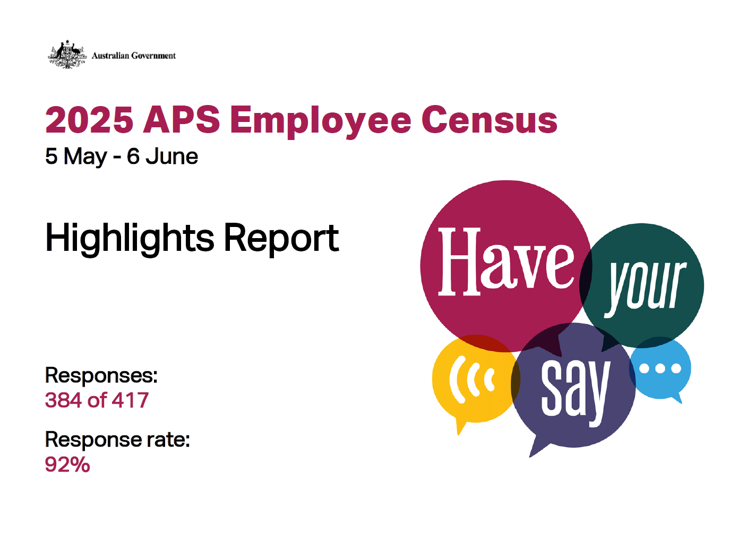
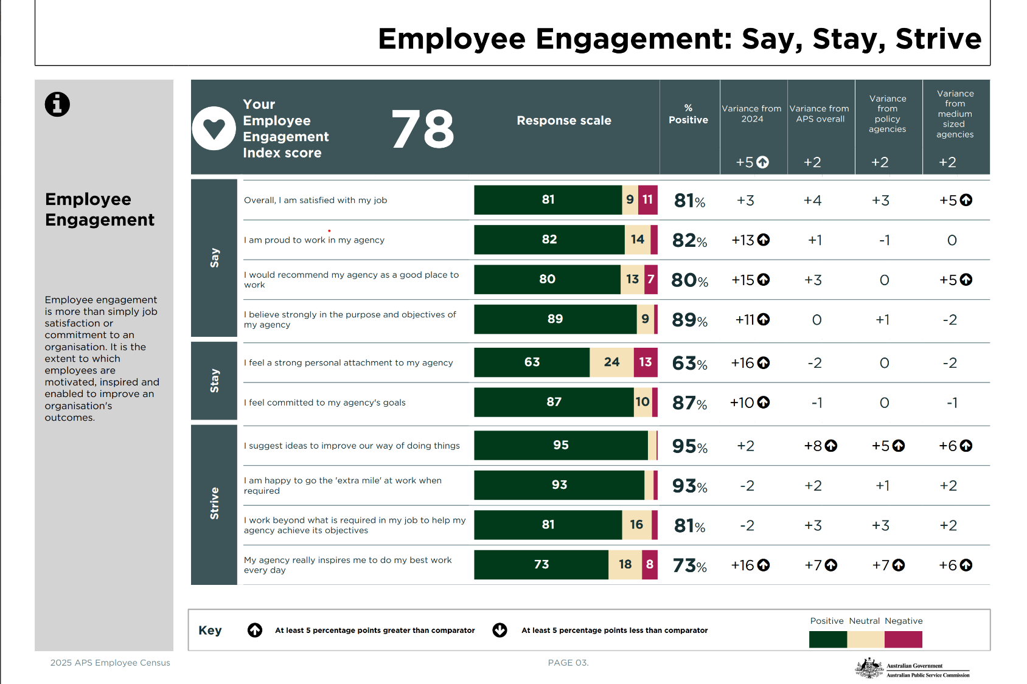

Example of online interactive dashboards

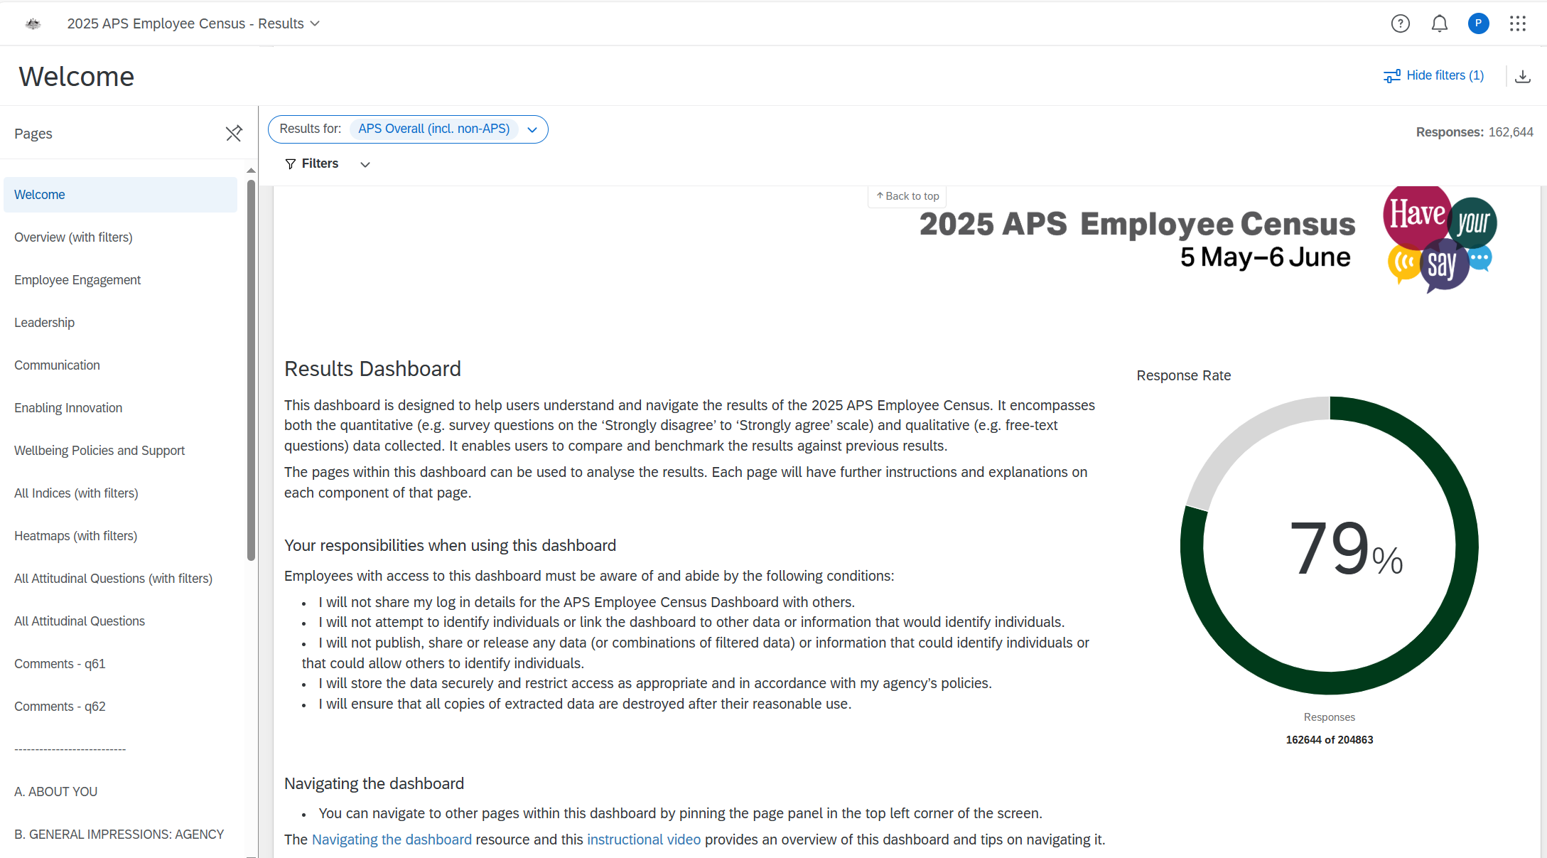
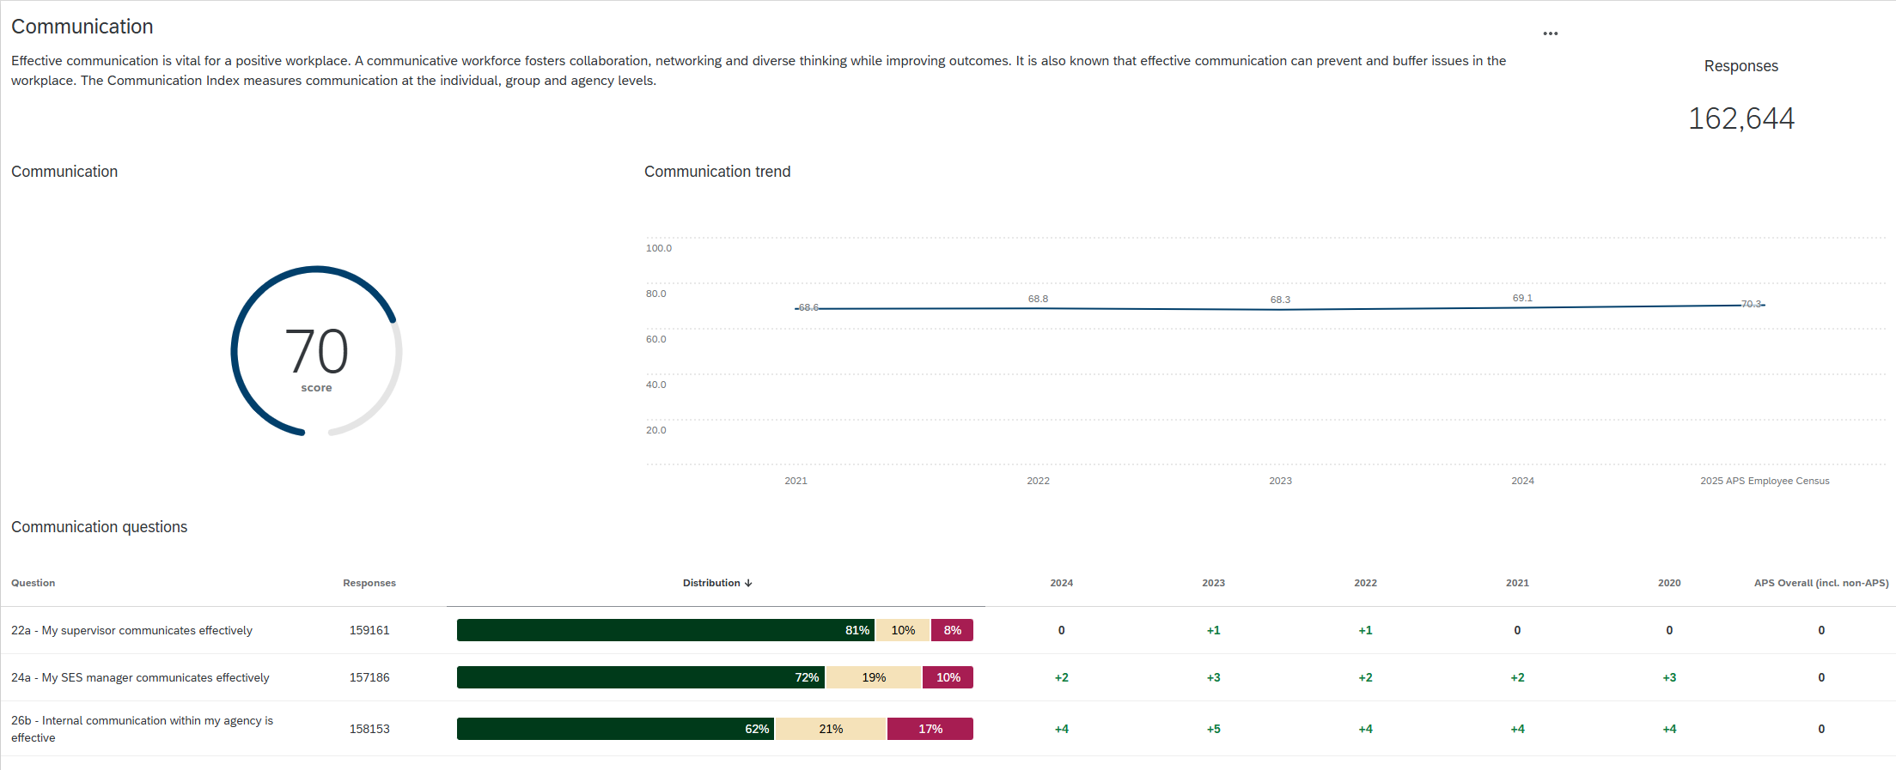

Example of a comparison Excel report (heatmap)

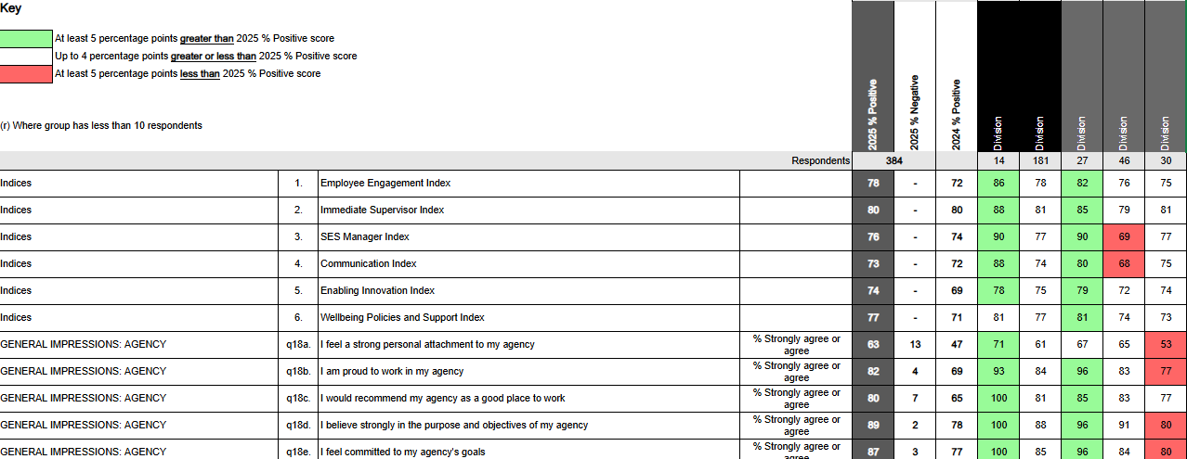
Example of APS Overall Flash Report
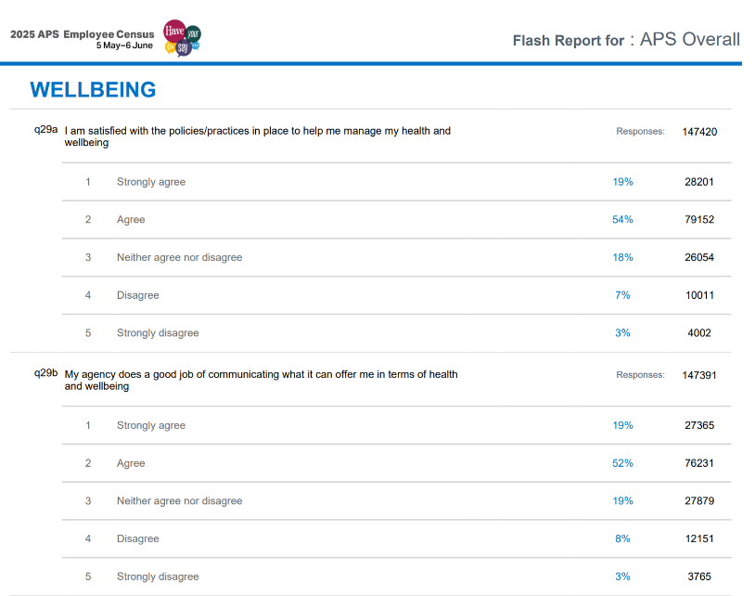

Appendix B – Action Planning Template
Target areas | Goals | Action steps | Potential  Obstacles | Due date | Agency position responsible for actions  E.g. Chief Operating Officer | Agency position responsible to review  E.g. Agency Head
1. |  | 1.  2.  3.  4.  ...
2. |  | 1.  2.  3.  4.  ...
3. |  | 1.  2.  3.  4.  ...

