Australian Public Service-Academia Collaboration Workshop 2023

Outcomes report

Table of Contents

Background 3
Overview 3
Top 6 mechanisms identified by participants 5
Mechanism 1: Cross-APS/academia conference 5
Mechanism 2: Explore ways to share impact 5
Mechanism 3: Expert panel 6
Mechanism 4: Knowledge brokers hub 6
Mechanism 5: Project focused fellowship program/secondments 7
Mechanism 6: Better procurement processes 8
Insights from the workshop 9

Background
On 28 July 2023, the Department of Prime Minister and Cabinet convened a one-day workshop with early and mid-career researchers aimed at identifying mechanisms to enhance collaboration between the research sector and Australian Public Service (APS).
The APS’s ability to work in genuine partnership with other sectors is crucial to delivering better outcomes for Australia. Partnering for greater impact was a cornerstone of the 2019 Independent Review of the Public Service, which identified academia as a key sector with insights into emerging trends and innovative solutions. Priority two of the government’s APS Reform agenda states that ‘genuine partnership and engagement with Australia’s people, communities, non-government sectors, academia, business and industry will help us develop policies and services that reflect the needs and aspirations of the people they affect’.
Over forty participants were invited to the workshop following an expression of interest process. They included researchers from across Australia, Pat Turner and Sir Roland Wilson PhD scholars, and a small number of public servants. A pre-workshop discussion paper prepared by Dr Sarah Ball (University of Melbourne) was circulated to all attendees.
The workshop organisers are very grateful to all who attended and shared their expertise and experiences. This report is a record of the workshop outcomes.

Overview
Opening the day we heard from the deputy commissioner of the Australian Public Service Commission, Dr Subho Banerjee. He shared his enthusiasm for exploring new opportunities for collaboration between the APS and academia, noting that reflecting on the outcomes of a similar 2013 workshop was a little sobering. While often discussed, the deputy commissioner noted, genuine collaboration remained elusive. However, he also shared his optimism, with the strong support from the Secretary of the Department of the Prime Minister and Cabinet and the APS Commissioner. Some of the ways forward would involve taking a relational approach, acknowledging the different incentives across academia and the APS, and working together to get clarity of purpose. He also shared his hope that there were opportunities to explore the mechanisms and practices that could support better collaboration in the future, moving beyond the transactional relationships that current procurement processes could lead to. Finally, deputy commissioner Banerjee shared the importance of going beyond courtesy and moving towards genuine respect, valuing what each group brings to the collaborative project. To explore collaboration with openness, curiosity and a true development of regard.
The opening keynote was delivered by Professor Helen Sullivan, who delivered some thoughtful provocations to set the tone for the day. Professor Sullivan posed four key questions:
- What is collaboration for? Collaboration is resource intensive and takes time to do it right, its important to have a good reason to do it.
- What is it that collaboration does? Some activities of collaboration seem normal to us but can feel alien to others. How can we be clear on communicating our practices?
- What do we mean by collaboration? We often assume collaboration, by its very nature, is inherently a good thing to do. This can lead us to forget to be clear on its purpose.
- What is the shape of collaboration? Who is included and excluded? Why do we avoid conflict? After all, it is inevitable. Managing conflict effectively is more useful than avoiding it. Who is considered an expert and why?
Two other key messages included a reminder to those taking part in the conversation that all evidence generation is political, all data is political. To try and avoid discussions of meanings and values is a futile endeavour. Responding to a question, Professor Sullivan reminded the academics in the room that independence is about independence of thought, and that the evidence we generate will never be ‘apolitical’ or independent. It will also reflect our own influences. This is one of the reasons it is so important to have an inclusive approach to who is involved. Don’t only work with people who look like you.
It is also important to remember that we shouldn’t try and reduce collaboration to a check list. There is no ‘one-size-fits-all’ approach. Again, in response to a question from the audience, Professor Sullivan reflected that collaboration is an important skill. It requires patience and respect for the difficulty of navigating relationships, differences and conflict.
Following these introductory reflections on the role of collaboration and its opportunities and challenges, we heard from Bede Jones from the Department of the Prime Minister and Cabinet on the run of the day and Dr Sarah Ball, from the University of Melbourne, on the collaborative process. This was driven by the importance of breaking the mechanisms down into discrete steps and articulating the aims and markers of success for each.

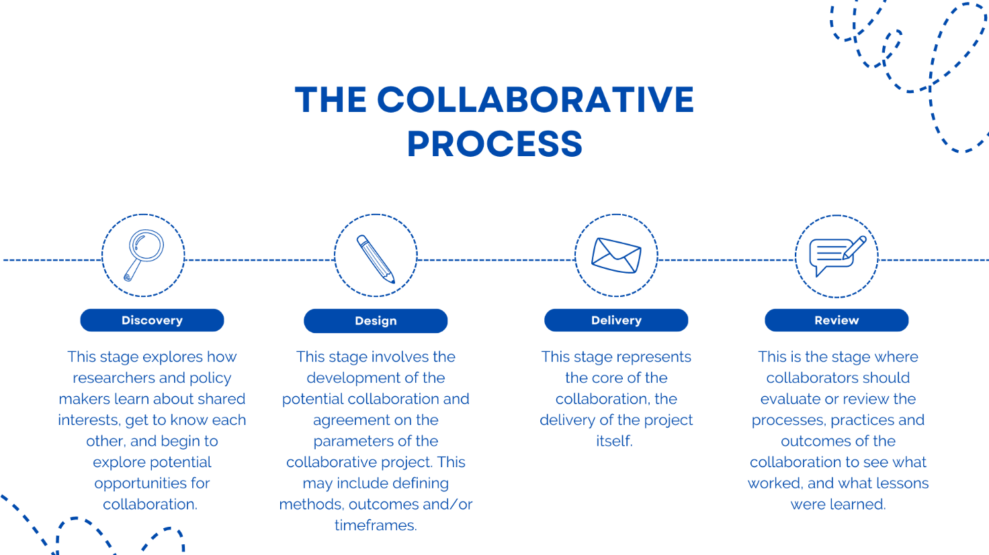

Finally, the facilitator, Professor Ariadne Vromen, shared the goals of the workshop and invited participants to vote on their top 3 mechanisms from the 14 proposed in the discussion paper. The mechanisms were then discussed in small groups. The outcomes of the vote, the preferences of the room, and the mechanisms as detailed by the groups, are discussed in the following sections.

Top 6 mechanisms identified by participants
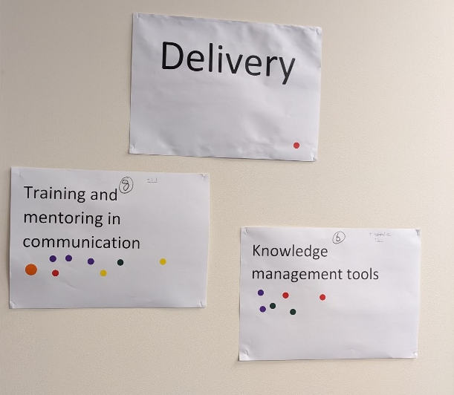
The first group session of the day saw participants engaging with the initial 14 mechanisms proposed in the discussion paper provided prior to the session. In the session after lunch the group discussed where the gaps were and what mechanisms were missed. This led to a group of 5 new mechanisms being added.

Below you will see the top 6 mechanisms as preferred by participants and focused on in the final session of the day. For this process, secondments and the project-based fellowships were merged into one broad mechanism. In this final session, in small groups, Professor Vromen encouraged participants to think more deeply about what these mechanisms might look like. She posed 4 key questions:
- Who provides the resourcing?
- How would it work in practice?
- How would you get buy-in from both APS and Universities?
- Who evaluates effectiveness?

Mechanism 1: Cross-APS/academia conference
This was one of the first new mechanisms to be discussed. A range of different engagement mechanisms were explored. It could be a conference/knowledge sharing event that would be used to discuss policy processes, such as collaboration, or an opportunity to focus on specific subject areas. Either the APS or academia could potentially provide resourcing. Academic groups running conferences might explore new ways of including or inviting the public sector to participate, and departments might choose to invite people to share through panels or seminars. It was proposed that the key was a clear articulation of purpose, although arguably this purpose could be relational or cultural. It could be an opportunity to break down silo’s and move beyond transactional processes where outcomes or outputs are required. Instead, it could be a chance to explore new ways of sharing with each other.

Mechanism 2: Explore ways to share impact
This was also a new mechanism although it was less defined what the mechanism itself would look like and more of a principle to be explored. The group explored new ways of sharing policy engagement moving beyond just the final policy outcomes. Is there a way for policy makers to communicate to researchers when their work has been part of a policy brief? A question on notice? Essentially, how could the public sector more effectively recognise when research influences policy – beyond the final policy outcome. Some potential mechanisms were considered, using something akin to LinkedIn’s ‘endorsed skills’ or the Web of Science Researcher profiles – where academics receive recognition for undertaking journal reviews. However, the group involved in discussing this idea were not confident this would be sufficiently rewarding for relationship building, and may be onerous on the public service.
It was recognised that this was an area of interest to the research sector and that Universities were likely to be exploring tools and metrics that would allow for better recognition of policy impact – but the main suggestion the group proposed on the day was for the possible consideration of including APS staff as a reference for academic employment or promotion.

Mechanism 3: Expert panel
Panel arrangements are commonly used by governments and are an arrangement where specific suppliers are selected, usually through a competitive process, to be put on a list from which a department or departments can then procure services. These suppliers will usually agree on a set price for services, a type of service to provide and the manner by which the service will be obtained (i.e. will there be competition or can they be procured directly). This mechanism would be a panel of experts/academics who could then be approached directly for short-term contracts to provide advice or small-scale collaborations. This was intended to address the gap identified by the group that building a collaborative relationship generally involves significant unpaid labour by the researcher. Alternatively, the APS first engages the researcher after the project goes to tender. This means that the project is already significantly developed, missing out on important early input that could have been provided.
There were many positives. It could provide official recognition of the researcher’s expertise, recognition which would be viewed highly within academia. It could allow for the APS to seek advice early. It did however raise risks of how transactional this could become. While the researcher may be paid for their time, there is little guarantee of developing larger, more collaborative projects. There is also a risk that this could exclude many academics, especially early career researchers (who lack experience) or those with less flexible work. The important question to consider is how this could be used in a way to support inclusive and collaborative working.

Mechanism 4: Knowledge brokers hub
A hub could pilot a series of relationship management approaches and knowledge broker functions (some discussed in this paper) to identify researchers with an APS-relevant focus and facilitate pathways to connect researchers and public servants. Knowledge brokers connect researchers and practitioners and help them better understand one another to identify shared objectives and promote knowledge exchange. A hub mechanism could provide a whole-of-service offering for the APS, enabling policy officers to identify research partners in their field.
When asked how it would work and who would provide resourcing, participants responded that this would need to be a government initiative – funded by government. It would need to have ministerial or at least senior executive support to succeed. The initial years would be a trial, with the goal to be to establish it as a statutory authority. The process would look like a hub and spoke model, with a central hub, within a central agency, and departmental ‘spokes’. This implies it could be combined with the Chief Knowledge Officers model outlined in the workshop discussion paper, as well as a ‘research agenda’.
Some of the concerns included the risk of focusing on individual knowledge brokers – with a strong preference for this operating as a centralised, specialised unit. This would also allow for continuity for people working with the hub. There were concerns about the resourcing costs versus the rewards, although again, the potential for secondments, fellowships or PhD internships could be explored here. The risk of gatekeeping or bias, depending on the agency that resources the hub, was also discussed. In particular it would be important to ensure a breadth of expertise was encouraged.

Mechanism 5: Project focused fellowship program/secondments
Under this model, the APS would establish a new fellowship program for academics to join a department for a short-term secondment and work collaboratively with a policy team on a particular policy topic. A secondment could also include members of the public sector moving into an academic environment such as in the National Security College at ANU (although the discussion focused exclusively on researchers in the APS). These secondments could also be project-specific, or broader. A key part of this mechanism would include establishing formal rules and explicitly outlining expectations – as secondments have been shown to be less likely to be effectively utilised when left to be arranged by individuals.
Participants in this group focused predominantly on how this might work in practice. It was proposed that this would be a useful tool for providing researchers with exposure to the policy environment and APS priorities. It could help in building empathy across the divide. It would be best if the program was used to link participants into a community or cohort of fellows/secondees, and that this cohort receive a suite of training/skills development to help build capacity.
Participants acknowledged that there is similar work happening already i.e. PM&C summer internships, ARC Industry Fellowships. A researcher-in-residence is also currently a system used by some departments. How would this be different? More information could be collected about existing practices and lessons learned.
Some of the key questions raised were around how a secondee or fellow would retain/ensure the right to publish and remain independent? How would they deal with potential conflicts of interest? We don’t want to accidentally exclude people from being able to tender for work.
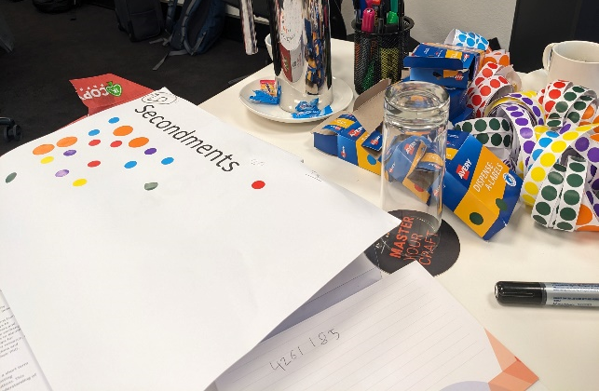
Some key concerns included the fact that follow through from these types of projects/secondments is often quite limited. How do you create a supportive community, rather than just leaving it to individuals? Would a team working in with government have to facilitate to avoid it being limited to one university?
Do you risk excluding people who might offer dissenting or critical perspectives or those who do not have capacity to take a ‘career-break’.

Mechanism 6: Better procurement processes
This recommendation was an addition on the day and reflected a very practical view. It was recognised that current procurement models often explicitly prevent meaningful collaboration. Some of the concerns and treatments raised included:
- Increasing the transparency of contracts
- Contracts are heavily standardised, and changing them requires time and effort
- Removing restrictions on publication as standard practice
- Feedback is not often provided after tendering, and when it is, it is very superficial.
It was suggested that the Commonwealth Contracting Suite could be used more effectively to develop more flexible templates. This could involve providing more training to APS staff. It could also be useful to use the expert panels discussed above – where academics would be able to be contracted more readily to undertake small-scale work. Being part of a panel could also trigger a security clearance process, for ease later on.
Importantly, these were acknowledged as minor tweaks that could improve how relationships develop between the APS and academia. It wasn’t inherently a collaborative mechanism. It was more about bringing down existing barriers. Whether this is about changing the contracts or the mindsets is, ultimately, unclear at this stage.

Insights from the workshop

Finding more effective ways of articulating and highlighting the value of collaboration between the APS and academia, and exploring ways to build more productive working relationships, were key goals for this workshop. It is important that we continue to develop better ways to bring research and policy together and we wanted to begin building a pathway forward for meaningful, actionable collaboration. During the workshop, in addition to the reflections on the individual mechanisms, many important discussions about collaboration were had. Some significant insights included:


Inclusion is critical. We need to ensure that mechanisms are inclusive of broad forms of expertise, capacity and allow for debate.


We are still thinking transactionally rather than relationally. How can we move beyond ‘mutual exploitation’ and focus on building something together?


There are many pockets of the APS and academia where this work is already happening. How can we prioritise collecting this information and learning from best practice more effectively?


Providing more information – knowledge hubs, lessons learned, databases of research or researchers – is only useful if people will access it. If we build it, will they come?



All of these mechanisms need to be supported by a broader shift in mindset – both within academia and the public sector but also within individuals themselves.

These insights show that there is still work to be done on this issue before we move forward with testing or trialling any specific mechanisms. Collaboration, and the barriers to achieving it, has significant, behavioural roots that cannot be addressed without thinking through how the solutions would actually be implemented and used by actors involved. For example, we could design a database or a hub for information-sharing but would it be used? We could find ways to encourage short-term engagement but who would most benefit?

Then there are more complex questions that go to the core of how teams work: How do we create space for debate? How do we listen and learn better from the perspectives of others and those experiences we don’t have?

Finally, we need to think about what level of change we want to see. Can we move beyond working with individuals and build communities and cultures of collaboration? Who would need to be involved and how would we begin?

There are still many questions and many issues that need to be interrogated. This is important work we hope will be ongoing as part of APS Reform but also motivated by the interests of academics and researchers who are passionate about making an impact on policy.
The APS looks forward to working in partnership over the coming months to continue the conversation and design of tangible approaches to enhance collaboration between the two sectors.

This report was prepared by:
Dr Sarah Ball
School of Social and Political Sciences, University of Melbourne
Victoria, 3010, Australia

