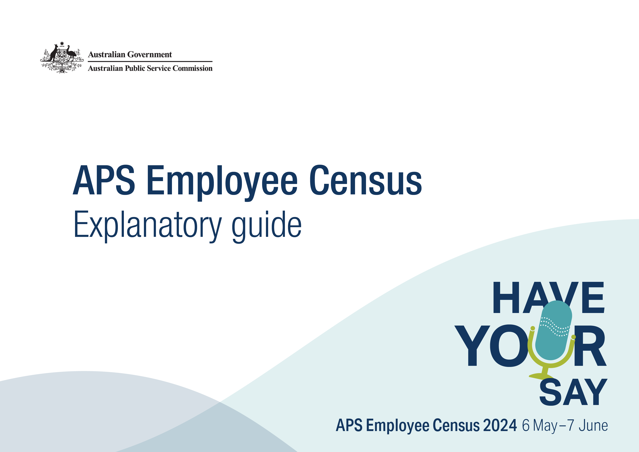
2024 APS Employee Census explanatory guide
Contents
Overview 4
Management and administration of the APS Employee Census 4
Timing 4
Questionnaire 4
Data collection 5
Participating agencies in 2024 6
The questionnaire 8
Development 9
Framework 10
Employee Engagement Index 11
Leadership indices 11
Immediate Supervisor Index 12
SES Manager Leadership Index 12
Communication Index 13
Enabling Innovation Index 14
Wellbeing Policies and Support Index 15
Calculating and interpreting index scores 16
Other topic areas 17
Other topics addressed in the APS Employee Census 18
Work-related demographics 18
Diversity details 18
Job family 18
General impressions: Current job 18
General impressions: Immediate workgroup 18
General impressions: Immediate supervisor 18
General impressions: Senior Executive Service 19
General impressions: Agency and APS 19
Productivity and Ways of Working 19
Developing capability 19
Work-life balance 19
Working away from the office 19
Wellbeing 19
Sources of stress at work 20
Recruitment and retention 20
Mobility 20
APS Values and unacceptable behaviours 20
Corruption 20
Free-text questions 20
Maintaining privacy 21
Reporting rules 22
Using the results 23
Using the results 24
Interpreting survey results 24
Differences between employee perception survey results and data from human resources information systems 24
Comparisons and internal benchmarks 25
Time series comparisons 25
Internal APS benchmarks 25
Differences in function and size 25
Comparisons with external benchmarks 26
Ranking of agencies 27
Rounding 28
Rounding 29
Further information 30
Further information 31

Overview
The APS Employee Census is an annual survey which is used to collect confidential attitude and opinion information from APS employees on issues in the workplace. It is an opportunity for APS employees to share their experiences of working in the APS.
In 2024, 173,830 employees from 106 APS agencies were invited to participate in the Census. A total of 140,396 responded, yielding a response rate of 81 per cent. This response rate is encouraging given the size of the APS workforce, the number of participating agencies and that the Census has been administered annually for some time. This response rate is also strong when compared with similar surveys in other jurisdictions:
- NSW People Matter Employee Survey (2023) – 53%
- QLD Working for Queensland Survey (2023) – 33%
- VIC People Matter Survey (2023) – 42%
- NT People Matter Survey (2023) – 39%
- WA Public Sector Census (2023) – 29%
- TAS State Service Employee Survey (2023) – 29%
- SA Your Voice Survey (2021) – 36%
- UK Civil Service People Survey (2023) – 65%
- Canada Public Service Employee Survey (2022) – 53%
- USA Federal Employee Viewpoint Survey (2023) – 39%

Management and administration of the APS Employee Census
The Census is managed and coordinated by the People Insights Branch within the Australian Public Service Commission (APSC). The APSC contracts an external service provider to support survey administration and reporting activities. Ipsos was this service provider in 2024.

Timing
Each year, the Census is administered over a five week period, usually beginning the second week of May. The 2024 Census opened on 6 May 2024. Results from the Census are used by agencies to inform planning, reform and other initiatives.

Questionnaire
All respondents to the Census are asked a standard set of questions. This approach is taken to generate APS level results and benchmarks for comparison purposes. While a standardised questionnaire is employed, agencies have the option of asking their employees a limited number of agency-specific questions.

Data collection
The Census is primarily an online survey. Respondents are invited to participate by email and are provided with a unique link to access the survey. A limited number of agencies distribute a paper version of the Census to personnel who do not have regular access to a work email account.
Although participation is encouraged, the Census is a voluntary activity. If a respondent chooses to participate, only a limited number of demographic-type questions must be answered. The remaining questions do not require a response if the respondent chooses not to answer.
Information about how privacy is maintained can be found on the APSC website:
Privacy policy

Participating agencies in 2024

Aboriginal Hostels Limited
Administrative Appeals Tribunal
Aged Care Quality and Safety Commission
Asbestos and Silica Safety and Eradication Agency
Attorney-General's Department
Australian Bureau of Statistics
Australian Centre for International Agricultural Research
Australian Charities and Not-for-profits Commission
Australian Commission on Safety and Quality in Health Care
Australian Communications and Media Authority
Australian Competition and Consumer Commission
Australian Criminal Intelligence Commission
Australian Digital Health Agency
Australian Electoral Commission
Australian Financial Security Authority
Australian Fisheries Management Authority
Australian Human Rights Commission
Australian Institute of Aboriginal and Torres Strait Islander Studies
Australian Institute of Family Studies
Australian Institute of Health and Welfare
Australian Law Reform Commission
Australian National Audit Office
Australian National Maritime Museum
Australian Office of Financial Management
Australian Pesticides and Veterinary Medicines Authority
Australian Public Service Commission
Australian Radiation Protection and Nuclear Safety Agency
Australian Research Council
Australian Skills Quality Authority
Australian Submarine Agency
Australian Taxation Office
Australian Trade and Investment Commission
Australian Transaction Reports and Analysis Centre
Australian Transport Safety Bureau
Australian War Memorial
Bureau of Meteorology
Cancer Australia
Clean Energy Regulator
Climate Change Authority
Comcare
Commonwealth Director of Public Prosecutions
Commonwealth Grants Commission
Defence Housing Australia
Department of Agriculture, Fisheries and Forestry
Department of Climate Change, Energy, the Environment and Water
Department of Defence
Department of Education
Department of Employment and Workplace Relations
Department of Finance
Department of Foreign Affairs and Trade
Department of Health and Aged Care
Department of Home Affairs
Department of Industry, Science, and Resources
Department of Infrastructure, Transport, Regional Development, Communications and the Arts
Department of Social Services
Department of the Prime Minister and Cabinet
Department of the Treasury
Department of Veterans' Affairs
Digital Transformation Agency
Fair Work Commission
Fair Work Ombudsman
Federal Court of Australia
Food Standards Australia New Zealand
Future Fund Management Agency
Geoscience Australia
Great Barrier Reef Marine Park Authority
Independent Parliamentary Expenses Authority
Inspector-General of Taxation and Taxation Ombudsman
IP Australia
Murray-Darling Basin Authority
National Anti-Corruption Commission
National Archives of Australia
National Blood Authority
National Capital Authority
National Disability Insurance Agency
National Emergency Management Agency
National Film and Sound Archive
National Health and Medical Research Council
National Health Funding Body
National Indigenous Australians Agency
National Library of Australia
National Mental Health Commission
National Museum of Australia
National Offshore Petroleum Safety and Environmental Management Authority
National Portrait Gallery
NDIS Quality and Safeguards Commission
Office of the Inspector-General of Intelligence and Security
Office of the Inspector-General of Aged Care
Office of National Intelligence
Office of Parliamentary Counsel
Office of the Australian Information Commissioner
Office of the Commonwealth Ombudsman
Office of the Special Investigator
Old Parliament House (Museum of Australian Democracy)
Organ and Tissue Authority
Parliamentary Workplace Support Service
Productivity Commission
Professional Services Review
Royal Australian Mint
Safe Work Australia
Screen Australia
Services Australia
Sport Integrity Australia
Tertiary Education Quality and Standards Agency
Torres Strait Regional Authority
Workplace Gender Equality Agency

Note:
Five non-APS agencies participated in the APS Employee Census in 2024 – Civil Aviation Safety Authority, Department of the House of Representatives, Department of the Senate, National Gallery of Australia, and the Parliamentary Budget Office.
Agencies can opt to invite non-APS employees to participate in the Employee Census. Any responses from respondents who identify as not being an APS employee are excluded when calculating APS overall results. This includes responses from non-APS agencies.
The number of APS employees invited to participate in the Employee Census differs from the size of the APS workforce officially reported in the APS Employment Data releases. These differences are for several reasons. It is up to agencies to set their own eligibility criteria, however:
- Employees on leave for the entire period of the Employee Census administration period are typically excluded from the survey population as it is assumed that they are not at work to complete a work activity.
- Employees who are very new to an agency prior to or during the administration period are typically excluded from the survey population as it is assumed they have not had sufficient exposure to the new agency to develop opinions. This means that APS staff who have moved between APS agencies during this period may be excluded.
Additionally, some agencies specifically choose not to invite their non-APS, intermittent or irregular APS employees to participate in the Employee Census.




The questionnaire

Development
The 2024 APS Employee Census questionnaire includes 138 individual questions grouped into 13 sections. Each section addresses a key aspect of working for an APS agency.
Each year the content of the Census questionnaire is reviewed to ensure that each question has value and meets a specific purpose. In 2021, a new underlying framework was applied to better align core sets of questions and harness greater value from results. In 2024, the APSC has continued to improve the questionnaire through:
- Broad consultation with subject matter experts from within the APSC and other APS agencies to seek their input to question design and information requirements for supporting APS-level policies and programs.
- Ongoing research to better understand contemporary workforce issues and options that relate to questionnaire content.
- Listening to and incorporating agencies feedback.

The questionnaire covers numerous themes and measures. Central to these are six indices addressing employee engagement, SES manager leadership, immediate supervisor leadership, communication, innovation and policies that support wellbeing.

Framework
The APSC employs the Job Demands-Resources model (JD-R) as the underlying framework for the 2024 APS Employee Census questionnaire.
The JD-R is a well-validated theory of occupational stress and engagement that has been applied across a broad range of fields (e.g. Christian et al., 2011; Demerouti et al., 2001; Lesener et al., 2019). The JD-R proposes that the interaction between two sets of work conditions (job demands and job resources) contribute to work outcomes.
Job demands refer to the organisational, social, and physical aspects of a job that require extended effort (mental or physical) to cope with.
Job resources are the aspects of a job that assist in achieving work goals, reducing job demands, and facilitating personal growth and development.
Job demands and resources interact in two ways. Strain and reduced employee wellbeing result when employees are required to cope with high job demands for extended periods and which exceeds their ability to adapt or cope.
Alternatively, greater employee motivation occurs when employees are provided with sufficient resources (e.g. support) and they are able to 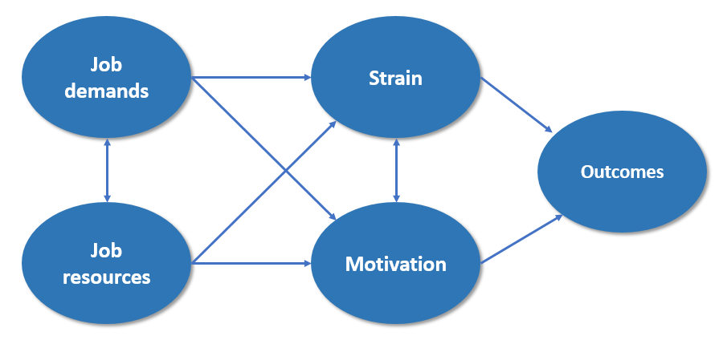
better engage with their work. Importantly, all these elements interact, resulting in positive and negative outcomes for the employee and organisation. An example of a positive outcome is high levels of work performance, while a negative outcome is employee turnover.
The APSC first piloted the JD-R in the 2020 APS Employee Census. This framework has since been expanded and applied to the 2021, 2022, 2023 and 2024 Employee Census questionnaires.
As an underlying framework, the JD-R informs the questions that are included within the APS Employee Census questionnaire and how results are reported and interpreted.

Employee Engagement Index
Employee engagement has been thoroughly researched over a number of decades. High levels of employee engagement is associated with positive benefits such as increased performance and productivity.
Employee engagement is more than simply job satisfaction or commitment to an organisation. It is the extent to which employees are motivated, inspired and enabled to improve an organisation’s outcomes. Engagement requires a two-way relationship between an employee and their organisation.
The APSC employs a model of employee engagement developed by the external service provider. This model addresses three attributes associated with employee engagement and measures the emotional connection and commitment employees have to working for their organisation. In this model, an engaged employee will “say”, “stay” and “strive”:
- Say – the employee is a positive advocate of the organisation
- Stay – the employee is committed to the organisation and wants to stay as an employee
- Strive – the employee is willing to put in discretionary effort to excel in their job and help their organisation succeed
The Say, Stay, Strive model of employee engagement is flexible and the APSC has tailored the questions for the APS context. The questions that address each attribute and contribute to the index score for employee engagement are presented to the right.

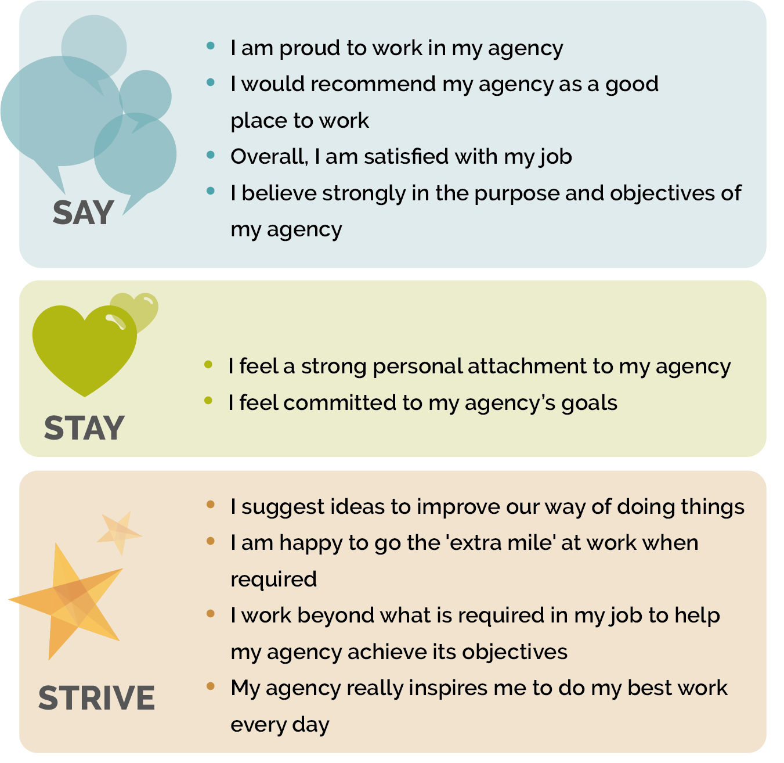
Leadership indices
Strong leadership is vital to high performance in the workplace. High quality leadership has been shown to boost positive workplace outcomes such as productivity, engagement and innovation. Strong leadership also supports times of high demand and contributes to lower employee turnover.
In line with the APS Workforce Strategy 2025, APS leaders require a broad range of leadership capabilities to navigate the APS through increasing complexity. The APS Leadership Capability Framework identifies six key capabilities (VICEED) that are critical for success:
- Visionary
- Influential
- Collaborative
- Entrepreneurial
- Enabling
- Deliver

Immediate Supervisor Index
The Immediate Supervisor Index assesses how employees view the leadership behaviours of their immediate supervisor. The questions that form the Immediate Supervisor Index are:
- My supervisor engages with staff on how to respond to future challenges
- My supervisor can deliver difficult advice whilst maintaining relationships
- My supervisor invites a range of views, including those different to their own
- My supervisor encourages my team to regularly review and improve our work
- My supervisor is invested in my development
- My supervisor ensures that my workgroup delivers on what we are responsible for

SES Manager Leadership Index
The SES Manager Index assesses how employees view the leadership behaviours of their immediate SES manager. The questions that form the SES Manager Leadership Index are:
- My SES manager clearly articulates the direction and priorities for our area
- My SES manager presents convincing arguments and persuades others towards an outcome
- My SES manager promotes cooperation within and between agencies
- My SES manager encourages innovation and creativity
- My SES manager creates an environment that enables us to deliver our best
- My SES manager ensures that work effort contributes to the strategic direction of the agency and the APS

Communication Index
Effective communication is vital for a positive workplace. A communicative workforce fosters collaboration, networking and diverse thinking while improving outcomes. It is also known that effective communication can prevent and buffer issues in the workplace.
The communication index measures communication at the individual, group and agency level. The questions that form the Communication Index are:
- My supervisor communicates effectively
- My SES manager communicates effectively
- Internal communication within my agency is effective

Enabling Innovation Index
Innovation is a particular focus for the APS as it can drive improved performance, productivity and work outcomes. Innovation and employee engagement are also linked, such that innovation can drive engagement, and innovation can flourish where employee engagement is high. The reciprocal relationship between employee engagement and innovation is summarised in the graphic to the right.
In part, the 2024 APS Employee Census addresses innovation through a set of dedicated questions that contribute to an index score. This innovation index score assesses both whether employees feel willing and able to be innovative, and whether their agency has a culture which enables them to be so.
The questions that form the Enabling Innovation Index are:
- I believe that one of my responsibilities is to continually look for new ways to improve the way we work
- My immediate supervisor encourages me to come up with new or better ways of doing things
- People are recognised for coming up with new and innovative ways of working
- My agency inspires me to come up with new or better ways of doing things
- My agency recognises and supports the notion that failure is a part of innovation

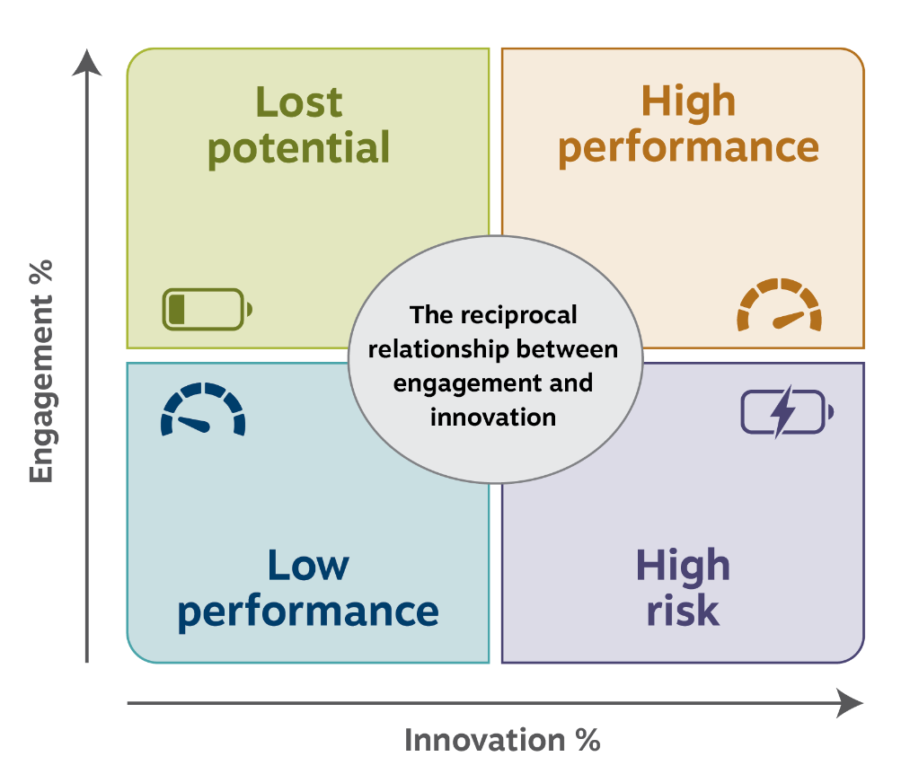

Wellbeing Policies and Support Index
The APS has long been focused on the wellbeing of its employees. As employers, APS agencies have obligations under Work Health and Safety legislation. Together with these obligations is an acknowledgement that high performance of employees and organisations cannot be sustained without adequate levels of employee wellbeing.
The Wellbeing Policies and Support Index included in the APS Employee Census measures both the practical and cultural elements that allow for a sustainable and healthy working environment.
The questions that form the Wellbeing Policies and Support Index are:
- I am satisfied with the policies/practices in place to help me manage my health and wellbeing
- My agency does a good job of communicating what it can offer me in terms of health and wellbeing
- My agency does a good job of promoting health and wellbeing
- I think my agency cares about my health and wellbeing
- I believe my immediate supervisor cares about my health and wellbeing

Calculating and interpreting index scores

The questions that comprise each index are asked on a five-point agreement scale. To calculate the index score, each respondent’s answers to the set of questions are recoded to fall on a scale between 0 and 100. The recoded responses are then averaged across the three or more index questions to provide the index score for that respondent. An individual only receives an index score if they have responded to all questions which comprise that index.
 | Strongly agree | Agree | Neither agree nor disagree | Disagree | Strongly disagree | Score
Weight | 100 | 75 | 50 | 25 | 0
Example question 1 |  |  |  |  |  | 75
Example question 2 |  |  |  |  |  | 75
Example question 3 |  |  |  |  |  | 50
Example question 4 |  |  |  |  |  | 25
Example question 5 |  |  |  |  |  | 100
Sum of question weights for this employee: |  |  |  |  |  | 325
Index score for this example respondent (325/5): |  |  |  |  |  | 65
Index scores for groups of respondents are calculated by averaging the respondent scores that comprise that group.
An index score on its own can provide information about the group to which it relates. Index scores, however, have the most utility when they are compared with scores over time or between work units, organisations and demographic groups.

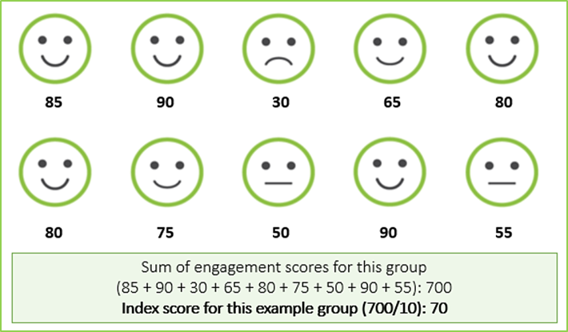

Other topic areas

Other topics addressed in the APS Employee Census

The Census addresses a broad range of topic areas. These topic areas and the questions that relate to them can change between years depending on priorities and areas of focus for the APS.
Each of the major topic areas addressed in the 2024 APS Employee Census is listed below.

Work-related demographics
As in previous years, the 2024 APS Employee Census included several questions about demographics such as employment status, classification, and location. These facilitate a greater understanding of workforce attitudes.

Diversity details
The Census captured a range of information to address the diversity and inclusion priorities of the APS, ongoing disability and identification as an Australian Aboriginal and/or Torres Strait Islander. To continue to better understand the diversity of APS employees questions were also added to include cultural diversity and neurodivergence.

Job family
The 2024 APS Employee Census included a question asking respondents to choose an option that best describes the type of work they do. The response options presented at this question corresponded with the job families within the APS job family model.

General impressions: Current job
Respondents were asked their attitudes towards their current job and working conditions. Some questions within this section contribute to measures of employee engagement. Most questions within this section have been included within the Census for a number of years and provide useful data for time series comparisons.

General impressions: Immediate workgroup
Respondents were asked a number of questions about the people they work with on a daily basis. Some of the questions within this section have been included within the Census for a number of years.

General impressions: Immediate supervisor
Respondents were asked for their views of their immediate supervisor. Some questions within this section have been included in the Census for a number of years. Others are relatively new and reflect contemporary skills and attributes of APS managers. Responses to selected questions form the immediate supervisor index score.

General impressions: Senior Executive Service
Respondents were asked for their views of their immediate Senior Executive Service (SES) manager as well as their thoughts on the SES cohort within their agency. For the purposes of the Census, an immediate SES manager is a Line/Branch/Group manager or equivalent. Responses to selected questions form the SES Manager Leadership Index score.

General impressions: Agency and APS
Respondents were asked for their attitudes towards their current agency and working in the APS. Several questions within this set contribute to measures of employee engagement, while others evaluate APS workforce strategies and the impacts of crises on working in the APS.

Productivity and Ways of Working
This section asks respondents for their views on their productivity and their workgroup’s performance, including barriers to high performance.

Developing capability
Questions assessing the ways that supervisors and individuals develop employee capability were created in 2018 in consultation with subject matter experts within the APSC. These have been included to assess skills or capability gaps within the immediate workgroup.

Work-life balance
The question asking respondents to indicate their satisfaction with the work-life balance of their current job has been included within the APS Employee Census since 2012.

Working away from the office
In 2024, the APS Employee Census added the question ‘During your usual working week, how often do you work away from the office/work from home?’ to supplement the existing flexible work question ‘Do you currently access any of the following flexible working arrangements?’. Data from both flexible work questions combine to form the ‘Working away from the office’ variable. This variable enables agencies and the APS to better understand both the frequency and perceptions of employees who work flexibly.
Calculating the ‘Working away from the office’ variable
To calculate the “Working away from the office” variable, data from the question ‘Do you currently access any of the following flexible working arrangements?’ contributed ‘none of the time’ and ‘did not disclose their arrangement’ responses. Data from the question ‘During your usual working week, how often do you work away from the office/work from home?’ contributed the ‘all of the time’, ‘some of the time as a regular arrangement’ and ‘only on an irregular basis’ responses. Missing data were also accounted for.

Wellbeing
Respondents were asked a series of questions that assessed organisational support for employees’ health and wellbeing. Responses to most of these questions were used to calculate the Wellbeing Index score. Respondents were asked if there have been changes in their general health and wellbeing, if their work is emotionally demanding and if they feel burned out by their work.

Sources of stress at work
The APS Mental Health and Suicide Prevention Unit have developed a suite known as ADDRESS: An APS model for responding to psychosocial hazards. The mapping screener uses Employee Census data to heat map risks and help agencies understand how particular work factors can contribute to psychological hazards in the workplace.
The United Kingdom’s Health and Safety Executive (UK HSE) identified six Management Standards that represent the primary sources of stress at work. The HSE Management Standards Indicator tool contains 35 questions to assess work stress, and as in previous years, the 2024 APS Employee Census uses seven of these questions.

Recruitment and retention
The 2024 APS Employee Census asked respondents about their reasons for staying in their current role.

Mobility
A number of questions have been included to better understand the barriers to mobility as the APS embraces working in different ways by mobilising staff to work in surge workforce teams, task forces and across teams.

APS Values and unacceptable behaviours
This section includes questions regarding APS Values, and perceived experiences of discrimination, harassment or bullying in the previous 12 months.

Corruption
Consistent with previous years, respondents were asked to indicate whether they had witnessed corruption in their workplace and to describe the behaviour they had seen, as well as whether or not they reported this behaviour.

Free-text questions
At the very end of the 2024 APS Employee Census, respondents were asked to provide comments to two questions: what the agency was doing well and the most important issue that the agency needed to address. Comments have been analysed and topics have been applied using Qualtrics comments analysis software based and the external service provider’s best practice public sector topic list. They are multi-themed, meaning they may be attributed to more than one theme.

Maintaining privacy

Reporting rules
The APSC employs specific rules around how results are reported. Such rules protect the privacy of respondents and individual agencies’ results.
De-identification of data is undertaken in accordance with guidance provided by the Office of the Australian Information Commissioner.
The APSC and the external service provider report Census results and make these available to agencies and other parties. Results are reported for groups of respondents. Groups can be formed by a combination of demographic information (such as age group, gender or classification level) and/or where the respondent works within an agency.
There are strict filters in place so that when less than 10 employees respond, no data is displayed in an agency’s online Census reporting portal. Free-text comments will only be attributable to particular groups where there are 30 or more comments from members of that group. For example, if a work unit has less than 30 respondents the free text questions will not be shown for that work group. More information is available in the Participant Information sheet which is available on the APSC website.
The APSC may provide agencies and external parties with de-identified Census datasets. As outlined in the APSC Privacy Policy, responses within these datasets will not be reasonably attributable to any specific individual.

Agencies may publicly release reports of their APS Employee Census results. These reports will be at the whole-of-agency level.
De-identified datasets are uploaded to data.gov.au in accordance with the Australian Government Public Data Policy.

Using the results

Using the results

Interpreting survey results
Most items in the Census ask respondents to rate the level of agreement regarding, or satisfaction with, workplace issues on a five-point, ordinal scale. The scales are generally balanced, allowing respondents to express one of two extremes in view (for example, satisfaction and dissatisfaction) and with a midpoint that allows respondents to enter a ‘neutral’ response. When reporting, the five points can be collapsed into three: agree/satisfied, neutral, and disagree/dissatisfied. Therefore, the neutral category refers to responses that reflect a ‘neither agree nor disagree’ sentiment.
When interpreting item responses, it is important to realise there is only an ordinal relationship between points in a scale. The strength of opinion to shift a respondent from ‘neutral’ to ‘satisfied’ may be much smaller (or larger) than the strength required to shift a respondent from ‘satisfied’ to ‘very satisfied’.
Although it can be a valuable resource and evidence base, it should be remembered that the Census is an employee perception survey. Respondents are asked to provide their opinions and perceived experiences.
As with any survey, the Census can involve error, both predictable and unpredictable. For example, respondents may provide a socially acceptable answer rather than their true attitudes.

Additionally, although all APS employees are invited to participate, not everyone chooses to do so. Even with a strong response rate at the APS overall level, there is a chance that non-respondents are different from those who completed the Census. At the APS level, four demographics are checked to ensure respondents are representative of the broader APS workforce. These demographics are age, gender, state/territory, and current classification. While each year there are no considerable differences in demographics among those who did and did not respond to the survey, some caution may be required when interpreting results from groups with lower response rates.

Differences between employee perception survey results and data from human resources information systems
Responses to the Census as an employee perception survey may differ to data held within human resources information systems. This is particularly true for demographic and diversity-related information.
There are numerous reasons for these differences. Some characteristics are not always permanent and impact an employee for a certain period of time (e.g. disability). Some employees also may not want to officially disclose and record some information on their agency’s human resources systems.

Comparisons and internal benchmarks

Time series comparisons
Results for the Census are compared with those from previous years wherever possible. This provides a source for trend comparisons and a benchmark for assessing whether results have changed.
The questions included within the Census can change between years. While most questions are retained without change, new questions are added, others removed and some are reworded. Results are typically only compared between years if the same question wording was used in each year. Changes in wording can alter the meaning of a question and change how it would be answered by respondents.

Internal APS benchmarks
Reporting of agencies’ APS Employee Census results primarily focus on comparisons with internal APS benchmarks.
Where an agency has opted to include an organisational hierarchy within the Employee Census and have results reported for individual work units, comparisons between work units can be another source of benchmarks/information.
Results for the APS overall provide the most common comparator for individual agencies’ results. Agencies are further grouped by size and function to provide other benchmark scores for comparisons.

Differences in function and size
There may be variability in results across the size of agencies, as well as the functions that agencies perform (e.g. regulatory, specialist, operational). Therefore, any comparison across agencies should also take into consideration other factors, such as size and functional cluster. More information about functional cluster and size can be found on the APSC’s website.

Comparisons with external benchmarks
While comparisons of results between years, APS agencies and work units are often the focus of analysis, comparisons with external organisations can also provide valuable information. Accepting that different organisations are likely to ask different questions of their employees, comparisons with external benchmarks are not as rigorous as time series or internal comparisons. External benchmarks, however, can provide indications of how an agency’s results compare to those from similar organisations and jurisdictions.
When comparing results to external benchmark scores, it is important to consider how well the Census and benchmarked questions match. While it is usually preferred that questions being compared have identical wording, it is sometimes reasonable to compare questions that are worded differently.
When comparing the results for questions with different wording, it is important to consider whether the questions measure the same thing in the same context. Differences can certainly be accommodated, but likely weaken any direct comparisons between the results.

For instance, the two questions below are similar, but are not directly comparable. The first is a question from the Census and the second is an example of an external question:
- Overall, I am satisfied with my job.
- I like the work I do in my current position.
While both questions seem to address how much a respondent likes their job, the first addresses general job satisfaction, while the second focuses more on how much the person likes the work they are asked to do in their job. Both concepts are similar, but not the same. Depending on the reasons why external benchmarks are required, it may still be appropriate to compare the results for these questions.
Additional external benchmarks may be self-sourced from other comparable jurisdictions and organisations.

Ranking of agencies
As in 2023, graphs were included in 2024 agency level highlights reports to display the spread of agency scores across the 6 indices. These graphs assist agencies visualise their engagement and wellbeing score positions in comparison to other APS agencies and the APS overall score.
The height of the bars (x-axis) display the number of agencies who have the same index score. Only index scores received by at least one agency are represented. Therefore, the y-axis values are not consecutive. This is important to note when understanding the true spread of the values.
An arrow indicates where the agency’s score sits within the data points. Another arrow shows the APS overall index score, although the APS overall index score does not have a data point within the graph (i.e. it is not represented in the height of the bar).
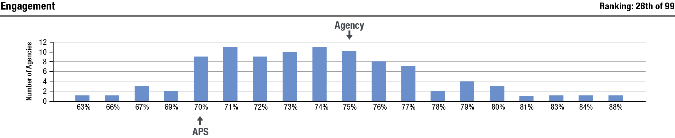
Agencies also receive a ranking for their index score. This ranking indicates how many agencies received a higher index score. Agencies with the same sindex score receive the same ranking (see graph and table). The APS overall index score is not included in the rankings.
The methodology applied for the rankings is as follows:
- all respondents (including non-APS employees) from APS agencies are included
- only APS agencies with 10 or more responses are included (non-APS agencies have not been included)
- ranking is on whole number index scores
Index score | Number of agencies with that index score | Number of agencies with a higher index score | Ranking agencies would receive
88 | 1 | 0 | 1st
84 | 1 | 1 | 2nd
83 | 1 | 2 | 3rd
81 | 1 | 3 | 4th
80 | 3 | 4 | 5th
79 | 4 | 7 | 8th
78 | 2 | 11 | 12th

Rounding

 | Strongly agree | Agree | Neither agree nor disagree | Disagree | Strongly disagree | Total
Number of responses | 151 | 166 | 176 | 96 | 24 | 613
Percentage | 24.63% | 27.08% | 28.71% | 15.66% | 3.92% | 100.00%
Rounded percentage | 25% | 27% | 29% | 16% | 4% | 101%
 | Positive |  | Neutral | Negative
Number of responses | 151 + 166 = 317 |  | 176 | 96 + 24 = 120 |  | 613
Percentage | 51.72% |  | 28.71% | 19.58% |  | 100.01%
Rounded percentage | 52% |  | 29% | 20% |  | 101%

Rounding

Results for the APS Employee Census are typically reported as whole numbers for ease of reading. Values from x.00 to x.49 are rounded down, while values from x.50 to x.99 are rounded up. Any rounding is performed at the last stage of calculation to maximise accuracy of the reported results.
In some instances, results may not sum to 100% due to rounding. Rounding may also mean that reported figures may not be identical to those calculated manually. Any differences, however, would not be more than one percentage point.
Rounding as applied to APS Employee Census results is illustrated in the table.

Further information

Further information
To access further information regarding the APS Employee Census and reported results, please go to the APSC website.
State of the Service Reports can be found on the APSC website.
To access APS Employee Census de-identified datasets, please go to data.gov.au.
To request further information about the APS Employee Census please contact the APS Employee Census team from the APSC at APSSurveys@apsc.gov.au or on 1800 464 926.

Christian, M. S., Garza, A. S., & Slaughter, J. E. (2011). Work engagement: A quantitative review and test of its relations with task and contextual performance. Personnel Psychology, 64, 89–136. doi:10.1111/j.1744-6570.2010.01203.x
Demerouti, E., Bakker, A. B., Nachreiner, F., & Schaufeli, W. B. (2001). The job demands-resources model of burnout. Journal of Applied Psychology, 86, 499–512.
Lesener, T., Gusy, B., & Wolter, C. (2019). The job demands-resources model: A meta-analytic review of longitudinal studies. Work & Stress, 33, 76–103. doi:10.1080/02678373.2018.1529065

