

Australian Public Service Employee Census

**Explanatory**

**Guide 2022**

**2022 APS Employee Census explanatory guide**

Contents

Overview 3

Management and administration of the APS Employee Census 3

Timing 3

Questionnaire 3

Data collection 4

Participating agencies in 2022 5

The Questionnaire 7

Development 8

Framework 9

Employee engagement index 10

Leadership indices 11

Immediate supervisor index 11

SES manager index 11

Communication index 12

Enabling innovation index 13

Wellbeing policies and support index 14

Calculating and interpreting index scores 15

Other topic areas 16

Other topics addressed in the APS Employee Census 17

Work-related demographics 17

Diversity details 17

Job family 17

General impressions: Current job 17

General impressions: Immediate workgroup 17

General impressions: Immediate supervisor 17

General impressions: Senior Executive Service 18

General impressions: Agency and APS 18

Productivity and Ways of Working 18

Developing capability 18

Work-life balance 18

Flexible working 18

Sources of stress at work 18

Wellbeing 18

Recruitment and retention 18

Mobility 19

APS Values and unacceptable behaviours 19

Corruption 19

Free-text questions 19

Maintaining privacy 20

Reporting rules 21

Using the results 22

Using the results 23

Interpreting survey results 23

Differences between employee perception survey results and data from human resources information systems 23

Comparisons and internal benchmarks 24

Time series comparisons 24

Internal APS benchmarks 24

Differences in function and size 24

Comparisons with external benchmarks 25

Rounding 26

Rounding 27

Further information 28

Further information 29

# Overview

The Australian Public Service (APS) Employee Census (the Census) is an annual employee perception survey of the APS workforce. All eligible personnel employed under the *Public Service Act 1999* are invited to participate.

In 2022, 145,051 employees from 99 APS agencies were invited to participate in the Census. A total of 120,662 responded, yielding a response rate of 83 per cent. This response rate is encouraging given the size of the APS workforce, the number of participating agencies and that the Census has been administered annually for some time. This response rate is also strong when compared with similar surveys in other jurisdictions:

* NSW People Matter Employee Survey (2021) – 44%
* QLD Working for Queensland Survey (2020) – 44%
* VIC People Matter Survey (2021) – 39%
* NT People Matter Survey (2021) – 46%
* WA Census Pilot (2021) – 48%
* TAS State Service Employee Survey (2020) – 22%
* SA Your Voice Survey (2021) – 36%
* UK Civil Service People Survey (2021) – 62%
* Canada Public Service Employee Survey (2020) – 61%
* USA Federal Employee Viewpoint Survey (2021) – 34%

## 

### Management and administration of the APS Employee Census

The Census is managed and coordinated by the Strategic Policy and Research Group within the Australian Public Service Commission (APSC). The APSC contracts an external service provider to support survey administration and reporting activities. Big Village (formerly Engine) was this service provider in 2022.

### Timing

Each year, the Census is administered over a five week period, usually beginning the second week of May. The 2022 Census opened on 9 May 2022. Results from the Census are used by agencies to inform planning, reform and other initiatives.

### Questionnaire

All respondents to the Census are asked a standard set of questions. This approach is taken to generate APS level results and benchmarks for comparison purposes. While a standardised questionnaire is employed, agencies have the option of asking their employees a limited number of agency-specific questions.

### Data collection

The Census is primarily an online survey. Respondents are invited to participate by email and are provided with a unique link to access the survey. A limited number of agencies distribute a paper version of the Census to personnel who do not have regular access to a work email account.

Although participation is encouraged, the Census is a voluntary activity. If a respondent chooses to participate, only a limited number of demographic-type questions must be answered. The remaining questions do not require a response if the respondent chooses not to answer.

Information about how privacy is maintained can be found on the APSC website:

[Privacy policy](https://www.apsc.gov.au/apsc-privacy-policy-part-b#census)

## Participating agencies in 2022

Aboriginal Hostels Limited

Administrative Appeals Tribunal

Aged Care Quality and Safety Commission

Asbestos Safety and Eradication Agency

Attorney General's Department

Australian Building and Construction Commission

Australian Bureau of Statistics

Australian Centre for International Agricultural Research

Australian Charities and Not-for-profits Commission

Australian Commission for Law Enforcement Integrity

Australian Commission on Safety and Quality in Health Care

Australian Communications and Media Authority

Australian Competition and Consumer Commission

Australian Criminal Intelligence Commission

Australian Digital Health Agency

Australian Electoral Commission

Australian Financial Security Authority

Australian Fisheries Management Authority

Australian Human Rights Commission

Australian Institute of Aboriginal and Torres Strait Islander Studies

Australian Institute of Family Studies

Australian Institute of Health and Welfare

Australian National Audit Office

Australian National Maritime Museum

Australian Office of Financial Management

Australian Pesticides and Veterinary Medicines Authority

Australian Public Service Commission

Australian Radiation Protection and Nuclear Safety Agency

Australian Research Council

Australian Skills Quality Authority

Australian Taxation Office

Australian Trade and Investment Commission

Australian Transaction Reports and Analysis Centre

Australian Transport Safety Bureau

Australian War Memorial

Bureau of Meteorology

Cancer Australia

Clean Energy Regulator

Climate Change Authority

Comcare

Commonwealth Grants Commission

Defence Housing Australia

Department of Agriculture, Water and the Environment

Department of Defence

Department of Education, Skills and Employment

Department of Finance

Department of Foreign Affairs and Trade

Department of Health

Department of Home Affairs

Department of Industry, Science, Energy and Resources

Department of Infrastructure, Transport, Regional Development and Communications

Department of Social Services

Department of the Prime Minister and Cabinet

Department of the Treasury

Department of Veterans' Affairs

Digital Transformation Agency

Fair Work Commission

Federal Court of Australia

Food Standards Australia New Zealand

Future Fund Management Agency

Geoscience Australia

Great Barrier Reef Marine Park Authority

Independent Parliamentary Expenses Authority

IP Australia

Murray-Darling Basin Authority

Museum of Australian Democracy at Old Parliament House

National Archives of Australia

National Blood Authority

National Capital Authority

National Disability Insurance Agency

National Disability Insurance Scheme Quality and Safeguards Commission

National Film and Sound Archive of Australia

National Health and Medical Research Council

National Health Funding Body

National Indigenous Australians Agency

National Library of Australia

National Mental Health Commission

National Museum of Australia

National Offshore Petroleum Safety and Environmental Management Authority

National Recovery and Resilience Agency

Office of National Intelligence

Office of Parliamentary Counsel

Office of the Australian Information Commissioner

Office of the Commonwealth Director of Public Prosecutions

Office of the Commonwealth Ombudsman

Office of the Fair Work Ombudsman

Office of the Inspector-General of Intelligence and Security

Office of the Inspector-General of Taxation and Taxation Ombudsman

Organ and Tissue Authority

Productivity Commission

Professional Services Review

Royal Australian Mint

Safe Work Australia

Screen Australia

Services Australia

Sport Integrity Australia

Tertiary Education Quality and Standards Agency

Torres Strait Regional Authority

Workplace Gender Equality Agency

Note:

Four non-APS agency participated in the APS Employee Census in 2022 – Parliamentary Budget Office, Department of the House of Representatives, Department of the Senate, and the National Gallery of Australia.

Agencies can opt to invite non-APS employees to participate in the Employee Census. Any responses from respondents who identify as not being an APS employee are excluded when calculating APS overall results. This includes responses from non-APS agencies.

The number of APS employees invited to participate in the Employee Census differs from the size of the APS workforce officially reported in the APS Employment Data releases. These differences are for several reasons. It is up to agencies to set their own eligibility criteria, however:

* employees on leave for the entire period of the Employee Census administration period are typically excluded from the survey population as it is assumed that they are not at work to complete a work activity
* employees who are very new to an agency prior to or during the administration period are typically excluded from the survey population as it is assumed they have not had sufficient exposure to the new agency to develop opinions. This means that APS staff who have moved between APS agencies during this period may be excluded.

Additionally, some agencies specifically choose not to invite their non-APS, intermittent or irregular APS employees to participate in the Employee Census.

The Questionnaire

## Development

The 2022 APS Employee Census questionnaire includes 147 individual questions grouped into 14 sections. Each section addresses a key aspect of working for an APS agency.

Each year the content of the Census questionnaire is reviewed to ensure that each question has value and meets a specific purpose. In 2021, a new underlying framework was applied to better align core sets of questions and harness greater value from results. In 2022, the APSC has continued to improve the questionnaire through:

* Broad consultation with subject matter experts from within the APSC and other APS agencies to seek their input to question design and information requirements for supporting APS-level policies and programs.
* Ongoing research to better understand contemporary workforce issues and options that relate to questionnaire content.
* Listening to and incorporating agencies feedback.

The resultant questionnaire covers numerous themes and measures. Central to these are six indices addressing employee engagement, SES manager leadership, immediate supervisor leadership, communication innovation and policies that support wellbeing.

## Framework

The APSC employs the Job Demands-Resources model (JD-R) as the underlying framework for the 2022 APS Employee Census questionnaire.

The JD-R is a well-validated theory of occupational stress and engagement that has been applied across a broad range of fields (e.g. Christian et al., 2011[1]; Demerouti et al., 2001[2]; Lesener et al., 2019[3]). The JD-R proposes that the interaction between two sets of work conditions (job demands and job resources) contribute to work outcomes.

**Job demands** refer to the organisational, social, and physical aspects of a job that require extended effort (mental or physical) to cope with.

**Job resources** are the aspects of a job that assist in achieving work goals, reducing job demands, and facilitating personal growth and development.

Job demands and resources interact in two ways. Strain and reduced employee wellbeing result when employees are required to cope with high job demands for extended periods and which exceeds their ability to adapt or cope.

Alternatively, greater employee motivation occurs when employees are provided with sufficient resources (e.g. support) and they are able to 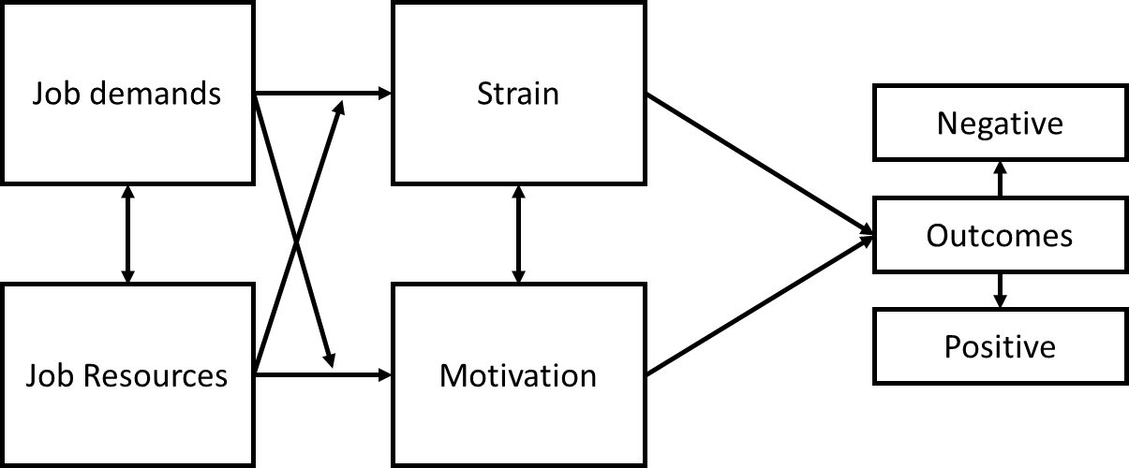  
  
better engage with their work. Importantly, all these elements interact, resulting in positive and negative outcomes for the employee and organisation. An example of a positive outcome is high levels of work performance, while a negative outcome is employee turnover.

The APSC first piloted the JD-R in the 2020 APS Employee Census. This framework has since been expanded and applied to the 2021 and 2022 Employee Census questionnaires.

As an underlying framework, the JD-R informs the questions that are included within the APS Employee Census questionnaire and how results are reported and interpreted.

## Employee engagement index

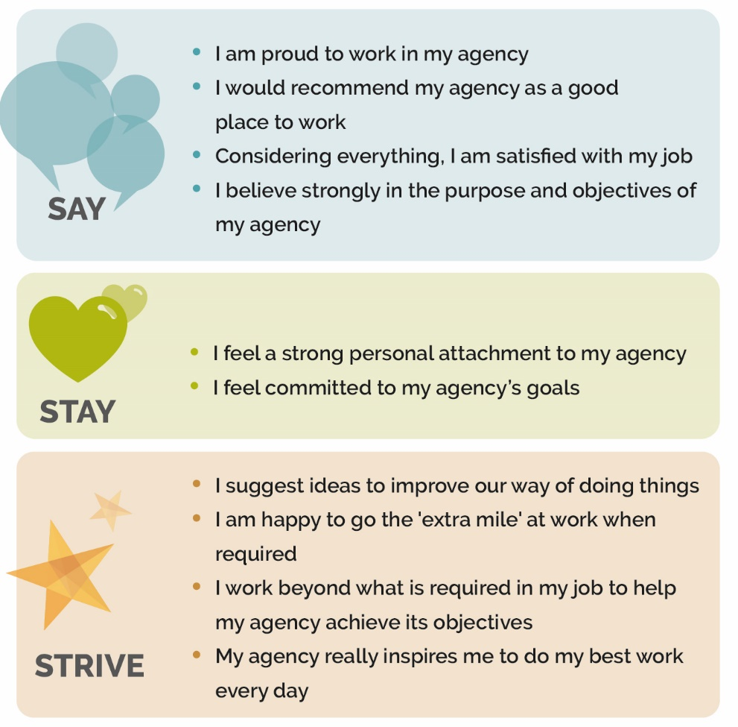Employee engagement has been thoroughly researched over a number of decades. High levels of employee engagement is strongly associated with positive benefits such as increased performance and productivity.

Employee engagement is more than simply job satisfaction or commitment to an organisation. It is the extent to which employees are motivated, inspired and enabled to improve an organisation’s outcomes. Engagement requires a two-way relationship between an employee and their organisation.

The APSC employs a model of employee engagement developed by Big Village (formerly Engine). This model addresses three attributes associated with employee engagement and measures the emotional connection and commitment employees have to working for their organisation. In this model, an engaged employee will “say”, “stay” and “strive”:

* Say – the employee is a positive advocate of the organisation.
* Stay – the employee is committed to the organisation and wants to stay as an employee.
* Strive – the employee is willing to put in discretionary effort to excel in their job and help their organisation succeed.

The Say, Stay, Strive model of employee engagement is flexible and the APSC has tailored the questions for the APS context. The questions that address each attribute and contribute to the index score for employee engagement are presented to the right.

## Leadership indices

Strong leadership is vital to high performance in the workplace. High quality leadership has been shown to boost positive workplace outcomes such as productivity, engagement and innovation. Strong leadership also supports times of high demand and contributes to lower employee turnover.

In line with the [APS Workforce Strategy 2025](https://www.apsc.gov.au/initiatives-and-programs/aps-workforce-strategy-2025#senior-leaders), APS leaders require a broad range of leadership capabilities to navigate the APS through increasing complexity. [The APS Leadership Capability Framework](https://www.apsc.gov.au/initiatives-and-programs/learning-and-development/leadership-capabilities) identifies six key capabilities (VICEED) that are critical for success:

* **V**isionary
* **I**nfluential
* **C**ollaborative
* **E**ntrepreneurial
* **E**nabling
* **D**eliver

### Immediate supervisor index

The immediate supervisor score assesses how employees view the leadership behaviours of their immediate supervisor. The questions that form the immediate supervisor index are:

* My supervisor engages with staff on how to respond to future challenges
* My supervisor can deliver difficult advice whilst maintaining relationships
* My supervisor invites a range of views, including those different to their own
* My supervisor encourages my team to regularly review and improve our work
* My supervisor is invested in my development
* My supervisor ensures that my workgroup delivers on what we are responsible for

### SES manager index

The SES manager index assesses how employees view the leadership behaviours of their immediate SES manager. The questions that form the SES manager leadership index are:

* My SES manager clearly articulates the direction and priorities for our area
* My SES manager presents convincing arguments and persuades others towards an outcome
* My SES manager promotes cooperation within and between agencies
* My SES manager encourages innovation and creativity
* My SES manager creates an environment that enables us to deliver our best
* My SES manager ensures that work effort contributes to the strategic direction of the agency and the APS

## Communication index

Effective communication is vital for a positive workplace. A communicative workforce fosters collaboration, networking and diverse thinking while improving outcomes. It is also known that effective communication can prevent and buffer issues in the workplace.

The communication index measures communication at the individual, group and agency level. The questions that form the communication index are:

* My supervisor communicates effectively
* My SES manager communicates effectively
* Internal communication within my agency is effective

## Enabling innovation index

Innovation is a particular focus for the APS as it can drive improved performance, productivity and work outcomes. Innovation and employee engagement are also linked, such that innovation can drive engagement, and innovation can flourish where employee engagement is high. Big Village (formerly Engine) summarises the reciprocal relationship between employee engagement and innovation with the graphic to the right.

In part, the 2022 APS Employee Census addresses innovation through a set of dedicated questions that contribute to an index score. This innovation index score assesses both whether employees feel willing and able to be innovative, and whether their agency has a culture which enables them to be so.

The questions that form the innovation index are:

* I believe that one of my responsibilities is to continually look for new ways to improve the way we work.
* My immediate supervisor encourages me to come up with new or better ways of doing things.
* People are recognised for coming up with new and innovative ways of working.
* My agency inspires me to come up with new or better ways of doing things.
* My agency recognises and supports the notion that failure is a part of innovation.

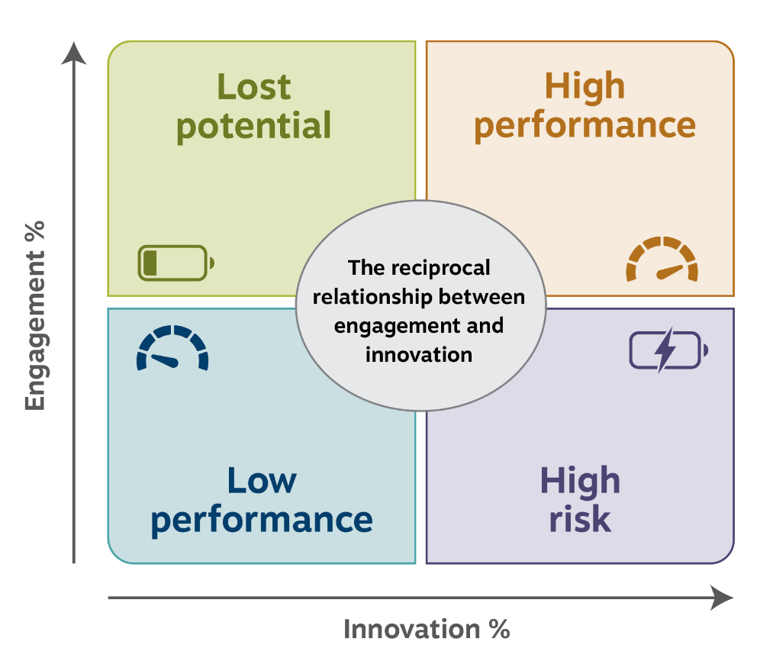

## Wellbeing policies and support index

The APS has long been focused on the wellbeing of its employees. As employers, APS agencies have obligations under Work Health and Safety legislation. Together with these obligations is an acknowledgement that high performance of employees and organisations cannot be sustained without adequate levels of employee wellbeing.

The wellbeing policies and support index included in the APS Employee Census measures both the practical and cultural elements that allow for a sustainable and healthy working environment.

The questions that form the wellbeing policies and support index are:

* I am satisfied with the policies/practices in place to help me manage my health and wellbeing.
* My agency does a good job of communicating what it can offer me in terms of health and wellbeing.
* My agency does a good job of promoting health and wellbeing.
* I think my agency cares about my health and wellbeing.
* I believe my immediate supervisor cares about my health and wellbeing.

## Calculating and interpreting index scores

The questions that comprise each index are asked on a five-point agreement scale. To calculate the index score, each respondent’s answers to the set of questions are recoded to fall on a scale between 0 and 100 percent. The recoded responses are then averaged across the five or more index questions to provide the index score for that respondent. An individual only receives an index score if they have responded to all questions which comprise that index.

|  | **Strongly agree** | **Agree** | **Neither agree nor disagree** | **Disagree** | **Strongly disagree** | **Score** |
| --- | --- | --- | --- | --- | --- | --- |
| **Weight** | **100%** | **75%** | **50%** | **25%** | **0%** |  |
| Example question 1 |  | 🗸 |  |  |  | 75% |
| Example question 2 |  | 🗸 |  |  |  | 75% |
| Example question 3 |  |  | 🗸 |  |  | 50% |
| Example question 4 |  |  |  | 🗸 |  | 25% |
| Example question 5 | 🗸 |  |  |  |  | 100% |
| Sum of question weights for this employee: | | | | | | 325% |
| **Index score for this example respondent (325/5):** | | | | | | **65%** |

Index scores for groups of respondents are calculated by averaging the respondent scores that comprise that group.

An index score on its own can provide information about the group to which it relates. Index scores, however, have the most utility when they are compared with scores over time or between work units, organisations and demographic groups.

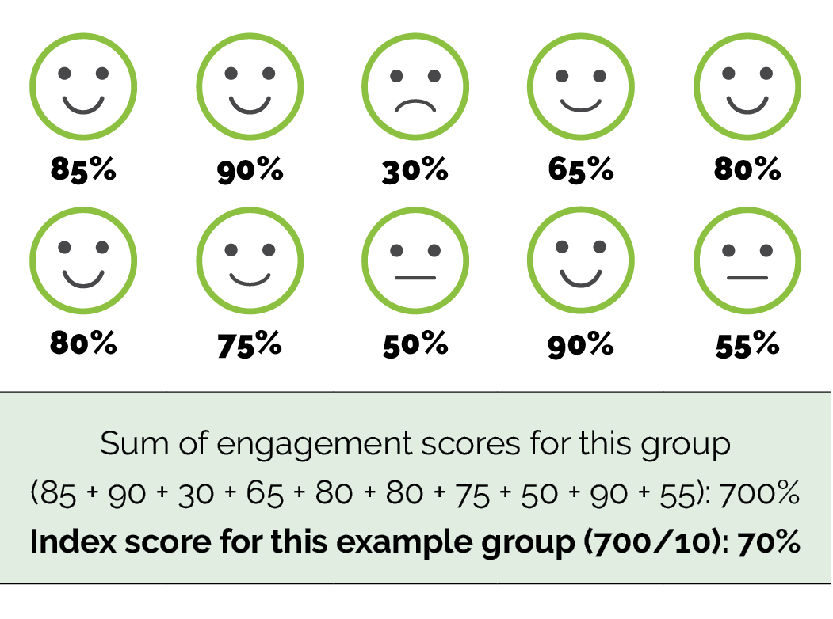

Other topic areas

## Other topics addressed in the APS Employee Census

The Census addresses a broad range of topic areas. These topic areas and the questions that relate to them can change between years depending on priorities and areas of focus for the APS.

Each of the major topic areas addressed in the 2022 APS Employee Census is listed below.

### Work-related demographics

As in previous years, the 2022 APS Employee Census included several questions about demographics such as employment status, classification, and workplace location. These facilitate a greater understanding of workforce attitudes.

### Diversity details

The Census captured a range of information to address the diversity and inclusion priorities of the APS, such as ongoing disability and identification as an Australian Aboriginal and/or Torres Strait Islander.

### Job family

The 2022 APS Employee Census included a question asking respondents to choose an option that best describes the type of work they do. The response options presented at this question corresponded with the job families within the [APS job family model](http://www.apsc.gov.au/publications-and-media/current-publications/job-family-model).

### General impressions: Current job

Respondents were asked their attitudes towards their current job and working conditions. Some questions within this section contribute to measures of employee engagement. Most questions within this section have been included within the Census for a number of years and provide useful data for time series comparisons.

### General impressions: Immediate workgroup

Respondents were asked a number of questions about the people they work with on a daily basis. Some of the questions within this section have been included within the Census for a number of years.

### General impressions: Immediate supervisor

Respondents were asked for their views of their immediate supervisor. Some questions within this section have been included in the Census for a number of years. Others are relatively new and reflect contemporary skills and attributes of APS managers. Responses to selected questions form the immediate supervisor index score.

### General impressions: Senior Executive Service

Respondents were asked for their views of their immediate Senior Executive Service (SES) manager as well as their thoughts on the SES cohort within their agency. For the purposes of the Census, an immediate SES manager is a Line/Branch/Group manager or equivalent. Responses to selected questions form the SES manager leadership index score.

### General impressions: Agency and APS

Respondents were asked for their attitudes towards their current agency and working in the APS. Several questions within this set contribute to measures of employee engagement, while others evaluate APS workforce strategies and the impacts of crises on working in the APS.

### Productivity and Ways of Working

This section asks respondents for their views on their productivity and their workgroup’s performance.

### Developing capability

Questions assessing the ways that supervisors and individuals develop employee capability were created in 2018 in consultation with subject matter experts within the APSC. These have been included to assess skills or capability gaps within the immediate workgroup.

### Work-life balance

The question asking respondents to indicate their satisfaction with the work-life balance of their current job has been included within the APS Employee Census since 2012.

### Flexible working

As in previous years, a question addressing whether respondents have access to flexible working options was included.

### Sources of stress at work

The United Kingdom’s Health and Safety Executive (UK HSE) identified six [Management Standards](https://www.hse.gov.uk/stress/standards/) that represent the primary sources of stress at work. The HSE Management Standards Indicator tool contains 35 questions to assess work stress, and as in previous years, the 2022 APS Employee Census uses seven of these questions.

### Wellbeing

Respondents were asked a series of questions that assessed organisational support for employees’ health and wellbeing. Responses to most of these questions were used to calculate the wellbeing index score. Respondents were asked if there have been changes in their general health and wellbeing, if their work is emotionally demanding and if they feel burned out by their work.

### Recruitment and retention

The 2022 APS Employee Census asked respondents about their reasons for staying in their current role.

### Mobility

As in 2021, questions have been included to better understand the mobility of employees as the APS embraces working in different ways by mobilising staff to work in surge workforce teams, task forces and across teams.

### APS Values and unacceptable behaviours

This section includes questions regarding APS Values, and perceived experiences of discrimination, harassment or bullying in the previous 12 months.

### **Corruption**

Consistent with previous years, respondents were asked to indicate whether they had witnessed corruption in their workplace and to describe the behaviour they had seen, as well as whether or not they reported this behaviour.

### Free-text questions

At the very end of the 2022 APS Employee Census, respondents were asked to provide comments to two questions: what the agency was doing well and the most important issue that the agency needed to address. Comments have been analysed and topics have been applied using Qualtrics comments analysis software based and Big Village (formerly Engine’s best practice public sector topic list. They are multi-themed, meaning they may be attributed to more than one theme.

Maintaining privacy



## Reporting rules

The APSC employs specific rules around how results are reported. Such rules protect the privacy of respondents and individual agencies’ results.

De-identification of data is undertaken in accordance with guidance provided by the Office of the Australian Information Commissioner.

The APSC and Big Village (formerly Engine) report Census results and make these available to agencies and other parties. Results are reported for groups of respondents. Groups can be formed by a combination of demographic information (such as age group, gender or classification level) and/or where the respondent works within an agency.

The APSC may provide agencies and external parties with de-identified Census datasets. As outlined in the APSC Privacy Policy, responses within these datasets will not be reasonably attributable to any specific individual.

Agencies may publicly release reports of their APS Employee Census results. These reports will be at the whole-of-agency level.

De-identified datasets are uploaded to data.gov.au in accordance with the Australian Government Public Data Policy.

Using the results



## Using the results

### Interpreting survey results

Most items in the Census ask respondents to rate the level of agreement regarding, or satisfaction with, workplace issues on a five-point, ordinal scale. The scales are generally balanced, allowing respondents to express one of two extremes in view (for example, satisfaction and dissatisfaction) and with a midpoint that allows respondents to enter a ‘neutral’ response. When reporting, the five points can be collapsed into three: agree/satisfied, neutral, and disagree/dissatisfied. Therefore, the neutral category refers to responses that reflect a ‘neither agree nor disagree’ sentiment.

When interpreting item responses, it is important to realise there is only an ordinal relationship between points in a scale. The strength of opinion to shift a respondent from ‘neutral’ to ‘satisfied’ may be much smaller (or larger) than the strength required to shift a respondent from ‘satisfied’ to ‘very satisfied’.

Although it can be a valuable resource and evidence base, it should be remembered that the Census is an employee perception survey. Respondents are asked to provide their opinions and perceived experiences.

As with any survey, the Census can involve error, both predictable and unpredictable. For example, respondents may provide a socially acceptable answer rather than their true attitudes.

Additionally, although all APS employees are invited to participate, not everyone chooses to do so. Even with a strong response rate at the APS-overall level, there is a chance that non-respondents are different from those who completed the Census. At the APS-level, four demographics are checked to ensure respondents are representative of the broader APS workforce. These demographics are age, gender, state/territory, and current classification. While each year there are no considerable differences in demographics among those who did and did not respond to the survey, some caution may be required when interpreting results from groups with lower response rates.

### Differences between employee perception survey results and data from human resources information systems

Responses to the Census as an employee perception survey may differ to data held within human resources information systems. This is particularly true for demographic and diversity-related information.

There are numerous reasons for these differences. Some characteristics are not always permanent and impact an employee for a certain period of time (e.g. disability). Some employees also may not want to officially disclose and record some information on their agency’s human resources systems.

## Comparisons and internal benchmarks

### Time series comparisons

Results for the Census are compared with those from previous years wherever possible. This provides a source for trend comparisons and a benchmark for assessing whether results have changed.

The questions included within the Census can change between years. While most questions are retained without change, new questions are added, others removed and some are reworded. Results are typically only compared between years if the same question wording was used in each year. Changes in wording can alter the meaning of a question and change how it would be answered by respondents.

### Internal APS benchmarks

Reporting of agencies’ APS Employee Census results primarily focus on comparisons with internal APS benchmarks.

Where an agency has opted to include an organisational hierarchy within the Employee Census and have results reported for individual work units, comparisons between work units can be another source of benchmarks/information.

Results for the APS overall provide the most common comparator for individual agencies’ results. Agencies are further grouped by size and function to provide other benchmark scores for comparisons.

### Differences in function and size

There may be variability in results across the size of agencies, as well as the functions that agencies perform (e.g., regulatory, specialist, operational). Therefore, any comparison across agencies should also take into consideration other factors, such as size and functional cluster. More information about functional cluster and size can be found on the APSC’s [website](https://www.apsc.gov.au/initiatives-and-programs/workforce-information/research-analysis-and-publications/aps-agencies-size-and-function).

## Comparisons with external benchmarks

While comparisons of results between years, APS agencies and work units are often the focus of analysis, comparisons with external organisations can also provide valuable information. Accepting that different organisations are likely to ask different questions of their employees, comparisons with external benchmarks are not as rigorous as time series or internal comparisons. External benchmarks, however, can provide indications of how an agency’s results compare to those from similar organisations and jurisdictions.

When comparing results to external benchmark scores, it is important to consider how well the Census and benchmarked questions match. While it is usually preferred that questions being compared have identical wording, it is sometimes reasonable to compare questions that are worded differently.

When comparing the results for questions with different wording, it is important to consider whether the questions measure the same thing in the same context. Differences can certainly be accommodated, but likely weaken any direct comparisons between the results.

For instance, these two questions are similar, but are not directly comparable:

* Overall, I am satisfied with my job.
* I like the work I do in my current position.

While both questions appear to address how much a respondent likes their job, the first addresses general job satisfaction, while the second focuses more on how much the person likes the work they are asked to do in their job. Both concepts are similar, but not the same. Depending on the reasons why external benchmarks are required, it may still be appropriate to compare the results for these questions.

Big Village (formerly Engine) collect and make available a range of external benchmarks drawn from their activities in numerous sectors around the world. These benchmarks can be viewed via the online portal and interactive tools that agencies can access to analyse their APS Employee Census results.

Additional external benchmarks may be self-sourced from other comparable jurisdictions and organisations.

Rounding



## Rounding

|  | **Strongly agree** | **Agree** | **Neither agree nor disagree** | **Disagree** | **Strongly disagree** | **Total** |
| --- | --- | --- | --- | --- | --- | --- |
| **Number of responses** | 151 | 166 | 176 | 96 | 24 | 613 |
| **Percentage** | 24.63% | 27.08% | 28.71% | 15.66% | 3.92% | 100.00% |
| **Rounded percentage** | 25% | 27% | 29% | 16% | 4% | 101% |
|  | **Positive** | | **Neutral** | **Negative** | |  |
| **Number of responses** | 151 + 166 = 317 | | 176 | 96 + 24 = 120 | | 613 |
| **Percentage** | 51.72% | | 28.71% | 19.58% | | 100.01% |
| **Rounded percentage** | 52% | | 29% | 20% | | 101% |

Results for the APS Employee Census are typically reported as whole numbers for ease of reading. Values from x.00 to x.49 are rounded down, while values from x.50 to x.99 are rounded up. Any rounding is performed at the last stage of calculation to maximise accuracy of the reported results.

In some instances, results may not sum to 100% due to rounding. Rounding may also mean that reported figures may not be identical to those calculated manually. Any differences, however, would not be more than one percentage point.

Rounding as applied to APS Employee Census results is illustrated in the table.

Further information



## Further information

To access further information regarding the APS Employee Census and reported results, please go to the APSC [website](https://www.apsc.gov.au/initiatives-and-programs/workforce-information/2022-aps-employee-census).

State of the Service Reports can be found on the APSC [website](https://www.apsc.gov.au/StateOfTheService).

To access APS Employee Census de-identified datasets, please go to [data.gov.au](https://data.gov.au/search?organisation=Australian%20Public%20Service%20Commission&q=APS%20employee%20census).

To request further information about the APS Employee Census please contact the APS Employee Census team from the APSC at [APSSurveys@apsc.gov.au](mailto:apssurveys@apsc.gov.au) or on 1800 464 926.

1. Christian, M. S., Garza, A. S., & Slaughter, J. E. (2011). Work engagement: A quantitative review and test of its relations with task and contextual performance. *Personnel Psychology, 64*, 89–136. doi:10.1111/j.1744-6570.2010.01203.x
2. Demerouti, E., Bakker, A. B., Nachreiner, F., & Schaufeli, W. B. (2001). The job demands-resources model of burnout. *Journal of Applied Psychology, 86*, 499–512.
3. Lesener, T., Gusy, B., & Wolter, C. (2019). The job demands-resources model: A meta-analytic review of longitudinal studies. *Work & Stress, 33*, 76–103. doi:10.1080/02678373.2018.1529065