# Australian Public Service

Hierarchy  
& Classification  
Review

© Commonwealth of Australia 2022

ISBN 978-0-6453376-3-1

With the exception of the Commonwealth Coat of Arms and   
where otherwise noted, this work is licensed under a Creative Commons   
Attribution 4.0 International Licence (CC BY 4.0).   
To view a copy of this licence, visit  
<https://creativecommons.org/licenses/by/4.0/>.

**Attribution**

This publication should be attributed as follows:

© Commonwealth of Australia

Australian Public Service Commission

Australian Public Service Hierarchy and Classification Review

**Enquiries**

For enquiries concerning reproduction and rights in Commission   
products and services, please contact:   
[media@apsc.gov.au](mailto:media@apsc.gov.au).

**Disclaimer**

This is an independent report representing the views of the Hierarchy   
and Classification Review panel.

# Table of Contents

Section

Message from the Panel 4

Recommendations 5

A new classification framework 6

Strategic context and objectives 7

**Recommendations**

RECOMMENDATION 1 | A new classification framework 15

RECOMMENDATION 2 | People-focused titles 18

RECOMMENDATION 3 | Planned, capability-driven progression 20

RECOMMENDATION 4 | Specialist pathways 22

RECOMMENDATION 5 | Appropriate spans of control 25

RECOMMENDATION 6 | Mandatory leadership development 27

RECOMMENDATION 7 | Strengthened role of APS Chief People Officer 30

RECOMMENDATION 8 | A charter of leadership behaviours 32

Implementation Considerations 33

Related observations and considerations 36

**Appendices**

Appendix A | Terms of Reference 39

Appendix B | Classification Schedule 41

Appendix C | Engagement 43

Appendix D | International public sector analysis 49

Appendix E | Comparisons with Australian State and Territory public services 51

Appendix F | Lessons from the private sector 54

Appendix G | The changing nature of work 56

Appendix H | Fit-for-purpose team design and management 57

Appendix I | Definitions and glossary 58

Appendix J | References 60

# Message from the Panel

The Australian Public Service (APS) exists to serve the people of Australia, through the government of the day.   
It is, therefore, imperative the APS is structured, skilled and resourced to meet the demands – the challenges and opportunities – that Australia will face in the decades ahead. As 2022 unfolds, Australia faces a world rife with uncertainty. The APS is a critical element of the infrastructure and institutional apparatus available to Governments   
to help navigate these shoals.

What is striking about these challenges is their interconnectedness – no longer can we ascribe key issues as falling within the remit of an individual department. We must reimagine an APS fit for purpose, both now and into the future. This requires an appreciation of the impact and potential of digital transformation, the diversity of the APS workforce, the changes to the work of government and the expectations of citizens. We note this is a conversation that is now three years old – beginning with the *Independent Review of the APS.*

The APS classification system has provided a robust and unifying framework over the last 30 years. However,   
with minimal structural reform over this period and ongoing expectations of significant change to the nature of work, we conclude systemic change is needed. Some levels are rarely used and guidelines are applied inconsistently.   
Other levels have grown significantly; the relative size of Senior Executive Service (SES) has increased by 40 per cent since 2000. The APS has largely failed to take heed of the *Optimal Management Structure Framework* agreed by Secretaries Board in 2014 to drive flatter and more responsive structures.

The APS workforce wants more of the flexible, less hierarchical ways of working experienced during the COVID-19 response. We heard there is a growing need for a mobile, agile workforce to manage crises and disruption as the   
new norm. We heard the APS workforce expects greater opportunity to apply their skills and knowledge more directly and visibly. We believe the APS should be at the forefront of public sector reforms that enable more flexible,   
dynamic and matrixed ways of working to deliver for citizens.

While our task was to look at the APS classification framework, we found the culture underpinning classification is critical. Consistent with the *Independent Review of the APS*, we found a deeply ingrained identification with rank.   
This flows through into rigid, hierarchical behaviour that dampens employee motivation and engagement,   
and impedes mobility, development and access to new skills.

In making our recommendations, we prioritised flexibility to allow different operational structures to evolve. We make recommendations to tackle undesirable behaviours, including removing the practice of referring to employees by numerical rank. We also want to see strategic people management prioritised as a key enabler of delivering government business. Our recommendations are emphatically not about reducing APS workforce numbers or remuneration. Lessons from other jurisdictions show that effective structural change leads to demonstrable cultural change to optimise delivery for citizens and government.

Modernising the classification framework will require strong leadership from Secretaries and Agency Heads, all the way through the workforce. Sustaining reforms will require an uplift in change management capability, learning from other public and private sector experiences. Culture, leadership and capability will help to drive change and are important factors in shifting hierarchical mindsets. Changing structure, while important, is but one component of the broader efforts needed to change the APS’s hierarchical culture.

We engaged extensively with APS employees, examined data on best practice and looked at relevant comparators across public and private sectors. We want to thank everyone we engaged with – you were generous with your time to support this review in the midst of a busy and unprecedented period.

| **Signature of Heather Smith PSM**  **Heather Smith PSM** | **Signature of Kathryn Fagg AO FTSE**  **Kathryn Fagg AO FTSE** | **Signature of Pratt AO PSM**  **Finn Pratt AO PSM** |
| --- | --- | --- |

# Recommendations

1. Modernise and simplify the *Public Service Classification Rules* *2000* from 13 to 8 classifications,   
   with Secretaries retaining flexibility to structure their organisations to optimise business needs.
2. Refer to people’s roles by descriptive job titles, rather than numerical classifications.
3. Enable progression for people within classifications through fair and transparent assessment driven by proficiency, skills development and workforce planning.
4. Recognise specialists for the value of their work within the new classification framework.
5. The Secretaries Board to implement spans of control for senior management roles ***generally*** within the range of 8-10 direct reports, consistent with contemporary organisational design.
6. Invest urgently in the capability of future leaders, particularly the EL2/Manager cohort, and mandate management and leadership training for all staff with supervisory responsibility.
7. Strengthen the role of the APS Commissioner as the Chief People Officer for APS people management.
8. The Secretaries Board to adopt and model a Charter of Leadership Behaviours for APS leaders to promote collaborative and team-based behaviours.

## Implementation priorities

* Building on the establishment of the APS Academy, the APSC and Departments upgrade substantially the investment in training for EL2s and those with future supervisory responsibilities.
* APS Commissioner’s role as Chief People Officer be strengthened immediately, with resourcing and a mandate to implement this review.
* Secretaries Board develops and implements the Charter of Leadership Behaviours.
* Make new Classification Rules in early 2022.
* Secretaries/Agency Heads design and implement structural changes appropriate for their organisations by the end of 2023, following APS-wide consultation.

## Related observations and considerations

1. A more consistent approach to remuneration would aid mobility, collaboration and reinforce principles of fairness and equity.
2. A more nuanced and contemporary approach to risk is required so that responsibilities do not continue to be drawn upwards, and material produced is not ‘over-worked’.
3. Rethinking classification and introducing new ways of working will present new opportunities to strengthen the ongoing commitment to a diverse and inclusive APS, helping to address systemic barriers to career development reported by underrepresented cohorts.
4. An urgent investment in change management capability, including taking lessons from experiences in other public sector and private sector organisations, is critical to successful implementation.
5. This review does not propose reductions in the APS workforce or remuneration; rather a streamlined, flatter and flexible APS structure to support a more responsive and adaptive 21st century workforce.

# A new classification framework

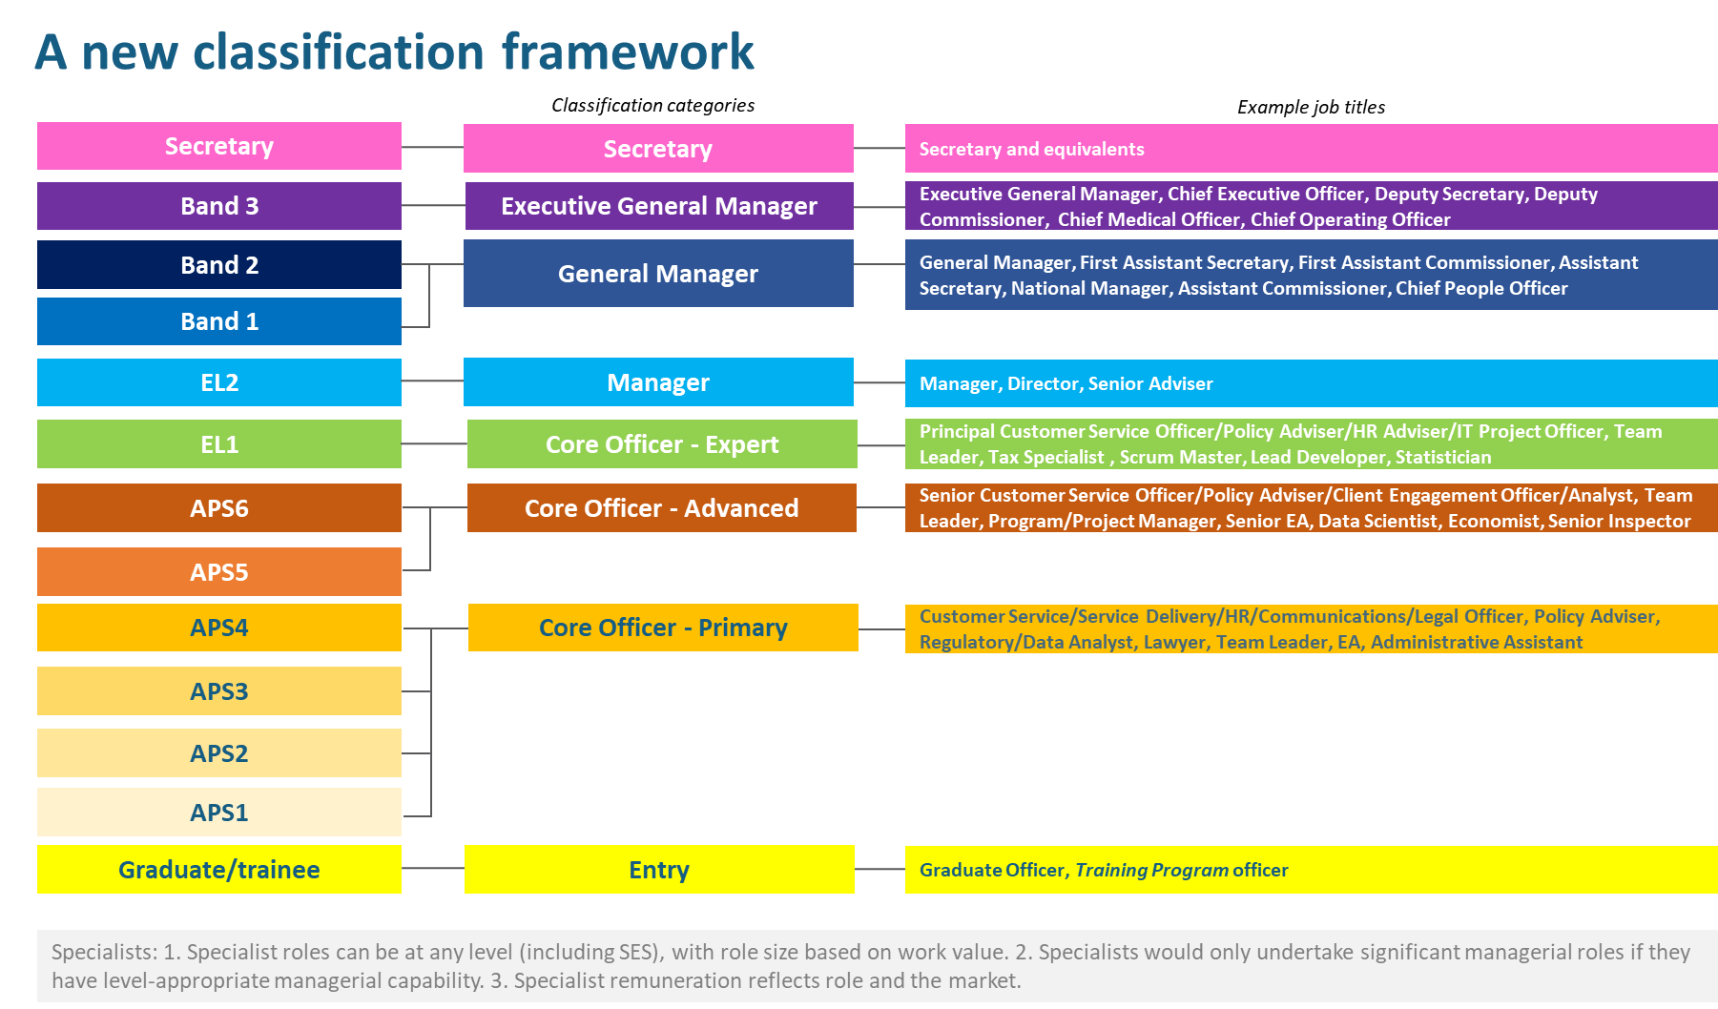

# Strategic context and objectives

## The APS is a complex and diverse enterprise

The APS of 2021 is complex and heterogeneous, with over 150,000 employees working in more than 100 agencies that vary in size (Figure 1).

Figure 1 | APS agencies by size[1]

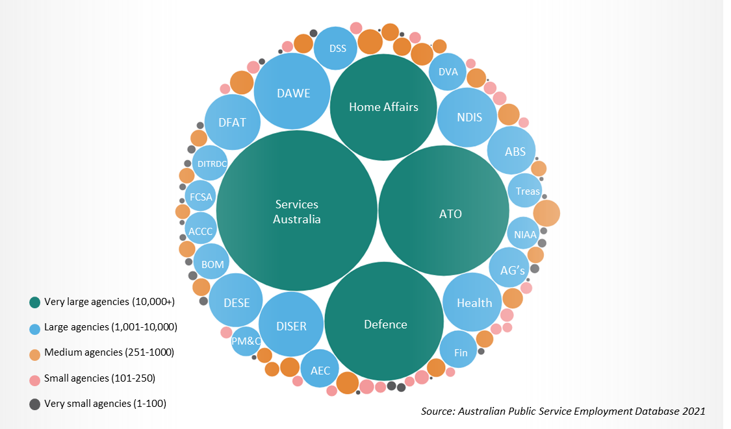

The APS serves the government and Australian citizens in a variety of functions, including service delivery, regulation and compliance, policy and enabling roles (Figure 2).

Figure 2 | APS workforce by job family[2]

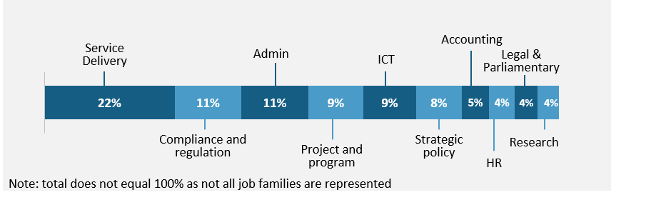

The composition of the APS workforce is changing, with APS6 the most common classification levels in 2021 (Figure 3). Comparatively, APS4 was the most common level in 2002.[3]

Figure 3 | Proportion of APS employees by classification[4]

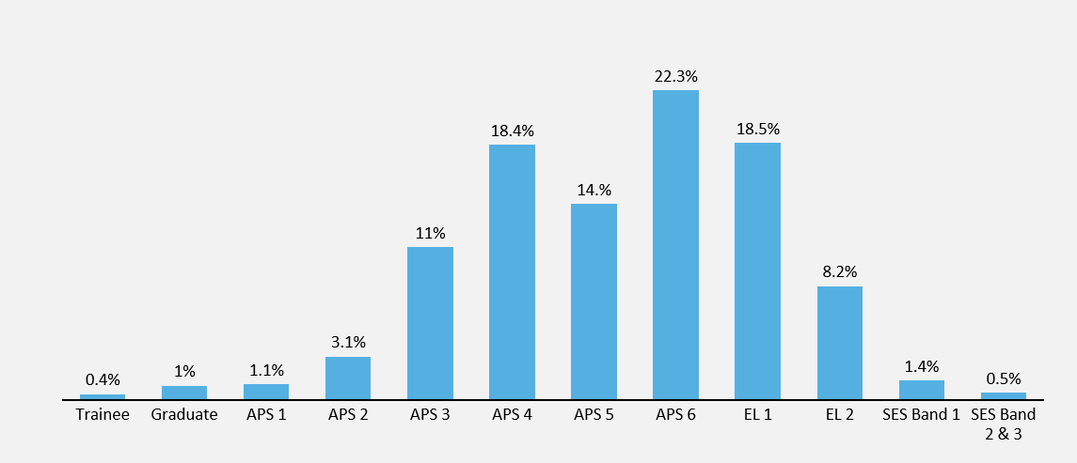

The APS is too hierarchical and needs a flatter structure to better serve the government and Australian citizens

In December 2019, the Government committed to an ambitious APS Reform Agenda in response to the *Independent Review of the Australian Public Service* (‘Independent Review’). The Independent Review suggested the APS typically operates in ‘silos, rigid hierarchies and traditional ways of working’ and called for it to ‘become a much more dynamic and responsive organisation’.[5] It made a number of recommendations to support a united, citizen-centric and adaptive APS, including undertaking this Hierarchy and Classification Review. This review is a significant next step looking at how to configure a modern, flexible APS to respond quickly, empower staff and deliver for the government and citizens into the future.

It is now three years since this discussion commenced and our consultations confirmed the Independent Review’s conclusion that the current classification system has too many layers, reflects outdated working practices and needs modernising. The Panel heard the APS workforce lacks confidence in the current classification structure and wants to see an updated system that empowers staff at all levels, adopts flatter structures and recognises expertise and contribution, not rank.

The current classification structure and its rigid hierarchy serves as a basis for reporting tiers,   
contributing to an excessively layered approach to decision-making. This has consequences for both enterprise efficiency and delivery of services. Figure 4 shows the shifting profile of the APS since the 1980s.

Figure 4 | The shape of the APS over time

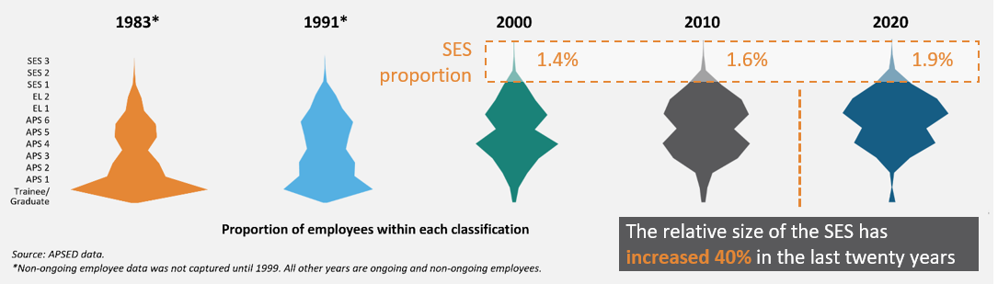

Notably, the relative size of the Senior Executive Service (SES) has increased by 40% over the past 20 years as the APS has become progressively top heavy. Consultations cited the demands of Ministers for enhanced risk management at senior levels as the reason for this growth. This profile also prompts reconsideration of where the ‘natural’ breaks are in APS classifications.

A strong theme throughout engagement with APS employees was that classification levels are used as a determinant of who to listen to, who to consult and who to value. A reluctance to delegate and deference to reporting lines, means the right people are not always involved in decision-making, a diversity of perspective is missed and employees are left feeling undervalued and untrusted. We heard in consultations that the APS competes with the private sector for talent, and consistently sees leakage of staff at junior levels because the system’s rigidity prevents the full utilisation of their capability. Figure 5 shows how different APS cohorts view layers of decision-making.

Figure 5 | Perception that layers of decision-making are a barrier to performance, by level[6]

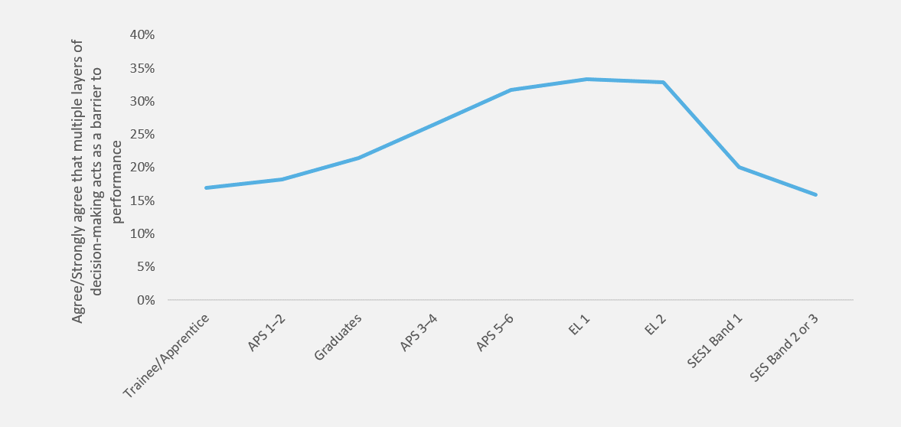

The APS classification structure needs modernising to adapt to changing workforce trends and ongoing disruption

While the current classification framework heralded ground-breaking reforms in the mid-1980s,   
it has undergone minimal reform since. This led the Panel to consider whether it is fit for purpose for   
the next 10‑20 years.

**Past reviews of the classification framework**

The 2011 Beale Review of the Senior Executive Service (SES) recommended a minor revision to the *Public Service Classification Rules 2000* (‘Classification Rules’) to abolish the Senior Executive Service (Specialist) classification and recommended mandatory assessment of SES positions against APS-wide SES work level standards.[7] That review was motivated by the desire to manage growth in SES levels, rather than consideration of broader APS organisational design or culture.

The complementary 2012 review of APS classifications, led by the APSC, recommended the gradual removal of ‘legacy’ classifications, many of which denote specialist roles used by a small handful of APS employees (e.g. Antarctic Medical Practitioner Level 1) or which refer to now obsolete entities   
(e.g. DAFF Bands 1-3; Customs Levels 1-5) and which remain in the Classification Rules. Both of these reviews took a narrower view of the purpose of the classification framework than this review.

Work in the APS will continue to change over the next 25 years, thus the profile of skills needed to deliver for government and Australians will also shift. APS functions have already adapted to increased automation and more digital ways of working. Heightened community expectations of the public sector’s responsiveness, service and agility, as well as a turbulent external environment, feed a more complex work environment. As the work becomes more complex, there is an increased requirement for the APS enterprise to work flexibly and for staff to adapt to new roles and work expectations.

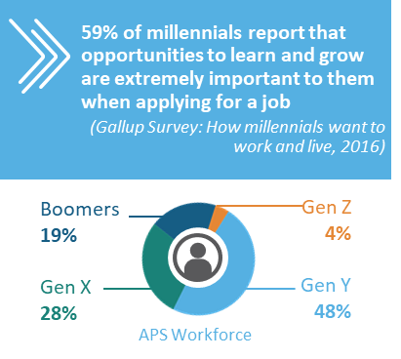At the same time, expectations of workers are evolving, wanting to join purpose-driven organisations with clarity about how they contribute to achieving the organisation’s objectives. The APS is increasingly seeking to attract and retain employees who value flexibility, investment in their capability and opportunities to work in more agile environments. Today, 50% of employees in the APS are ‘digital natives’ from Gen Y and Gen Z,[8] who expect the nature of their roles to encompass advances in technology and more hybrid working models.[9] The APS is sourcing talent from an increasingly competitive labour market, where it will need to demonstrate a focus on strategic people management, culture, development and workforce strategy to attract the right skills and expertise into the APS.[10]

**The future of work and the Intergenerational Report**

The 2021 Intergenerational Report noted the radical changes in the occupational structure of the Australian labour force in the last 50 years, including the decrease in manual roles and the increase of professional, community and personal service workers. The report notes the main drivers of these shifts include “increasing global interconnectedness, technological change and automation”.[11]

In understanding what the future of work holds for Australia, the Intergenerational Report noted that “new technologies will mean jobs are redesigned to take maximum advantage of the capabilities enabled by new technologies” and emphasised the need for “[b]usinesses…to invest in improving managerial expertise to best manage how these enhancements are integrated into organisational   
work practices”.[12]

We strongly agree this learning should be applied in the APS context, together with the Intergenerational Report’s support for ‘lifelong learning’ to achieve a resilient and adaptable workforce that can support future economic growth.

## Structural transformation will create a more agile and future-fit APS

The rigidity reinforced by the current APS classification structure stands in striking contrast to the flatter, team‑based and matrixed structures of many organisations consulted through this review. Leading organisations embrace a mindset of constant adaptation to ensure their workforce is able to respond in a rapidly changing world to meet the needs of customers/citizens.[13]

Many public and private sector organisations are moving to flatter, more dynamic structures with greater spans of control to enable a system that is more flexible to respond and reconfigure quickly to changing government priorities and citizen expectations. Reforms in the UK Civil Service, for example, highlight the need for the workforce to be as mobile and agile as possible, to manage crises and disruption as they become the new normal.[14] This approach is also consistent with the *2014 APS Framework for Optimal Management Structures*, which notes that “[m]anagement structures with fewer organisational layers and broader spans of control improve productivity and support change.”[15]

The APS has shown an impressive ability to respond quickly and effectively to emergencies, particularly the COVID-19 pandemic. In these situations, teams coalesce quickly and use flatter structures, and work is assigned to those with the relevant knowledge, skills and experience (with less attention to classification or organisational affiliation). They collaborate efficiently to achieve desired outcomes, prioritise appropriately, making decisions quickly while still producing robust and comprehensive advice. The challenge is to introduce the flexibility the APS embraces when confronted with crises in its day-to-day operations.

APS employees consulted for the review referred positively to this experience. The 2020 APS Census data showed that 89% of respondents agreed their working group successfully adapted to new ways of working and 80% of respondents agreed their agency quickly adapted and responded to changing priorities in response to COVID-19. The positive impacts were evident to the APS’s customers as well. In the 2021 Citizen Experience Survey, perceptions of APS responsiveness increased markedly (Figure 6). However,   
APS employees expressed concern that any benefits gained from COVID-19 responses may be short lived, with a reversion to less flexible, less efficient and more hierarchical practices already happening.

Figure 6 | Public perceptions of service responsiveness: “Australian Public Services are Responsive”[16]

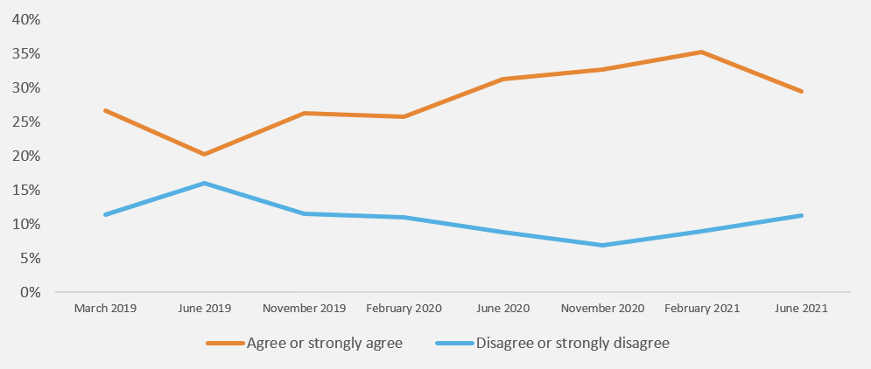

There is a genuine opportunity for the APS to harness these experiences and build the structures that will support a contemporary, engaged and flexible workforce.

**The APS Optimal Management Structure (OMS) Framework**

The APS already has sensible, although rarely utilised, guidance on organisational design, known as the 2014 APS Framework for Optimal Management Structures (‘the Framework’). The Framework was developed in response to the 2014 *National Commission of Audit* finding that ‘there [was] significant scope to improve structures within many Commonwealth organisations.’[17]

The Commission did not advocate specific span of control targets, arguing Departmental Secretaries ‘should be responsible and accountable for their own management practices and structures.’[18]

The Framework has five key principles that underpin the design of an agency’s management structure:

1. Vertical design: An agency should not have more organisational layers than is absolutely necessary to perform effectively.
2. Accountability and decision-making: Decisions should be made at the lowest practical level.
3. Relative complexity of tasks: The optimal number of direct reports will depend upon the type of work being managed.
4. Innovation and adaptability: Structures should maximise the opportunity for innovation and provide flexibility to respond to change.
5. True work value: Jobs should be classified across the APS according to work value.

The Framework indicates the optimal number of organisational layers should be, in most cases, between 5-7. The Framework also notes classification levels do not determine layers and a layer may include several levels. The Framework also provides a *guide* for the number of direct reports for different APS work types, varying between 3-7 for specialist policy and 8-15+ for high volume   
service delivery. [19]

While we agree the Framework provides a sensible basis for APS organisational design, we would like to see a push towards a span of control of generally 8‑10 direct reports (discussed in Recommendation 5).

Unfortunately, there is little evidence that the APS has taken action to implement the Framework.   
This is despite a Secretaries Board agreement for all agencies to conduct a self-assessment of their existing management structures against the Framework’s principles and benchmarks; and develop a plan to achieve improved management structures over a three year period from 2015 to 2018.

This experience has influenced our view that it is appropriate to recommend a firm change to the Classification Rules, rather than a softer, policy-based approach.

## Investment in culture, leadership and capability at the enterprise level is critical for a well-equipped ‘One APS’

The strong message from our engagement across all sectors was the need to take a holistic approach to structural change, attending to purpose, leadership, capability, culture and working practices to meet the changing needs of government and Australians. Over the last decade, several State Governments have undertaken structural change which has supported demonstrable cultural change and better delivery of services for citizens. Structural reforms in NSW, for example, have seen a more efficient, responsive and citizen-centric public service emerge (Appendix E | Comparison with Australian State and Territory public services refers), as well as the NSW public service becoming an employer of choice.[20]

APS employees require new skills to work in a changed environment with a different approach to decision-making, accountability and risk management. This is particularly true for the pivotal middle manager cohort who most acutely feel the impact of overly layered approaches to decision-making. Investment in leadership and people management capability will enhance the APS’s ability to deliver effectively.

The Panel also heard from many private sector Australian-based companies with international operations about how they place immense value on people management. The APS is noticeably less mature in the management of whole-of-enterprise people matters and should embrace strategic people management as a key way of building capability to better deliver government objectives and retain a skilled workforce.

## Acting now will ensure sustained delivery into the future

The APS has shown it can implement better practices and behaviours that produce better outcomes as well as provide more rewarding careers for the employees who are the APS’s lifeblood. The APS should act swiftly to capture and build on this momentum.

Engagement with officials in other State/Territory and international governments reinforced the common imperative for public services globally to build adaptation into the way they think about their organisations. There is a genuine opportunity for the APS to harness these experiences and build the structures that will support a contemporary, engaged, flexible and agile workforce that will be positioned to deal with 21st century issues as they arise.

This package of recommendations complements ongoing current APS reforms. To ensure success,   
APS leaders must take a complete view so that changes introduced are presented as a mutually reinforcing whole and implemented consistently as a single enterprise, to reinforce ‘One APS’. With such focus and commitment, the APS can confidently position itself as a contemporary enterprise, where all arms of government can work in an increasingly integrated manner to ensure they are fit for the challenges to come over the next several decades.

|  |
| --- |
| RECOMMENDATION 1 | **A new classification framework** |
| **Modernise and simplify the *Public Service Classification Rules 2000* from 13 to 8 classifications, with Secretaries retaining flexibility to structure their organisations to optimise business needs.** |

“The APS needs to configure itself around the needs of the Government of the day and the expectations of citizens.”  
Phil Gaetjens

## Why do we need change?

The recommended changes to the classification framework are driven by an appetite to streamline decision-making, reduce unnecessary clearance layers, push risk down and empower staff across all levels of the workforce. An excessively layered approach to decision-making has consequences for both enterprise efficiency and delivery of services to Australians.

We heard consistently in consultations with APS staff that, for a contemporary workforce, the current APS classification structure is too hierarchical, has too many levels and the ingrained identification with levels as opposed to skills/expertise creates barriers to participation. We also heard the current classifications often underpinned team designs with layered structures, low appetite for risk and an administratively burdensome clearance process. This approach has been magnified by the shift in the APS profile over time, towards an increasingly top heavy structure.

Reducing layers and removing excessive reporting layers is a critical success factor in enabling accountability and decision-making to be pushed down to lower levels. A shift to a flatter structure, particularly at the senior executive levels, creates the opportunity for APS agencies to empower non-SES staff to take greater responsibility within their teams, delegate responsibility and manage risk appropriately to strengthen their engagement. Valuing the contribution of employees at all levels will help to attract the next generation into the public sector, while retaining and growing the current capabilities in the APS.

The new classification structure, combined with recommendations on spans of control and cultural change, will also see the EL2 cohort take on a greater role in risk management, representational responsibilities, and organisational leadership. This aligns with what the Panel heard from private sector entities and other state and territory public services – empowering middle managers to take a greater leadership role in the day-to-day business operation, while freeing up senior executives to focus on high priority issues, ministerial engagement, strategic organisational and people matters, and ‘One APS’ collaboration.

## What change are we recommending?

The Panel recommends flattening the APS classification framework from 13 to 8 levels, both to match   
the changing composition of the APS workforce and to remove unproductive, hierarchical barriers to decision‑making.

* APS levels should be consolidated into two levels, Core Officer – Primary (current APS1-4) and Core Officer – Advanced (APS5-6).
  + Consolidating APS1-4 levels into the Core Officer – Primary level reflects a simplification of the existing lower end of classifications into a single level. It recognises the increased complexity of roles in the APS and works to realign the classifications to recognise the skills and proficiencies required in a modern public service.
  + Consultations strongly suggested there was a lack of distinction between APS5 and APS6 roles in the APS, which is also reflected in the APS6 now being the most common classification level in the APS.[21] Consolidating the APS5-6 levels into one new classification reflects the natural break currently occurring in classification levels.
* The EL1 level should be reclassified as Core Officer – Expert, recognising the significant expertise that is expected at this level.
* The EL2 level should be recalibrated to play an enhanced and strengthened leadership role.
  + Combined with greater spans of control (see Recommendation 5), the new classification structure will see the Manager cohort take on a greater role in risk management, representational responsibilities, and leadership of the organisation. This aligns with what the Panel heard from private sector entities and other State and Territory public services – pushing responsibility down to the lowest level where it is safe and effective to do so, empowering middle managers to take a greater leadership role. The Panel considers these responsibilities are consistent with the pay offered at this level, with the mean EL2 base salary over $143,000 per year.[22]
* At the SES level, the Panel proposes to consolidate three levels into two – an Executive General Manager and a General Manager classification. This change does not recommend removal of a specific layer, instead proposes to consolidate the existing SES Band 1 and Band 2 levels –   
  this would result in a new Work Level Standard (WLS) for each new level to reflect the changed nature of these roles.
  + In recommending a flatter SES structure, the Panel encourages the use of flexible   
    team structures and a departure from traditional chains of clearance that can see work passing through four lines of clearance before reaching a Secretary, or five before   
    reaching a Minister.
  + The Panel envisages the two new SES levels would result in broader salary ranges   
    at each level.
* Graduates and other entry level staff across all agencies should have their own classification level throughout the life of their program, and will move into the relevant Core Officer level (determined by the agency) at the completion of their graduate program.
* The Panel is not recommending a loss of any terms, conditions or remuneration at any level.

## Implementation Considerations

A mapping of today’s public service to the new classification framework is illustrated in Figure 7.

Figure 7 | Anticipated proportion of roles at classification levels under the current and new structures[23]

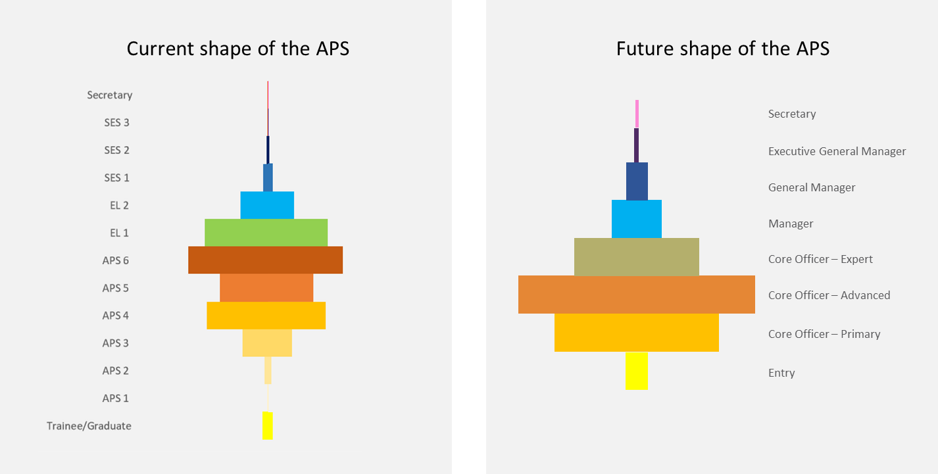

Introducing a new classification framework is not intended to result in job cuts or loss of remuneration. Secretaries are encouraged to redesign a flatter organisational structure in a flexible manner, best meeting their business needs while also removing unnecessary decision-making layers. We recommend:

* Agencies have support and information to transition to the new classification structure.
* The APS Commissioner issues new Classification Rules to support and underpin new structures.
* The APSC works with the Chief Operating Officers (COO) Committee, agencies and the APS Professions to update the WLS, Integrated Leadership System (ILS) and role evaluation methodologies and associated frameworks, to reflect the new classifications.
* The APSC conducts open consultations with the CPSU and other relevant professional bodies in developing updated WLS and Classification Rules, where practical.
* Implementation plans developed to facilitate and guide consistent and cohesive transformation. Transition guidance will cover implications for enterprise bargaining and individual arrangements, interagency mobility during transition, and mechanisms for supporting vulnerable groups; and
* Agencies use careful workforce management to avoid salary creep.

Recognising the complexities in moving to the new classification structure and the strong identity APS employees attach to their levels, sensitive and well-informed change management will be essential in navigating the change. This should include urgent capability uplift and support for APS leaders to successfully achieve sustained, enterprise-wide organisational change.

|  |
| --- |
| RECOMMENDATION 2 | **People-focused titles** |
| **Refer to people’s roles by descriptive job titles, rather than numerical classifications** |

“In the APS, you are a rank first, and a person second”  
APS Graduate

## Why do we need change?

This recommendation speaks to broader cultural reform necessary for the APS to modernise its ways of working – valuing the contributions employees make to their team and their organisation, rather than the position they hold in the hierarchy.

Another strong theme that emerged from engagements with APS employees was that classification levels tend to be used as a determinant of who to listen to, who to consult and who to value. APS employees noted their professional identity – from their own and others’ perspective – was bound-up with their classification level and seniority was a key factor in determining how APS colleagues relate to each other. Consequently, their experience was that they were:

* Not allowed, or could not practically, communicate with colleagues at higher classification levels (even when there was a work imperative to do so), creating inefficiency and hampering productivity; and
* Not invited to participate in meetings on the basis of their classifications, meaning decision-makers are denied access to their expertise or valuable perspectives.

A move to generic, non-numeric classification titles, accompanied by more specific job titles, is intended to encourage a focus on role and contribution rather than position on a ‘ladder’. Specifically, it would discourage practices of organising by classification level and a reliance on positional authority to wield influence – notably, committees whose membership is based on classification level. Such practices embed a culture of deference to others on the basis of their level rather than expertise or experience (including frontline delivery experience). Hierarchical behaviours like these do not align with modern, flexible and productive organisations that are focused on citizen outcomes.

Using more descriptive job titles brings other advantages:

* They provide greater transparency for external customers and stakeholders who engage with government, by better reflecting the responsibility and expertise associated with a role.
* It promotes stronger identification with work teams, as opposed to those at the same classification, which is known to inspire higher levels of creativity and engagement.[24]
* It encourages sideways mobility to develop breadth rather than aspiring to the next level, by reducing the emphasis on position in the hierarchy.

This change is more than just administrative, it will embed new ways of working to support broader cultural reform, seeing a move away from hierarchical practices into an environment where APS staff are valued for the skills and expertise they bring to their role.

* Using a set of consistent titles across an organisation that emphasise the role or the skillset   
  (as opposed to the layer in the hierarchy) enables a culture that values people’s expertise as opposed to their rank. It also aids mobility across the agency and broader APS with a clear understanding of the skills and experience of employees in each role.
* This shift has already started in the APS, with the ATO introducing work titles that reflect the work undertaken by staff as opposed to their level in the hierarchy. The use of a title that is reflective of someone’s position has not only enhanced mobility in the organisation, but has also led to a 4-5% increase in innovation within the organisation (according to APS census data collected by the ATO).

## Implementation Considerations

The classification framework will adopt new language to describe job titles, moving away from numerical language that denotes a classification level. Job titles will be appropriate and descriptive, reflecting the nature of the work performed.

* The APSC will work with Agencies, COO Committee and the HR Professions group to provide guidance on the implementation and use of appropriate and descriptive job titles.
* Agencies will have discretion on which titles are used but are encouraged to adopt titles that are meaningful to current and potential employees, and internal and external stakeholders.
* Agencies will actively reward leaders for creating opportunities for colleagues to bring forward their expertise irrespective of classification level, including when briefing senior decision-makers and Ministers.

Over time, and in conjunction with the other recommendations, this should result in an environment   
where staff, irrespective of classification level are taking on broader responsibilities and are valued for their expertise as opposed to their rank.

|  |
| --- |
| RECOMMENDATION 3 | **Planned, capability-driven progression** |
| **Enable progression for people within classifications through fair and transparent assessment driven by proficiency, skills development and workforce planning.** |

“There are extraordinary opportunities within the public service to expand capability, however we need to be more targeted to build capability where it is needed and for the right types of roles” Jacqui Curtis, Head of HR Profession

## Why do we need change?

The APS needs a mechanism for enabling structured and fair growth and development within the new classifications. Managing progression within levels requires attention to:

* Equity – ensuring regular opportunities for external applicants to compete for roles at higher level.
* Effective workforce management – maintaining the appropriate overall workforce profile that is consistent with operational needs and salary budgets.

The review recommends the introduction of progression points within each classification level to both promote capability development and facilitate planned and well-managed progression.

Capability development must be a key priority for the APS.[25] Contemporary approaches to job design emphasise the importance of stimulating work that provides a sense of mastery.[26] We heard fromAPS employees that access to growth opportunities and interesting/challenging work are key motivators. By 2025, 50% of the APS workforce will be Gen Y and Z – the ‘digital natives’ – who will make up around 85% of new recruits.[27] We know professional development and career progression are highly valued by these generations (Figure 8), and targeted, digitally enabled forms of learning are increasingly the norm. The ability to map out fulfilling and staged career pathways will be critical to attract and retain these workers.

Figure 8 | Why different age groups stay in the APS[28]

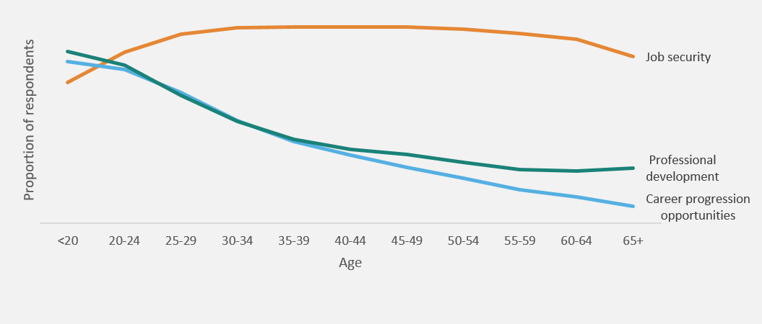

The concept of planned, well-managed progression through introduced progression points draws on practices used by agencies with broadbanded classifications. Under current rules – which the review proposes not to change – Agency Heads can combine two or more classifications into a ‘broadband’ to enable an employee’s advancement between levels where work at a higher level is needed and they have demonstrated the relevant capabilities. We heard strong support for the principles that underpin broadbanding arrangements “as a measure to attract and retain employees”,[29] along with calls for a more consistent, fair, enterprise-wide approach.

The recommendation proposes progression within classification levels is facilitated and managed through consideration of the following criteria:

* Capability development – extent to which there has been evident growth in skills and knowledge.
* Performance in the role – how capabilities have been applied to deliver the desired outcomes.
* Fairness and transparency – ensuring systems to assess capability and past performance are clear and objective, nurturing capability development and valuing both breadth and depth of experience.
* Strategic workforce planning – alignment to short- and longer-term workforce strategies within the business unit and agency.
* Efficiency – minimising onerous administrative processes.

The review recommends a system for progression that balances a ‘One APS’ approach to classification with agency-specific needs.For example, in very large agencies or in workforces with many jobs of the same type, there are likely to be opportunities to introduce more standardised practices in the management of progression. For smaller or more specialised agencies, different practices are likely to be appropriate.

## Implementation Considerations

To ensure consistency and fairness across agencies, the APSC, with the COO Committee and HR Profession, will develop guidelines to support a staged and balanced approach to progression points. We recommend:

* The APSC, in consultation with the COO Committee and HR Profession, provide guidance on the operation of progression points to ensure consistent communications and application across the APS. Agencies can implement up to three progression points within a classification.
* Agency Heads make the final determination on the exact structure for progression within their organisation, to ensure their workforce is optimised to meet business needs.
* Updated WLS are used as a baseline for developing the progression points. They will be drafted to help prevent backwards bracket creep.
* The APS Commissioner plays a strong role in overseeing how WLS are applied, undertaking periodic reviews to ensure ongoing relevancy and auditing progression decisions when required to ensure consistent and fair application across the APS.
* Assessments of work availability are based on robust workforce planning, taking into consideration whole of organisation business needs (rather than individual level, as is the current practice) and career pathways for employees.
* Employee progression is supported with proficiency assessments, providing employees with a transparent appraisal of their skills, timely provision of clear feedback to enable development   
  and investment in capability development and effective performance management.

|  |
| --- |
| RECOMMENDATION 4 | **Specialist pathways** |
| **Recognise specialists for the value of their work within the new classification framework.** |

"Many technical specialists do not want to manage employees  
but want to have a career path where the increased complexity of work  
can be recognised as they progress through the classification structure"  
Public submission

## Why do we need change?

The APS operates in an increasingly competitive labour market for particular specialist skills,[30] which has a direct impact on the ability of the APS to attract and retain technical experts in pivotal roles. 71% of the 95 agencies that responded to the 2021 Agency Survey identified critical skills shortages across emerging specialist roles, including 70% in data and digital, and 50% in ICT. In an increasingly disrupted and constantly evolving environment, it is crucial that the APS can attract and retain specialist skills required in the modern workforce to deliver for government and citizens.

Definitions of specialist skills can also take on a narrow view of technical capability. Our consultations identified there is likely an undervaluation of Indigenous APS employees’ cultural competency. Highly skilled roles requiring complex stakeholder engagement and highly attuned cultural competency, for example land management roles, are often classified in the lower APS classifications.

Opportunities to better attract, retain and utilise specialists featured heavily in review consultations with the APS workforce. While some submissions suggested a separate technical stream for specialists,[31] [32]   
we considered the value inherent in a uniform classification system should be preserved. Instead, the APS should endeavour to more clearly articulate specialist career pathways – looking beyond the traditional ladder approach to career progression. Consultations also highlighted the need for greater consistency across the APS on how specialists are valued, while also ensuring agility and flexibility for agencies   
and employee.

The Panel heard of the need for the APS to accommodate roles for senior specialists who do not manage people. There is a current tendency to over-emphasise people leadership as a requirement for senior roles. This has been problematic in situations where an employee is needed to perform roles of a high work value, but does not have the aspiration or experience to manage large teams. Requiring such individuals to manage people is an ineffective use of expertise and does not result in a positive team experience.[33] This experience holds true for private and non-Public Service Act organisations, who have adopted ways of classifying and recognising specialists that values their technical expertise and leadership.

* CSIRO, as a non-APS agency, has a single classification system that reflects an integrated approach to their workforce, where technical specialists are catered for across the entire classification system. The classification system is structured around classification level descriptors that can accommodate both technical specialists and leadership roles. This allows technical specialists to move through the system based on their specialist role and/or their managerial functions, if they wish to take on a managerial role, providing CSIRO requires the role to be performed at the higher level for the foreseeable future.
* Within the single classification system, the Department of Defence utilises a flexible process that recognises the increasing difficulty in attracting and maintaining personnel with identified critical skills. The Department uses the ‘Building Defence Capability Payment’ and other benefits to appropriately value relevant critical skills,[34] aiding attraction and retention without over-classifying the role within the APS classification framework.
* Most private sector entities we consulted provide separate pathways for technical leadership, requiring all employees taking on senior organisational leadership roles to have the appropriate organisational leadership skills and training (Appendix F | Lessons from the private sector refers).

The review therefore recommends more explicit recognition of specialist pathways in order to address:

* **Instances of ‘misclassification’** where a role is assigned a higher level than the applicable work level standards would suggest, in order to enable payment of higher salaries to individuals to match market rates for high-demand talent in particular fields.
* **Attraction and retention of specialists**. Clear pathways would provide more motivation for specialist staff and allow better recognition for their distinct contribution. It would also improve the value proposition for potential candidates and complement the APS Professions initiative, which seeks to nurture communities of practice that can enrich and expand capability in key functions across the APS.
* **Greater access to expertise.** More exposure and visibility increases the likelihood of those with deep subject matter knowledge or technical expertise being involved in decision-making processes.
* **Undervaluing of particular specialist skill sets** where the specialist contribution of a role is not appropriately recognised in role evaluation.

## Implementation Considerations

Specialist roles to be accommodated across all classifications, with no artificial ceiling placed on the progression of technical experts. Senior executive roles will recognise both technical and general leadership, acknowledging the separate expertise specialists bring to an agency.

* Revised WLS and role evaluation methods will give appropriate weight to technical expertise and include consideration of level of expertise, complexity and decision-making responsibilities.
* The APS Employment Database will maintain information on roles in specific specialist categories, for periodic reviews.
* Flexibility will be built in for those who have the appropriate people management skills and wish to move into roles with people management responsibilities. If specialists do move to a supervisory role, they would undertake relevant mandatory training (Recommendation 6 refers).

Building on the work underway by the APS Professions, the APSC should work with the COO Committee and Heads of Professions, to play a strengthened role on issues of attraction, retention, progression and job design for specialists, including:

* Defining criteria for allocating roles as specialist (with periodic reviews of the criteria, acknowledging the changing nature of the APS and broader workforce).
* Providing centralised guidance and oversight to agencies on in-demand specialist occupations, including supporting more transparent and consistent decision-making about remuneration.
* Developing clear career progression pathways for those in roles requiring specialist skills and technical expertise.
* Supporting the agile use of expertise across the sector and mobility into/out of the private sector.

|  |
| --- |
| RECOMMENDATION 5 | **Appropriate spans of control** |
| **The Secretaries Board to implement spans of control for senior management roles *generally* within the range of 8-10 direct reports, consistent with contemporary organisational design.** |

“Leaders are less focused on the strategic vision and more involved in the detail and delivery, because the way they've been promoted is based on their ability to deliver. You’ve got to trust the people that you hire” Workshop participant

## Why do we need change?

In general, spans of control for the APS senior leadership are narrower than contemporary practice in large organisations. More than 75% of ASX200 companies have eight or more direct reports to the CEO.[35] A 2018 survey of global organisations showed an average of eight direct reports to the leader in large organisations[36] (5% public service). In contrast, the average span of control across the APS is 3-5 (Table 1).[37] Widening the spans of control at senior levels is enabled by shifts away from more traditional team structures and increasing adoption of self-managing and Agile principles.[38]

To fully realise the benefits of modernising the classification framework, particularly consolidating the SES levels, the APS needs to think differently about the way that team structures are designed. Senior leadership roles need to be clearly focused on creating the environment for teams to succeed by guiding, enabling and empowering employees. Wider spans of control are a mechanism for:

* **Promoting delegated decision-making**, encouraging responsibility to be exercised at the appropriate level and discouraging ‘micro-managing’.
* **Enabling an appropriate risk tolerance**, in which managers support decision-making by employees, however, do not pull risk inappropriately up the line.
* **Focusing leaders on the core task of ‘leading’**, rather than ‘doing’.

Table 1 | Average Spans of Control across the APS

|  | **Specialist policy** | **Policy/Program development & program delivery** | **High level service delivery/case management** | **High volume service delivery/Regular and less complex tasks** |
| --- | --- | --- | --- | --- |
| OMS benchmark | 3 - 7 | 5 - 9 | 6 - 9 | 8 – 15+ |
| **Average Spans of Control across APS** | **3.8** | **3.2** | **3.8** | **5.1** |

A consistent message from consultations, particularly with the private sector, was that higher spans of control provide more organisational agility, and allow them to develop capable, empowered and engaged employees, particularly in middle management (Appendix F | Lessons from the private sector refers). The UK Civil Service is another public service looking to increase spans of control as part of their reforms to improve agility and implement flatter structures.[39] Consultations repeatedly emphasised that a contemporary approach to risk management is key to the effective operation of flatter and more responsive structures (see related observations).

Acknowledging the optimal design of a senior leadership team will depend on specific agency functions and the context of its operations, this recommendation drives a more intentional and systematic approach to the design of APS senior leadership teams. It draws on lessons learned from unsuccessful attempts to implement the OMS guidance in 2014; while there needs to be some flexibility, a driving commitment is required to ensure sustained efforts to move closer towards the recommended organisational structures.

The APS’s history of unwillingness to adopt structural guidance suggests a different approach is necessary. The review recommends adoption of a default position on spans of control, accompanied by careful management of exceptions and ongoing incentives (including regular reporting requirements), to achieve more systemic change over time.[40]

## Implementation Considerations

Agencies to be supported by the APSC to design organisational structures that are aligned with contemporary practice and allow sufficient flexibility to ensure the APS maintains its core focus on meeting the expectations of government and citizens.

* ***Generally,*** across the APS senior management roles will have 8-10 direct reports, providing clearer line of sight and accountability for an agency’s strategic priorities to all employees.
* Updated OMS guidance reinforces this general principle and sets out circumstances when spans outside 8-10 are appropriate to meet business needs. Such circumstances include where:
  + *New leaders are developing.* Narrower spans of control are appropriate for roles that provide opportunities to build leadership skills.
  + *Roles require high expertise and teams need active coaching.* Narrower spans enable greater involvement in highly complex work requiring deep expertise and support.
  + *Roles with high exposure.* This might include roles with serious, high-consequence risks, greater external scrutiny and/or more regular and intensive interaction with Ministers.
  + *Teams undertake standardised work.* Broader spans of 15 or higher are appropriate when direct reports operate more independently, work is more standardised and/or minimal training is required. Very large spans are likely to impact pastoral care functions for teams.
  + *Where mature Agile is in place.* In mature Agile environments where teams have motivation and experience, leaders can coach up to 25 people.
* Combined with flatter structures and capability uplift, decisions will be made at the lowest practical level to empower staff to take on additional responsibility (especially at the EL2 level).
* Agencies will invest urgently in training and capability uplift to ensure staff are appropriately skilled to safely make decisions and successfully take on the additional responsibility.

|  |
| --- |
| RECOMMENDATION 6 | **Mandatory leadership development** |
| **Invest urgently in the capability of future leaders, particularly the EL2/Manager cohort, and mandate management and leadership training for all staff with supervisory responsibility.** |

“Set up leaders for success – they need new skills aligned across  
the APS to drive and deliver consistent change”  
Workshop participant

## Why do we need change?

APS staff consulted expressed a strong desire to see improved leadership capabilities, recognising that successful change must be led from the top. In APS workshops, 90% of participants saw leadership as a critical enabler of positive change in the APS. They admired agencies who invested in their leaders (e.g. Defence and Services Australia) and noted leadership programs can make a significant difference.

Investment in leadership capability development was a significant theme in consultations with the private sector and counterpart public sectors (appendices refer). NSW and Victoria, for example, attributed a significant proportion of their successful transformation efforts to their structured and dedicated efforts to uplift leadership capability, especially at middle manager levels. Increasing leadership and management skills in this cohort will be critical to the APS, as they continue to play a central role in ensuring equitable access to career development opportunities and creating cohesive and productive teams.

Agencies across the APS are experiencing shortages in critical leadership skills. Figure 9 shows agencies across all functions do not have enough leaders with the skills to guide their workforce, with policy and small operational areas experiencing the greatest capability gap.

Figure 9 | Proportion of agencies, by function, that are experiencing leadership skill shortages[41]

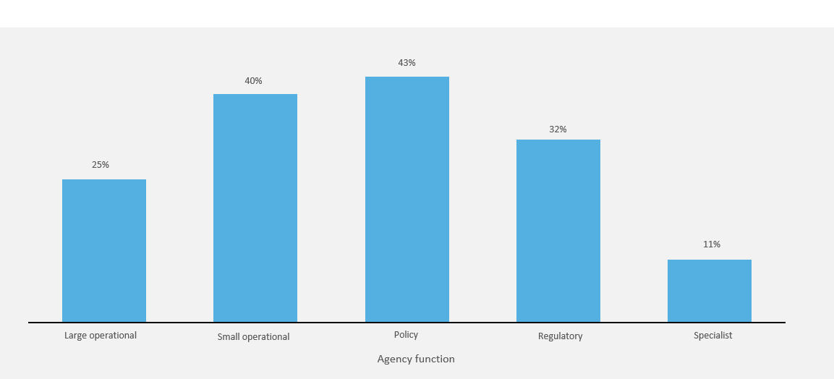

Mandating appropriate leadership development for those assuming supervisory responsibilities is critical.

* **Not all leaders are well-prepared for their roles.** It is not unusual for employees to be appointed to supervisory roles without ever receiving formal leadership training or havingbenefited from leadership development opportunities. The work of the APS relies almost entirely on the ability to build and deploy the capabilities of its people; strong leadership and people management qualities are essential.
* **Leadership challenges are evolving**. Particularly in a post-COVID-19 world, it is important to recognise that leaders now need to: be effective in working with distributed teams; adopt new, customer-centric ways of work; and be digitally literate and confident in using data.
* **Effective leadership is required to drive ambitious change**. Given the centrality of leadership to the review’s desired cultural and structural change, it is crucial to better equip and support APS leaders.

Consultations suggested a focus on effective risk management and delegation as part of any leadership program, as well as collaborative ways of working to empower staff to do work appropriate to their level. This is consistent with data from SES leadership capability assessments, showing leadership competencies most in need of development for SES are *entrepreneurial*, including finding ways to challenge current perspectives, generate new ideas, experiment with different approaches and manage risk, and *enabling*, creating an environment that empowers diverse individuals and teams to deliver their best.[42]

## Implementation Considerations

Managers across all levels of the APS must have the skills, training and support to successfully embed dynamic, responsive and non-hierarchical ways of working sustainably across the APS.

* Urgent investment in capability uplift to begin at the EL2/Manager level, to ensure they are equipped to effectively manage the transition period, while also providing the skills to effectively lead modern,   
  agile and high performing teams.
* Employees at all levels to be required to undertake appropriate leadership and people management training before advancing into a role with supervisory responsibilities. Training requirements will vary for different classification levels.
* Advancement should not be denied to those who do not initially have these skills. However, they will be required to attain them within three months of any advancement. The APSC, with advice from the APS Academy, should issue guidelines on minimum training requirements to ensure consistency and fairness in access to, and quality of, training. Delivery should be at the discretion of each agency.
* The APS Academy will play a critical role in ensuring consistent and fair training across the APS,   
  while noting agencies will have different requirements. Consideration will be given to utilising existing training programs within the APS (particularly looking at the largest APS agencies) and rolling out enterprise-wide training in digital format, to ensure both consistency and cost-effectiveness. Common training requirements across the APS should include:
  + - Effective people leadership – how to form, oversee and enable successful teams, including across dispersed workforces or in ‘hybrid’ working arrangements.
    - Effective risk management and delegation.
    - Effective change management.
    - Modelling non-hierarchical behaviours and collaborative ways of working.
    - Self-awareness – identifying strengths and weaknesses, setting goals, acting on feedback.
    - Practical resources/tools to promote ongoing learning and improvement, beyond short courses.

Leadership and management training to be supported by other important initiatives, including effective performance management, coaching and talent management. Cross-agency programs are encouraged, enabling leaders to establish and strengthen networks across the service and promote a ‘One APS’ ethos.

A significant investment in capability uplift across the APS, combined with flatter structures and reduced hierarchical behaviours, will empower the APS workforce across all classifications. With this, there is an expectation that staff across all levels take a greater level of accountability and responsibility in the operation of their organisation, driving the best possible outcomes for the government and citizens.

|  |
| --- |
| RECOMMENDATION 7 | **Strengthened role of APS Chief People Officer** |
| **Strengthen the role of the APS Commissioner as the Chief People Officer for APS people management**. |

“To meet this vision, the APS will need to invest in the professionalism and expertise of its people and leaders, who are at the heart of its organisational capability. This includes adopting a strategic approach to workforce management to improve how the APS attracts, recruits, develops and deploys its people” Independent Review of the APS

## Why do we need change?

Strategic people management is critical to the continued evolution of the APS. In engagements with the private sector, there were striking differences in the extent to which people management at senior levels was valued relative to the APS. The Panel observed in leading private sector organisations, immense value is placed on people management (Appendix F | Lessons from the private sector refers), with Chief People Officers having a seat at the leadership table.

Research suggests organisational performance is improved when people management is considered core business as part of strategy and leadership from the top down.[43] Giving more prominence to such roles elevates the issues, and promotes a mindset and capability shift among leaders of all types to see people management as ‘their’ business, not an ‘HR’ problem. More generally, strengthening strategic people management capability ensures agencies improve their approaches to organisational design and job design.

The Panel also sees this recommendation as critical to ensuring the ongoing accountability and the effective implementation of the review in its entirety. To achieve full impact and value, there needs to be an ongoing focus on implementation for sustainable, lasting change. The APS Chief People Officer will play a key role in providing quality guidance and support to agencies, and monitoring progress and outcomes of implementation at an enterprise level. The APSC will also report to Parliament annually on progress against these recommendations through the State of the Service Report.

Strengthening the role of the APS Commissioner as the APS Chief People Officer not only provides an opportunity to ensure comprehensive implementation of the review, it also positions the Commissioner to oversee strategic people management across the APS and take a lead role in embedding long-term change to the way the APS operates and delivers for the government and wider community.

## Implementation Considerations

A strengthened role for the APS Chief People Officer would drive stronger people management practices through the APS. It would provide clearer mechanisms for information sharing, collaboration and the provision of guidance, helping to align HR practices across agencies and ensure an enterprise-wide focus is brought to the APS’s most significant people challenges.

The APS Chief People Officer should have authority and resourcing to:

* Oversee the implementation of the revised classification framework and supporting measures, together with Agency Heads.
* Oversee strategic management issues into the future.
* Lead initiatives on whole-of-enterprise people matters.
* Provide oversight to data collection, audits and an accountability framework (e.g. spans of control).
* Support enterprise alignment through consistent and comprehensive implementation across agencies.

To assist the transition period and to embed an ongoing, enterprise view of strategic people management and HR, it is critical for the Chief People Officer role to be supported by Agency Heads, the COO Committee, and the APS Professions.

* The COO Committee should play a central role in advising and supporting the Chief People Officer, to align transition arrangements, ensure consistent implementation across the sector and provide advice to both the Chief People Officer and Secretaries Board on critical enterprise-wide strategic HR and people management priorities – giving it a stronger voice at the leadership table.
* The APS Professions, particularly the HR profession, will be critical in supporting the Chief People Officer – both in implementation of the review and in ensuring people matters are front and centre for their organisations.
* Ongoing engagement and leadership by Secretaries and Agency Heads would ensure that strategic people management is considered under a ‘One APS’ approach and is a key factor in organisational and strategic decision-making.

|  |
| --- |
| RECOMMENDATION 8 | **A charter of leadership behaviours** |
| **The Secretaries Board to adopt and model a Charter of Leadership Behaviours for APS leaders to promote collaborative and team-based behaviours.** |

“If you have support from leaders that mistakes are okay and you can  
learn from it – if that culture is present, it is a lot easier to work with new  
ideas and be adaptable to change as there is a culture of learning”  
Workshop participant

## Why do we need change?

A shift away from unnecessarily hierarchical behaviour and towards an empowered and agile APS must be driven and modelled by leaders.

* **APS leaders are key to the success of enterprise reforms**. Leaders – most notably Departmental Secretaries and other Agency Heads – are central to driving the recommended package of reforms set out in this report. The commitment of these leaders must be evident in action they take to change culture within their organisations and to emulate new norms of behaviour.
* **There needs to be agreement and role modelling from the top on new behavioural standards**. The purpose of this recommendation is to define the desired ‘norms’ and to give them force as a new set of standards to observe and be held accountable to. The proposed ‘signature behaviours’ would need to reflect a shared understanding about what non-hierarchical behaviour ‘looks like’, while also reinforcing other related aspects of effective and adaptive leadership.
* **Signature behaviours can prevent backsliding**. The signature behaviours can both mitigate the risk of a relapse to more traditional mindsets and ways of working, and set a positive, enterprise-wide frame for defining leadership excellence in the APS.

In making this recommendation, the Panel notes that there is a strong base of capability to build on. The desired behaviours are in evidence across many APS agencies and among leaders at all levels. The COVID-19 experience is illustrative of what can be achieved when hierarchies and status are put to one side in favour of strengths-based collaboration to improve the outcomes for citizens and businesses.

Adopting a Charter of Signature Behaviours has proven to have had a significant impact on cultural change, particularly in the private sector context. Organisations like Microsoft, NAB and Atlassian have used tools such as a leadership charter to send strong signals of intent from the top of the organisation (Appendix F | Lessons from the private sector refers). Johnson and Johnson’s “Credo” guides decision-making and operations across the company, with performance of executives measured against the Credo, ensuring accountability to uphold the organisation’s values.

# Implementation Considerations

The Secretaries Board will develop a Charter of Signature Leadership Behaviours that they, and their executive-level colleagues, are prepared to promote, model and be held accountable to.

* The Charter will set clear expectations for the APS’s most senior leaders about the types of behaviours that will be valued and necessary to succeed.
* It will not replace the APS Code of Conduct. These remain the behavioural foundation for all APS employees. Nor will the charter detract from internal values set by Agencies.
* Input from APS staff will be sought in the development of the charter; an indicative set of behaviours is offered in Figure 10.

The APSC will provide clear implementation advice which will include examples of good practice, to ensure there is full take-up and alignment with related leadership and cultural change initiatives.

The APSC will include a question in the annual APS Employee Census/Agency Survey to measure progress with, and accountability against, the Charter.

**Figure 10| Indicative set of leadership behaviours to consider for inclusion in a charter**

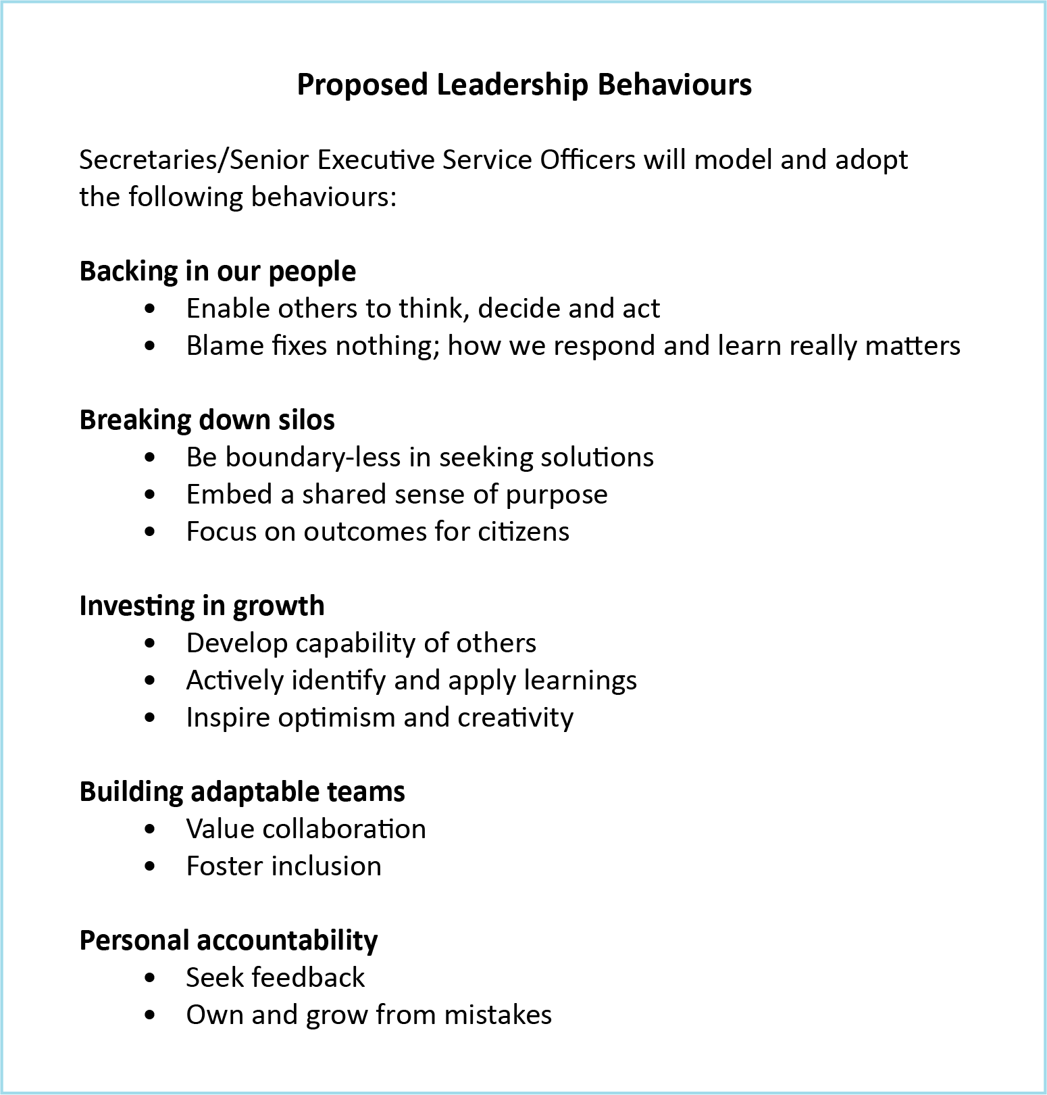

|  |
| --- |
| **Implementation Priorities** |

## Immediate Priorities

* Building on the establishment of the APS Academy, the APSC and Departments upgrade substantially the investment in training for EL2s and those with future supervisory responsibilities.
* APS Commissioner’s role as Chief People Officer be strengthened immediately, with resourcing and a mandate to implement this review.
* Secretaries Board develops and implements the Charter of Leadership Behaviours.
* Make new Classification Rules in early 2022.
* Secretaries/Agency Heads design and implement structural changes appropriate for their organisations by the end of 2023, following APS-wide consultation.

Decisive and comprehensive implementation of coordinated change is key to success and minimising disruption. A strong theme through consultation was that an implementation plan that is too extended risks losing momentum and intent. Leaders must provide certainty to the APS workforce that a single enterprise approach will be taken.

## Roles and responsibilities

Accountability for successful implementation must be led by Secretaries Board and shared by leaders across the APS, including Agency Heads, the COO Committee and Heads of Professions. This should be accompanied by a strong, consistent narrative articulated across the APS workforce. A lesson from other public sectors, both Australian and international, was the importance of ministerial endorsement and support in driving urgent and sustained change. Support from Ministers and Ministers’ Offices will be critical in ensuring decision-making is pushed down appropriately and the right expertise are involved, regardless of rank.

A strengthened role for the APS Chief People Officer provides clear mechanisms for information sharing, collaboration and the provision of guidance to align implementation across agencies and ensure that an enterprise-wide focus is brought to transition and ongoing reforms.

Successful implementation of the recommendations relies on the urgent investment in enhancing EL2/Manager capability to reposition these roles as APS powerhouses – particularly looking at capabilities in risk management, ministerial engagements, strategic HR and change management. Learning and development of this cohort needs to be considered both in the transitional period as well as the continuum for the service moving forward.

Investment in leadership and management training for supervisors at all levels will also be critical for implementation, so they are well-placed to manage more agile, flexible and collaborative teams.

The HR Profession will play a critical role in ensuring comprehensive and consistent implementation   
across the service. The APS must ensure it has the HR expertise for successful implementation,   
including organisational design, strategic HR and change management.

## Actions

* The APSC to work with agencies, the Secretaries Board, the COO Committee, HR professionals and others, to develop a detailed implementation plan incorporating all the governance and change management functions required to assist agencies to deliver the reforms.
* Making new Classification Rules early in 2022 will signal clear appetite for change, maintain momentum and set the expectation of enterprise-wide transformation. It will also provide opportunity for clear, consistent messaging across the sector on the intent, timing and expectations of reforms.
* Investment in leadership development will enhance and strengthen the capability and role of EL2/Managers and will be critical for implementation and ensuring they are well placed to manage more flexible, agile and collaborative teams.
  + Drawing on the APS Academy and APS Professions groups, the APSC will work with agencies to build on training opportunities for EL2s and those with supervisory responsibilities.
  + Training programs will provide skills in effective leadership, risk management, delegation and collaborative ways of working to create cohesive and productive teams.
* Urgent uplift in change management capability and support for the APS leadership will support sustained, enterprise-wide organisational change, acknowledging the complexity of implementing system-wide structural and cultural change.
* Enterprise-wide rules should allow for agency-level variation within reason, whilst maintaining and reinforcing the ‘One APS’ ethos for consistency, fairness, mobility and career progression.
  + Noting the diversity of the APS, Agency Heads/Secretaries will retain flexibility to structure their organisation to optimise their business needs to meet the needs of Government and the community. Mechanisms that may be used to support flexibility include: intra-band reporting, use of broadbanding at non-SES levels and Agile teams and taskforces.
  + Note the Panel is not recommending the loss of any terms or conditions, or any changes to staffing levels in the implementation of these recommendations; although it notes decisions taken by Agency Heads in implementing the new structures could result in efficiencies over time.
* The APSC should lead in-house support, governance and change management functions to assist agencies to deliver change.

## Recommended Implementation Milestones

The recommended implementation timeline is provided in Figure 11.

Figure 11 | Implementation timeline

| **Timeframe** | **Key Milestone** |
| --- | --- |
| December 2021 | Final report provided to APS Commissioner. |
| March 2022 | Charter of Leadership Behaviours developed and adopted. |
| Early-2022 | APS Commissioner makes new Classification Rules. |
| Through 2022 | APS-wide consultations. |
| End-2023 | Full implementation of new structure. |

# Related observations and considerations

Several issues arose during our consultations that did not squarely fit within the review’s Terms of Reference, although should be borne in mind in responding to the foregoing recommendations.   
Three, in particular, are highlighted below.

## Consistency in remuneration

There was substantial commentary on remuneration in workshops and submissions, with the key concern being the apparent inconsistency in approaches to remunerating staff who do similar work. This was producing mixed messages about work value. In the view of the Panel, a more consistent approach to remuneration and associated terms and conditions would:

* Facilitate greater mobility of staff between APS agencies.
* Reinforce the principles of fairness and equity.
* Strengthen the alignment between work value and classification.

On the latter point, the key is to separate classification decisions from remuneration arrangements to enable more transparency in situations where remuneration is designed to attract in-demand skills.

## A contemporary approach to risk management

A distinctive feature of the APS is its perceptions of and engagement with risk. APS leaders operate within a complex authorising and stakeholder environment that increases the sense of exposure to risk. This in turn fosters mindsets that are inherently risk-sensitive and therefore prone to trigger cautious and defensive or protective behaviour. This is a rational response; however, it can have unintended consequences.   
APS employees can define desired outcomes in narrow ways, and can seek to exercise control over products and processes that should be handled at lower levels.

A different approach to engaging with risk is therefore a critical element of APS cultural reform and leadership development. APS employees need assurance *and* evidence that they will be both trusted to exercise their responsibilities without undue interference or ‘micro-management’. Change must be led from the top, with those at the most senior levels demonstrating trust in their staff, being clear when the stakes are high and when they are not, and providing an environment where responses to mistakes are reasonable and proportionate.

The review understands that such changes are not easy and require support from Ministers’ offices and others. Nevertheless, they are worth pursuing if the APS is to counter the trend of work and decision-making continually being ‘pushed upwards’ and employees feeling their roles are being hollowed-out.

## Supporting a diverse and inclusive APS

An ongoing commitment to a diverse and inclusive APS is key to realising the vision of an agile, flexible APS that delivers for Australian citizens. This review offers several points of intersection with the diversity and inclusion agenda. Rethinking classification and introducing new ways of working, along with new approaches to progression and development, all present opportunities for the APS to address systemic barriers to career development reported by underrepresented cohorts. For example, ensuring that people with the right skills and knowledge are included in decision-making is highly relevant, particularly when considering the value of involving people who bring a customer perspective or lived experience relevant to the issue at hand. Leadership development, including the cultivation of behaviours that recognise different working styles and mitigate the risk of bias provides a similar opportunity to reinforce diversity and inclusion principles.

It is important to guard against unintended outcomes from acting on the review’s recommendations.   
Doing this requires vigilance in seeking out and understanding the experiences of under-represented employees (and prospective employees). The review received rich insights from these cohorts, some of which relate directly to questions of hierarchy and classification, and others that ranged more broadly.   
Key themes to highlight were as follows:

* **Aboriginal and Torres Strait Islander** employees who responded to our survey perceived limitations   
  on their career progression opportunities, driven in part by limited cultural competency in   
  (non-Indigenous) leaders and a lack of appropriate mentors to support their growth and development.
* **People from culturally and linguistically diverse** **backgrounds** noted that levels of cultural diversity in the APS (especially in senior leadership) were relatively low and felt that systemic features such as a heavy reliance on interview performance in selection processes created barriers to progression.
* **People with a disability** said that assumptions about their capability and career aspirations   
  had a detrimental impact and emphasised the importance of promoting disability awareness   
  and understanding.

Such views are illustrative rather than comprehensive. However, they underline the need to capture the opportunities implicit in the recommendations to create a more equitable and inclusive APS that reflects the rich diversity of the Australian community that it serves.

Appendix A | Terms of Reference

**Review principles**

The Review Panel will provide recommendations on an optimal management structure for the APS   
which represents:

* Streamlined decision‐making and accountability with flexibility to respond to changes including   
  new ways of working;
* A culture of responsibility and decision‐making being delegated to the lowest level possible;
* Spans of control reflecting the type of work being managed; and
* Simplified and clear workforce management guidelines.

Recommendations should be practical and allow employees and duties to be classified under a common APS‐wide classification system. Any new approach should allow for differentiation depending on agency size and role.

Specific deliverables for this project include:

* Review and report on the current APS classification framework and develop recommendations on a clear, effective and efficient structure that is fit for the future.
* Provide advice to the APS Commissioner on implementation of recommendations arising from the APS Hierarchy and Classification review.
* Review and update the APS Framework for OMS.

**In‐scope**

The following is included in the scope of work for this project:

* Review of the APS Hierarchy and Classification structure (APS1‐6, EL1‐2, SES 1‐3) with particular attention on future‐state and potential for new structures.
* Examine apprentice, graduate, trainee and cadet classifications (training classifications).
* Consider occupational‐specific classifications and agency‐specific classifications.
* Consider the use of broadbanding within the APS classification framework.
* Review of the *Public Service Classification Rules 2000*.
* Review and update the 2014 APS Framework for OMS.
* Comprehensive service wide consultation and communications at all levels.
* Stakeholder engagement including union bodies and representatives.
* Implementation plan for recommendations from the Hierarchy and Classification review and provision of advice to the APS Commissioner to engage with APS leadership and staff.

**Out‐of‐scope**

The following is not included in the scope of work for this project:

* Individual capability assessments.
* Non‐APS classification structures.
* Changes to the current enterprise bargaining framework or harmonisation of pay and conditions   
  across the APS.
* Remuneration settings.
* Average staffing levels (ASL) rules and decisions.
* Regulation Impact Statement (RIS)/legislative amendment (to be addressed as part of implementation in forward years).
* Workforce planning tools and practices (i.e., role evaluation) which may form initiatives to be designed and delivered as separate projects under the implementation roadmap and/or APS Workforce Strategy.
* Strategies to increase diversity representation at non‐SES and SES levels (delivered via other initiatives).

Appendix B | Classification Schedule

Proposed changes to the *Classification Rules 2000* are detailed below to shift from 13-8 classification levels:

| **Schedule 1 – Approved Classifications** | | |
| --- | --- | --- |
| **APS group** | **Current Classification** | **Proposed Classification** |
| Group 1 | APS Level 1 | Core Officer – Primary |
| Group 2 | APS Level 2 |
| Group 3 | APS Level 3  APS Meat Inspector 1  Customs Level 1 |
| Group 4 | APS Level 4  APS Meat Inspector 2  DAFF Band 1 |
| Group 5 | APS Level 5  APS Meat Inspector 3  Customs Level 2 | Core Officer – Advanced |
| Group 6 | APS Level 6  APS Meat Inspector 4  Customs Level 3  DAFF Band 2  Examiner of Patents  Medical Officer Class 1  Valuer |
| Group 7 | Antarctic Medical Practitioner Level 1  Customs Level 4  Executive Level 1  Medical Officer Class 2 | Core Officer – Expert |
| Group 8 | Antarctic Medical Practitioner Level 2  Customs Level 5  DAFF Band 3  Executive Level 2  Medical Officer Class 3  Medical Officer Class 4 | Manager |
| Group 9 | Antarctic Medical Practitioner Level 3  Chief of Division Grade 1  Chief Research Scientist Grade 1  Medical Officer Class 5  Senior Executive Band 1 | General Manager |
| Group 10 | Chief of Division Grade 2  Chief Research Scientist Grade 2  Medical Officer Class 6  Senior Executive Band 2 |
| Group 11 | Chief of Division Grade 3  DAFF Band 4  Senior Executive Band 3 | Executive General Manager |

As Secretary is not an approved classification in the *Classification Rules 2000*, they will retain the title of Secretary as per the *Public Service Act 1999*.

|  |  |  |  |
| --- | --- | --- | --- |
| **Schedule 2 – Training Classifications** | | | |
| **Group** | | **Training classification** | **Operational classification** | **Proposed Training Classification** |
| APS Trainees | | Apprentice APS (Trades) | APS Level 2 | Entry |
| Cadet APS | APS Level 3 |
| Cadet APS (Research Scientist) | APS Level 6 |
| Graduate APS | APS Level 3 |
| Trainee APS (Administrative) | APS Level 1 |
| Trainee APS (Technical) | APS Level 3 |
| Agency Trainees | | Aboriginal Cadet | Customs Level 1 |
| Customs Trainee | Customs Level 1 |
| Cadet APS | Customs Level 1 |
| Customs Trainee Graduate | Customs Level 2 |
| Valuer‑in‑training | Valuer |

Appendix C | Engagement

The review engaged over 1000 people, including a large and representative cross-section of APS staff, academic experts, private sector leaders and union representatives. Engagement took place through a range of mediums, including workshops and focus groups, public submissions, interviews, meetings and a survey. Figure 12 summarises key engagement statistics, including participant characteristics that were collated from responses submitted through Mentimeter, an interactive workshop polling software.

**Figure 12 | Summary of consultations**

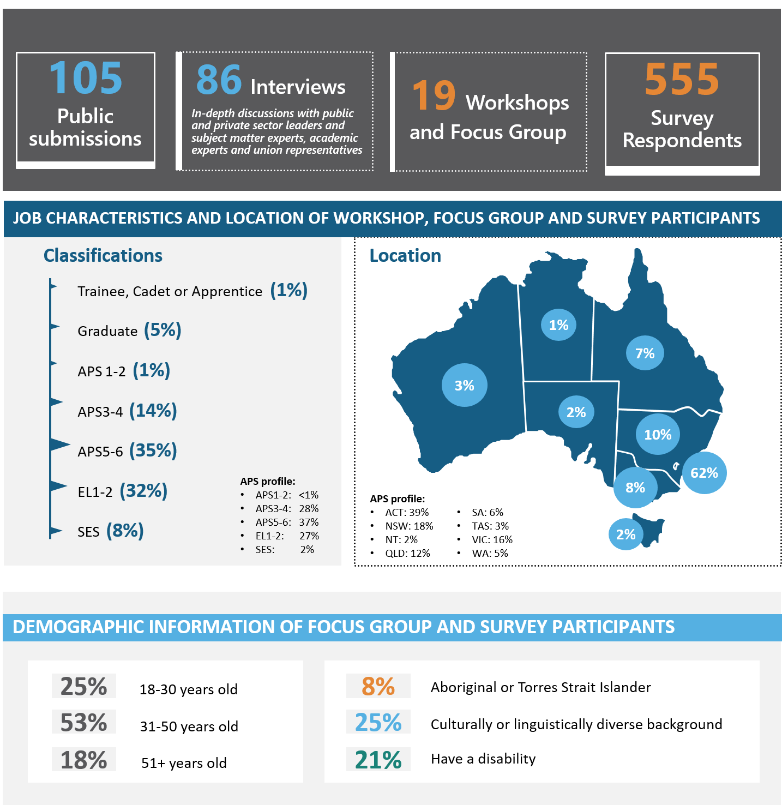

**Workshops and focus groups**

Workshops and focus groups were conducted with approximately 298 APS employees across all job groups, classifications, agencies and locations. Through focus groups, we undertook targeted consultation with APS entry level program participants, APS Diversity Champions and representatives from the SES cohort.

* Participants saw the largest opportunities in improving how hierarchy is used, revising classification structures, building specialist talent and enabling and encouraging leadership development.
* Workshop participants identified underpinning structures, specialist roles and leadership commitments as the three areas that would benefit most from change.
* Hierarchy was described as both an enabler and a barrier in the workplace, with examples of participants’ views of the mixed impacts of hierarchy outlined below:

| **Hierarchy and/or classification structures help when…** | **Hierarchy and classification structures and/or hinder when…** |
| --- | --- |
| * Provides a ‘safety net’ where new or more junior employees can learn, make mistakes, and receive feedback safely. * Enables equal pay and creates and even playing field for those without bargaining power. * Provides accountability and helps manage risk. * Provides role and decision-making clarity and delegation pathways. | * Drives unhelpful hierarchical behaviours stemming from a fear of failure and risk aversion. * Inhibits collaboration between individuals and agencies. * Used to exclude people from providing input or having a voice, including subject matter experts. * Creates unnecessary duplication of work, bottle-necks and slows down decision-making due to linear ‘up and down the line’ communication. * Used as a proxy for status and empowers/disempowers employees depending on their classification level. |

Aggregated messages from each of the workshop streams are provided in Table 2. Note these are not exhaustive and seek to capture the mood and key messages from participating APS employees.

Table 2 | Summary for APS workforce engagements

|  |
| --- |
| **APS non-SES** |
| * Hierarchy creates a ‘safety net’ to allow for learning, making mistakes and feedback, and provides role clarity, accountability and delegation pathways. * However, it also inhibits collaboration and can be exclusive, especially for small and medium-sized enterprises. * Areas that will benefit the most from change are underpinning structures, specialist roles and leadership commitment. * Common classification language should be introduced across the APS to encourage and allow for easier mobility. |
| **Entry Level participants** |
| * Participants saw progression negatively, feeling pressure to move up and away from entry classification as quickly as possible. Change of classification is seen as mark of progress and development, and would provide access to different work opportunities. * Participants also felt stuck. At some agencies, time spent at the agency was more important to progression than capability. Some felt they could be at a higher classification but needed to wait. * Hierarchy impedes agile work practices, noting a lack of guidance on how to utilise these practices. |
| **SES focus group** |
| * The political space creates the need for hierarchy structures to absorb the reputational risk. * Hierarchy creates silos and can inhibit productivity, however it can provide clarity on the work and risk that is appropriate at each level. * Need to teach people to how to coach, mentor, manage and delegate. There is basic capability building that needs to be done to show people how to successfully push work down. * Consider what the APS incentivises and rewards in terms of culture, acknowledging it is about the journey to get the results as well as the result. * Hierarchy precludes having the experts and decisions makers in the room at the same time. |
| **Diversity** |
| * The APS has a culture of ladder and classification climbing as the definition of success – need to redefine success away from classification. Change needs to be driven by leaders. * Flattening structures may give people with diverse backgrounds less opportunities for promotions and less visibility in senior roles, as people could spend more time at the same level. * If structures are more consistent across agencies and can harbour ‘One APS’, it will give people a better sense of career pathways to help foster and attract diverse employees. New structures must foster and utilise affirmative measures to ensure diversity within the APS. * Staff in regional areas have to work against the structural “top heaviness” in Canberra, which often prevents them from delivering to their full potential. * Management capability is key – often people are given positions with management responsibilities due to their other capabilities but lack people management skills. |

**Survey**

A Mentimeter survey was distributed to enable participation by employees who may have been unable to attend a workshop or focus group due to operational requirements. Over 500 responses were received from a broad cross-section of the public service. Questions were based on similar topics to the workshops and focus groups, with responses focused on hierarchy, specialist roles and the impact of classification.

Results were analysed for input into key recommendations, with analytical tools used to conduct algorithmic assessment of text responses. Sentiment analysis of the question that asked respondents “thinking about hierarchy at work, what is one word that sums up your experience?” netted mixed results. 14% of responses were positive words (e.g. necessary, supportive), 27% were negative (e.g. rigid, frustrating) and 58% were neutral (e.g. structured, bureaucratic).

#### **Public submissions**

Submissions were received from APS employees across Australia, as well as a limited number of non-APS or former APS employees.

* A small number of submissions were made on behalf of agencies or organisations including the CPSU, IP Australia, the DTA Agile Champions Network and Professionals Australia.
* Relative to other agencies, a larger proportion of submissions (10%) were received from Services Australia staff.[44]

The top three areas of focus advocated in public submissions were underpinning structures (50% of submissions related to this area), specialist roles (37%) and workforce capability (29%).

Key points from agency, union and network groups are summarised in Table 3.

Table 3 | Submissions from key stakeholders

| **Submission** | **Key Points** |
| --- | --- |
| **Digital Transformation Agency / Digital Professions** | * The ability to attract, develop, manage and retain talent is significantly impacted by the rapid growth in demand for digital talent and the inability for current talent pipelines to meet this demand. |
| **APS Agile Champions Group** | * Public sector agility remains an important priority in the 21st century workplace. Australia sits behind other countries in terms of Agile practices and project delivery. * The biggest barriers to adoption of Agile are culture and leadership. |
| **Australian Competition and Consumer Commission** | * Similar classification structures across the APS provide a ‘common language’ and support cross-agency mobility. Any changes to classification frameworks should be cognisant of implications for mobility. * The majority of ACCC staff are classified at EL1 and EL2 levels, creating challenges in promotion and succession. |
| **Intellectual Property Australia** | * Supports flatter structures supported by agile movement across business priorities without being restricted by hierarchy. This should be supported by genuine devolution of decision-making to lower levels. |
| **Community and Public Sector Union** | * *Consistency* - classification system should be sufficiently rigorous to accurately reflect work value. WLS is currently lacking. * *Under-classification* - there is a tendency to under-classify service delivery roles and to push increasingly complex work down to lower-level employees. * *Reducing layers of hierarchy in higher levels* - efforts to free up decision-making should focus on higher levels where there are bottlenecks. * *Broadbanding* - broadbanding should be more widely utilised. * *Labour market shortage and skills in demand* - there must be mechanisms to attract and retain skills and expertise that are in high demand. * *APS professionals* - APS should support its professional employees including lawyers, ICT/Digital specialists, graduates and scientists to enable effective attraction, retention, recognition and career development. |
| **Professionals Australia** | * The APS does not collect sufficient data on the capability of its workforce. * This review is an opportunity to invest in its people now and into the future. * A consistent, APS-wide recognition of specialists will improve the ability of the APS to retain, recruit and retrain for the skills the APS has identified it needs. |

#### **Consultation meetings**

The Panel conducted 86 consultations with a broad range of Commonwealth agencies, domestic and international jurisdictions and private sector organisations. Consultations are listed in Table 4.

Table 4 | List of consultation meetings

| **Panel Interviews** | |
| --- | --- |
| **Public Service Leaders and Union Representatives** | |
| Andrew Metcalfe Department of Agriculture,  Water and the Environment | Katherine Jones (on behalf of Greg Moriarty) Department of Defence |
| Andrew Shearer Office of National Intelligence | Kathryn Campbell Department of Social Services |
| Brad Chapman Australian Taxation Office | Liz Cosson Department of Veterans’ Affairs |
| Brendan Murphy Department of Health | Liz Williamson Department of the Treasury |
| Chris Jordan Australian Taxation Office | Mary Wiley-Smith Department of Industry, Science,  Energy and Resources |
| Clare Walsh Department of Finance | Melissa Donnelly CPSU |
| Dale Beasley Professionals Australia | Michael Pezzullo Department of Home Affairs |
| David Fredericks Department of Industry, Science,  Energy and Resources | Michele Bruniges Department of Education, Skills and Employment |
| David Gruen Australian Bureau of Statistics Head of APS Data Profession | Patrick Hetherington Australian Public Service Commission |
| David Thodey Lead Reviewer, Independent Review of the APS | Phil Gaetjens Department of the Prime Minister and Cabinet |
| David Williamson Department of Industry, Science,  Energy and Resources | Randall Brugeaud Digital Transformation Agency Head of APS Digital Profession |
| Frances Adamson Department of Foreign Affairs and Trade | Ray Griggs Department of Social Services |
| Gordon de Brouwer Chair, IPAA Australia | Rebecca Skinner Services Australia |
| Graeme Head Former NSW Public Service Commissioner | Rosemary Huxtable Department of Finance |
| Grant Hehir Auditor-General | Roxanne Kelley Department of the Treasury |
| Grant Lovelock Australian Public Service Commission | Simon Atkinson Department of Infrastructure, Transport,  Regional Development and Communications |
| Iain Anderson Attorney-General’s Department | Stephanie Foster Department of the Prime Minister and Cabinet |
| Ian Watt Former PM&C Secretary | Stephen Sedgwick Former APS Commissioner |
| Jacqui Curtis Australian Taxation Office Head of APS HR Profession | Steven Kennedy Department of the Treasury |
| Justine Greig Department of Defence |  |
| **Private Sector Organisations** |  |
| Atlassian | Johnson & Johnson |
| Aurecon | Microsoft |
| BAE Systems | NAB |
| BHP Billiton | PwC Australia |
| Challenger | Telstra |
| Commonwealth Bank | Worley |
| **State and Territory Government Representatives** | |
| Australian Capital Territory | South Australia |
| New South Wales | Victoria |
| Northern Territory | Western Australia |
| Queensland |  |
| **International Government Representatives** |  |
| Canada | Singapore |
| New Zealand | United Kingdom |

Appendix D | International public sector analysis

**Panel Engagements**

The UK is undergoing significant public sector reform, with a reform statement co-signed by the Prime Minister and Head of Civil Service. The challenges of dealing with Brexit and COVID-19 experiences has triggered greater mobility and new ways of working across the service. They have identified the need for a sector that has maximum agility; and as such, are moving to a more matrixed, smaller and flatter workforce. The new structure will see them aiming for 6-7 layers and spans of control of 8-10.

* As part of the reform, the service is focusing on recruiting and uplifting capabilities to align with future of work. For example, it wants to create people who are highly digitally literate, understand data and can undertake project management.
* They are currently working to lift workforce planning capability and increase knowledge capture, to minimise use of contingent labour/consulting to where it is most needed.
* The UK Civil Service noted the importance of constant deliverables along the reform journey, to demonstrate progress and bring people along and remove cynicism. Seeing the public sector as a partnership, not a corporation, fosters collaboration across the system. Building collaboration at the ‘team’ level across departments requires leadership and encouragement. There should be no barriers to sharing or being open source, and deploying as quickly as possible as a single enterprise.

The Canadian Public Service is focused on job security, career progression and retaining what was gained from the COVID-19 response, such as greater flexibility and mobility. Treasury Board of Canada (TBC) identified the current classifications system as too rigid for transfers and secondments. Learning from previous reform attempts, TBC noted the focus should be placed on the flow of the work.

* Classifications are considered a barrier to moving forward. The classification specialists are risk averse due to working with the existing classification tools for so long. The focus for systemic change is on reducing the number of classification tools and making them multi-disciplinary.
* Past attempts at classification reform in Canada have underpinned the importance of implementation. TBC regularly engages HR heads and HR specialists across the sector to ensure they are trained and well-equipped to support their department. HR specialists have a governance requirement to TBC and provide direct data to ensure change is implemented successfully.

In the Singapore Public Sector, initiatives exist to help foster a culture of innovation and agility. Work is underway to review the way the workforce is organised and structured, focused on the 3W’s of Work, Workforce and Workplace.

* The Singapore Public Service provides leadership development opportunities for leaders at all organisational levels, anchored around a set of leadership competencies for different leadership tiers. They have a set of core competencies all public service officers need to develop, including adoption of a ‘one public service’ mindset and effective collaboration across organisations.
* In order to attract specialists, the civil service pays competitive salaries at all levels of seniority, across different skill areas. Salaries are regularly benchmarked with comparable job families in the private sector and adjusted where appropriate. Work to uplift the capability of specialists includes implementing career development roadmaps, facilitating deployment/rotations across the service and short term talent attachments into the private sector.

The New Zealand Public Service currently works under a devolved system where individual departments consider workforce issues. They recently commenced work to develop WLS for application across the policy profession, with a view to aid mobility, workplace planning and provide common pathways for staff.

**Desktop Research**

The review included a desktop review of approaches to classification across other countries and within Australia (Appendix E | Comparisons with Australian State and Territory public services refers). The aim of this analysis was to understand the APS’s current approach to classification relative to other jurisdictions. The intention was not to seek alignment with other jurisdictions, rather to understand what can be learned from current practice. Based on findings from this analysis, the review proposes that the APS be at the forefront of classification reform that enables more collaborative, flexible and dynamic ways of working.

The review found that the APS’s universal classification system sets it apart from other countries. For example, Canada, New Zealand and Singapore organise roles based on occupation groups, while the UK links classifications more closely to its professions model. However, such approaches provide targeted career pathways for people with technical and specialist skillsets (Figure 13).

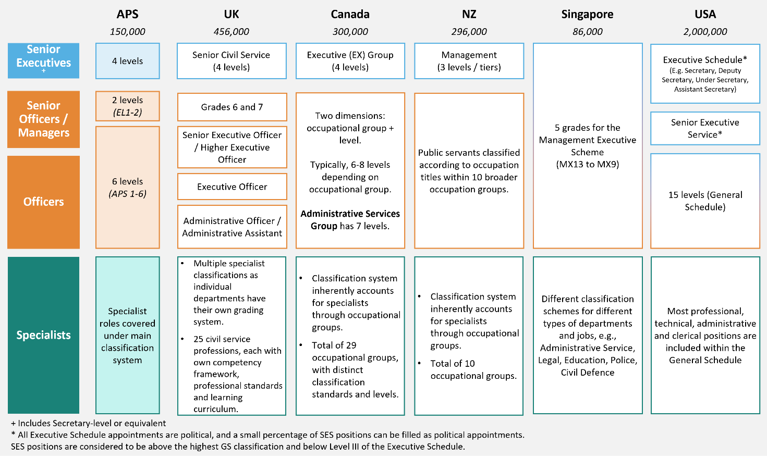Figure 13 | Approach to classification structures across selected international jurisdictions

Appendix E | Comparisons with Australian State and Territory public services

**Panel Engagements**

The State and Territory public services noted **hierarchy can be perceived as a barrier to innovation and decision-making** by their workforces, prompting consideration of introducing fewer layers in their structures. Employees in the Northern Territory expressed the desire for greater autonomy, with leaders now encouraged to push work and responsibility down to lower levels in their structures to increase workforce engagement and development. During the recent crises, ACT found that having fewer layers of decision-making due to the urgent nature of the work was a positive experience.

**Descriptive job titles** allow stakeholders and employees to easily identify what work an individual is responsible for. The Victorian Public Service is shifting to more consistent and descriptive work titles across the service to increase transparency and rigour. In NSW, classifications do not generally define the work undertaken by an employee, enabling quick decision-making that relies on the subject matter experts.

It is common practice in the public sector for **specialist** remuneration to be based on their technical expertise, rather than promoting to people managers in order to receive higher remuneration. However, the lack of transparency of this across each service was noted as a consideration. Western Australia and South Australia both modified classification frameworks to allow for necessary role qualifications and a greater focus on attraction and retention.

**Spans of control** across the State/Territory public sectors are not consistent and are often not benchmarked. Consultations suggest spans for senior executives generally range from 5-14 direct reports. Consistent factors were identified for consideration when agreeing spans of control, including:

* The context and nature of the work being undertaken.
* The ability to delegate tasks that will build employee capability and ensure employee feels supported.
* The need to build a culture that facilitates actively pushing work down to a lower level.

Most State/Territory public services have **leadership training and/or programs in place**. Key elements making up their leadership training include:

* Continually investing in leaders and upcoming high performers.
* Addressing risk management in NSW to encourage a culture that facilitates capability development by actively pushing things down to lower levels.
* Having a long standing Leadership Academy in the South Australian public service, to ensure they have a pipeline of future talent and have succession plans.
* Ensuring first time people leaders and managers are provided with leadership training to enable them to perform to a high standard in the Northern Territory public service.

NSW lead by example with their Public Service Commissioner embedding leadership programs, the capability framework and training programs for new executives to the sector. The Commissioner also looks at strategic people matters, ensuring leadership is consistent across their public sector, and oversees the public service’s workforce strategy, reforms, framework and guidance.

Culture was discussed in each of the public sector consultations, highlighting this is typically set from the top down. Leaders should be setting the example for a culture that:

* Encourages mobility across the sectors and ensure the government of the day is served.
* Focuses on collaboration across the sector and for leaders to be stewards of their sector.
* Empowers employees to make decisions and receive the support to do so.

In order to **implement** **wide-scale reforms** in the public sectors in Australia, consultations suggested government imprimatur is critical.

* In South Australia, the public service identified a number of drivers for change in their classification system, however noted government support is needed for successful change.
* In NSW in 2011, a Commission of Audit report resulted in a number of major reforms. The change in government gave the authority and created the right environment for change, alongside the political desire to prioritise becoming a world class public service (which is a priority still today).
* In WA, 2017 saw government-driven structural changes and reform as a result of budget restraints and machinery of government changes.
* Victoria opted to pilot structural changes to their executive levels in one department before implementing the reforms across the whole sector. Outcomes of the pilot were presented to their Secretaries Board in 2019, with the pilot being used to show the reform was fit for purpose.

**Desktop Research**

While there are differences in roles and responsibilities between the APS and State/Territory public services, classification structures across all jurisdictions are broadly comparable (Figure 14). For example, most jurisdictions have distinct classification schemes for the ‘officer’ level and the ‘senior executive’ level, with approximately four senior executive classifications (including Secretary).

Figure 14 | Public service classification structures across Australia

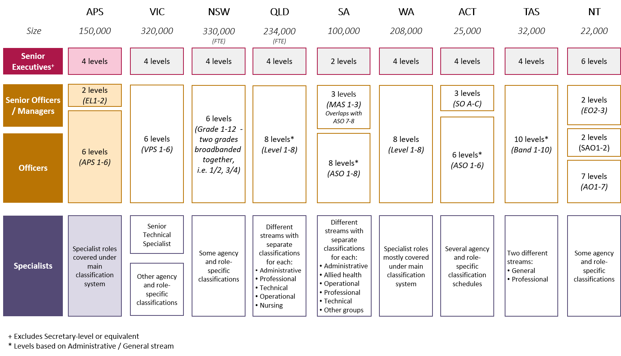

A key area of divergence is the handling of specialist roles. Some jurisdictions capture them through separate streams or specific classifications while others include specialist roles within a single classification system. Where jurisdictions have separate streams for specialist roles, some (e.g. Queensland) have a system in place to accommodate transfer within and between classification levels and systems, preserving mobility. Another area of divergence is the differentiation of middle managers. Unlike the APS, most (five out of eight) Australian jurisdictions do not differentiate their middle managers with a separate classification to officers.

Reforms to classification structures in other Australian jurisdictions have tended to focus on the senior executive service. For example, new Executive Classification Frameworks were introduced in New South Wales in 2013, the ACT in 2013 and Victoria in 2019. The drivers for change differed across jurisdictions, from removing remuneration overlap and enabling clearer delineation between levels (VIC), to removing excessing reporting layers (NSW). There is limited reporting on the effectiveness of various reforms; however, the importance of implementation support(including appropriate resources and funding) was consistently highlighted as a key success factor during consultations.

Appendix F | Lessons from the private sector

Across private sector consultations, we heard from most organisations that **flatter organisational structures** suit the agile and flexible 21st century workforce. The most common number of layers from our consultations was eight, which is currently used at BHP Billiton, Challenger and Commonwealth Bank. Organisations also told us that **contributions made by individuals should be valued based on their work** and expertise, rather than their level in the hierarchy. Telstra found that when job titles were consolidated and based on the work the employee contributed, their organisational structure was flattened.

**Meaningful career progression** was important to both employees and organisations engaged for the review. BAE Systems’ human resources function created a framework for career progression of their employees. It includes a number of education and other outcomes that employees need to attain in order to progress and is managed within the employee’s specific functional group, supported by HR as necessary.

Many organisations consulted identified with the Panel’s recommendation to properly **recognise specialists and value their technical expertise**. Similar to the APS, some specialists in organisations had previously been promoted into managerial roles in order to be remunerated appropriately and progress in their careers. Now, all organisations consulted have a specialist pathway, or are currently developing one, to ensure specialists are able to advance their technical skills and can have meaningful career progression without the need to become a manager unless they would like to do so. Aurecon and Johnson & Johnson have also incorporated an element of leadership by encouraging mentorships across their business’   
to ensure there are continual opportunities for growth.

**Spans of control** across the private sector were consistent and commonly sat between 6-10 direct reports for managers. Some of the key factors that are used to consider if a manager’s span of control should be increased or decreased include:

* The complexity of the work that is being undertaken.
* Ensuring teams and managers feel supported and have manageable workloads.
* Stakeholder and customer relationships are able to be maintained.

Larger spans of control were noted to be used in service delivery areas and mining sites and narrower   
spans of control for highly specialised work.

All private sector organisations consulted had **leadership training and/or programs** in place: both modular ‘off the shelf products’ that can be rolled out at scale, as well as bespoke training for senior leadership.   
It was widely agreed that leaders need to be well equipped to successfully support their teams and deliver for the organisation.Some of the key elements that make up leadership training across the sector include:

* A leadership group, L40, at Aurecon who meet three times a year and discuss how they progress the leadership strategy. This is also used as a feedback session on the understanding of the leadership strategy and celebrated areas of achievement.
* Providing individual coaches for senior leaders at Commonwealth Bank who can assist with development plans. Consideration is also given to future leaders to ensure capabilities that might be required in the future are highlighted as what might be essential down the track.
* Ongoing leadership programs, as PwC Australia have identified that one leadership program will not mean competence for the rest of an employee’s career.
* Identifying that people leaders will be required to develop additional soft skills especially in   
  the context of the COVID-19 pandemic, such as creating psychological security for employees   
  at Challenger.
* Ensuring that people leaders are supported and are able to deliver outcomes and have open and honest conversations with their team members. Johnson & Johnson want their leaders to feel confident and empowered to have conversations and be their best self.

**Strategic people management** was highlighted to improve business performance when it is a core part of an organisation.In particular, BHP Billiton noted their Chief People Officer roles were really crucial in driving the desired culture and helping to influence and build leaders. This enabled them to set the culture from the top of the organisation and ensured that leaders modelled it. Similarly, Aurecon noted the need for people to be at the centre of their organisation, particularly given “they are in the people business”.

A **leadership charter** was important for most consulted organisations, allowing leaders to define and set the example of how an organisation works. Johnson & Johnson are closely linked to their credo as a “moral compass”, including management training and using it to guide their Executives in their decision-making. Performance against Credo responsibility is also rated in the form of a survey. This allows for accountability and highlights areas for development for Johnson & Johnson leaders. Similarly, NAB use their core values to provide a clear statement of ‘what we do and what we don’t do’.

Appendix G | The changing nature of work

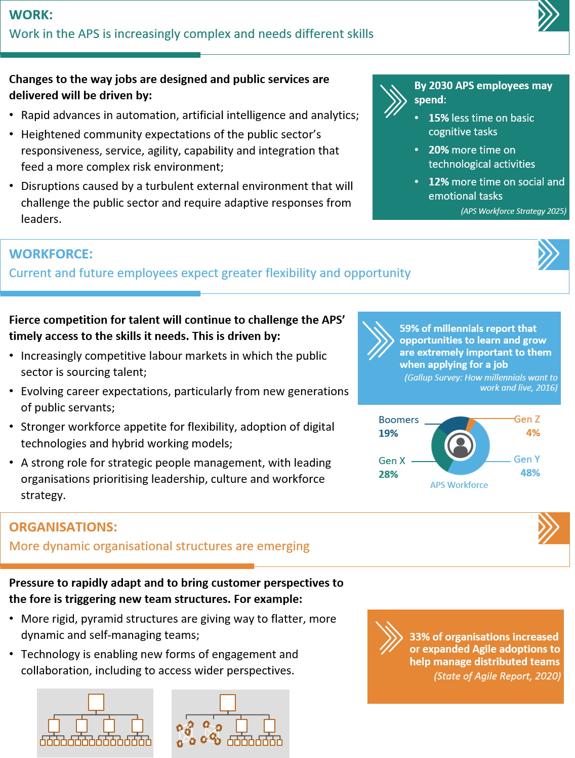

Appendix H | Fit-for-purpose team design and management

The APS can assemble fit-for-purpose teams that work collaboratively and productively during a crisis, however, finds it hard to maintain these ways of working in a business-as-usual environment. There have been successful models of task forces and rapid response or project teams – some of which use Agile approaches and some that operate with more traditional roles and structures.

There is no single preferred approach, however, it is important to acknowledge the global trend away from ‘pure’ hierarchies to improve adaptability, build links across business units and provide a higher degree of autonomy. According to a global survey, three-quarters of work across enterprises of >10,000 employees was done within hierarchical structures, and the balance in team-based structures.[45] While we do not have comparable data for the APS, the latter figure is likely to be much lower.

Even when required to maintain more traditional structures, APS leaders should use implementation of the review’s recommendations as a catalyst for adopting principles and practices of more innovative and dynamic team-based work. These include:

* **Setting the right tone from the outset.** There should be opportunities for individuals to share with others what they bring to the team, where their skills and knowledge might be best used, their preferred ways of working and their professional development goals. Leaders should actively consider what this means for providing direction and support to team members based on this information.
* **Maintaining a regular rhythm of open communication.** Team meetings should be inclusive and have agendas that enable all participants to share what they are working on and what they need from others to get the job done. There should be a preference for regular, short and relatively informal (though well-structured) meetings over less frequent, more formal sessions with one person dominating. Formal presentations to or meetings with senior supervisors should be similarly inclusive, with participation based on expertise and contribution rather than classification level.
* **Working with a ‘co-design’ mindset wherever possible.** It is far more effective to obtain senior input early in the process of problem-solving or developing a product. Where possible this should be done through sharing early thoughts and seeking reaction in the moment rather than documenting ideas   
  for written responses (which can trigger a focus on presentation and wordsmithing over pushing around ideas).
* **Actively seeking external perspectives,** rather than default to the usual stakeholders for feedback.   
  It is important to structure in opportunities to hear from front-line service delivery staff, customers and people with technical expertise. Creating a culture of open critique and feedback is crucial to countering reflexive, hierarchical responses.

Doing so will help to both lock-in the benefits experienced by many of the APS’s approach to responding to COVID-19, and help embed a less hierarchical structure with wider spans and greater recognition of individuals’ value beyond that which is indicated by their classification level.

Appendix I | Definitions and glossary

| **Term** | **Definition/Glossary** |
| --- | --- |
| **Agency** | (a) a Department; (b) an Executive Agency or (c) a Statutory Agency as defined in s7 of the *Public Service Act 1999.* |
| **Agency Head** | (a) the Secretary of a Department; or (b) the Head of an Executive Agency; or (c) the Head of a Statutory Agency as defined in s7 of the *Public Service Act 1999.* |
| [**APS Academy**](https://www.apsacademy.gov.au/) | The Academy was established in July 2021 as a networked hub to support learning and development initiatives across the APS. Its focus is core APS capabilities, including: working in government, engagement and partnership, leadership and management and strategy, policy and evaluation. |
| **APS Employment Database (APSED)** | The database collates and stores the employment data of all current and former APS employees. It is maintained by the APSC and used information provided by agencies. |
| [**APS Professions Streams**](https://www.apsc.gov.au/initiatives-and-programs/aps-professional-streams) | The APS Professional Streams are workforce development initiatives established to increase the capability of APS employees working in critical disciplines or functional areas.  There are currently three professional streams.   * **APS Data** – Launched in September 2020 to lift the capability of the workforce in generating deeper data insights to inform decision-making in policy development, programme management or service delivery. * **APS Digital** – Launched in April 2020 to lift the digital expertise of staff to meet the long term capability needs required to transform government services. * **APS Human Resources** – Launched in October 2019 this stream seeks to build and uplift strategic HR skills across the APS by identifying core, long-term capability needs, standards and career pathways. |
| **APSC** | Australian Public Service Commission |
| ***Public Service Classification Rules 2000***  **(Classification Rules)** | The Classification rules are a legislative instrument under section 23 of the *Public Service Act 1999*, outlining the APS wide framework for approved classifications in the APS, including training classifications. The assessment for each classification is based on the work value of the duties being performed. |
| **Chief Operating Officers (COO) Committee** | The Chief Operating Officers Committee is a sub-committee of the Secretaries Board. It first met in February 2020 with a remit to embed an enterprise-wide approach to APS operations and management. It is comprised of the Chief Operating Officers from all departments and major agencies. |
| **CSIRO** | Commonwealth Scientific and Industrial Research Organisation |
| [**Integrated Leadership system (ILS)**](https://www.apsc.gov.au/working-aps/aps-employees-and-managers/classifications/integrated-leadership-system-ils) | The Integrated Leadership system was launched in July 2004. It supports the building and sustainment of strong APS wide leadership and provides capability descriptions and desired behaviours for each APS level. |
| [**Independent Review of the APS**](https://www.apsreview.gov.au/about) | The aim of Independent Review of the APS was to identify reforms to ensure the APS is fit-for-purpose for the coming decades, and to guide and accelerate future reform activities. The Australian Government released the report in December 2019 and announced an ambitious APS reform agenda. |
| [**Optimal Management Structure**](https://www.apsc.gov.au/sites/default/files/2021-04/2014%20Optimal%20Management%20Structure%20Guidance.pdf) **(OMS)** | In 2014 the APSC published a framework for establishing Optimal Management Structures. This framework requires agencies to have the smallest number of organisational layers necessary to perform effectively. |
| **Secretaries Board** | Means the Secretaries Board established by s64 of the *Public Service Act 1999*. The Secretaries Board has a number of functions, it is responsible for the stewardship of the APS and for developing and implementing strategies to improve the APS.  The Secretaries Board is responsible for delivery of the APS reform program, with the Secretary of PM&C and the APS Commissioner the chief change leaders. |
| [**Senior Executive Service**](https://legacy.apsc.gov.au/senior-executive-service-ses-0) **(SES)** | SES established by s35 of the *Public Service Act 1999*. The role of the Senior Executive Service is to provide APS-wide strategic leadership of the highest quality that contributes to an effective and cohesive APS. |
| [**Work Level Standards**](https://www.apsc.gov.au/working-aps/aps-employees-and-managers/work-level-standards-aps-level-and-executive-level-classifications) **(WLS)** | WLS provide a consistent platform for classifying jobs across the APS, structured to differentiate work expected (i.e. responsibilities and duties) at each level. |
|  |  |

Appendix J | References

Australian Public Service Commission (2018) *2018 APS Agency Survey* [unpublished data set].

Australian Public Service Commission (2020) *2020 APS Agency Survey* [unpublished data set].

Australian Public Service Commission (2021) [*APS Delivering for tomorrow: APS Workforce Strategy 2025*](https://www.apsc.gov.au/sites/default/files/2021-03/APS_Workforce_strategy.pdf)*.*

Australian Public Service Commission (2021) *APS Employee Census 2021* [unpublished data set].

Australian Public Service Commission (2020) *APS Employee Census 2020* [unpublished data set].

Australian Public Service Commission (2021) [*APS Employment database (APSED)*](https://www.apsc.gov.au/employment-data/aps-employment-data-30-june-2021), APSC website.

Australian Public Service Commission (2020) [*APS Employment database (APSED)*](https://www.apsc.gov.au/employment-data/aps-employment-data-30-june-2021), APSC website.

Australian Public Service Commission (2014) [*The APS Framework for Optimal Management Structures*](https://www.apsc.gov.au/publication/optimal-management-structures),   
APSC website.

Australian Public Service Commission (2021) State of the Service Report 2020-2021, APSC website.

Commonwealth of Australia (2019) [*Our Public Service, Our Future. Independent Review of the Australian Public Service*](https://www.pmc.gov.au/resource-centre/government/independent-review-australian-public-service)*.*

Chief Executive Women (2020) [*CEW ASX200 Senior Executive Census 2020*](https://cew.org.au/wp-content/uploads/2020/09/14_CEW_ASX200-SEC-2020_V3.3-Single-Page-RGB.pdf)*.*

Commonwealth of Australia (2021) [*2021 Intergenerational Report: Australia over the next 40 years*](https://treasury.gov.au/publication/2021-intergenerational-report).

Commonwealth of Australia (2011) [*Review of the Senior Executive Service*](https://legacy.apsc.gov.au/sites/default/files/reviewofses.pdf)*.*

Commonwealth of Australia (2014) [*Towards Responsible Government ‐ Report of the National Commission of Audit: Phase Two.*](https://australianpolitics.com/downloads/budgets/2014/14-05-01_commission-of-audit-report2_phase2.pdf)

CPSU (2021)[*Submission to the Hierarchy and Classification Review*](https://app.converlens.com/apscom/hc-review/survey/list)*.*

Deloitte Research Article (2020) *Benchmarking Findings: Organization Design* [available under license].

Department of Defence (2017) [*Defence Enterprise Agreement (DEA) 2017 – 2020*](https://www.defence.gov.au/sites/default/files/2020-10/DEA-2017-2020.pdf)*,* Defence website.

Department of the Prime Minister and Cabinet (2021) [*Citizen Experience Survey*](https://www.pmc.gov.au/public-data/citizen-experience-survey/2020-2021-citizen-experience-results-summary), PM&C website.

Digital Transformation Agency (2021) [*Public Submission to the Hierarchy and Classification Review*](https://app.converlens.com/apscom/hc-review/survey/list)*.*

Gallup Report (2016) [*How Millennials Want to Work and Live,*](https://www.gallup.com/workplace/238073/millennials-work-live.aspx) Gallup.

Government of the United Kingdom (2021) [Declaration of Government Reform](https://www.gov.uk/government/publications/declaration-on-government-reform).

Gregory, S (2018) [*The Most Common Type of Incompetent Leader*](https://hbr.org/2018/03/the-most-common-type-of-incompetent-leader), Harvard Business Review*.*

Haslam, SA, Adarves-Yorno, I, Steffens, NK & Postmes, T (2019) [*Inspired and Appreciated by the Group: The Social Identity Approach to Creativity*](https://doi.org/10.1093/oxfordhb/9780190648077.013.8), The Oxford Handbook of Group Creativity and Innovation, edited by Paulus, BP & Nijstad, BA, Oxford University Press.117-131.

Jyoti, J, Chahal, H & Rani, A (2016) [*The effect of perceived high performance human resource practices on business performance: Role of organizational learning*](https://journals.sagepub.com/doi/10.1177/0972150916631193#:~:text=Results%20indicate%20that%20high%2Dperformance,HR%20practices%20and%20business%20performance.), Global Business Review, vol. 17, no. 3(supp).

Kleinman, S, Simon, P & Weerda, K (2020) [*Fitter, flatter, faster: How unstructuring your organization can unlock massive value*](https://www.mckinsey.com/business-functions/people-and-organizational-performance/our-insights/the-organization-blog/fitter-flatter-faster-how-unstructuring-your-organization-can-unlock-massive-value),McKinsey and Company.

NSW Government (2021) [*NSW Government named employer of choice among Australia's graduates*](https://www.nsw.gov.au/media-releases/nsw-government-named-employer-of-choice-among-australias-graduates) [media release], NSW Government, 12 February 2021.

Parker, SK, Morgeson, FP & Johns, G (2017) [*One hundred years of work design research: Looking back and looking forward*](https://www.futureofworkinstitute.com.au/smart-workdesign), Journal of Applied Psychology, 102(3), 403.

Professionals Australia (2021) [*Public Submission to the Hierarchy and Classification Review*](https://app.converlens.com/apscom/hc-review/survey/list)*.*

Thaler, RH & Sunstein, CR (2009) *Nudge*, Penguin.

Williamson, S, Pearce, A, Dickinson, H, Weeratunga, V & Bucknall, F (2021) [*Future of Work Literature Review: Emerging Trends and Issues*](https://www.unsw.adfa.edu.au/sites/default/files/documents/Future_of_Work_Literature_Review.pdf), UNSW.

Zoller, YJ & Muldoon, J (2020) [*Journey of a concept: span of control – the rise, the decline, and what is next?,*](https://www.emerald.com/insight/content/doi/10.1108/JMH-04-2020-0027/full/html) Journal of Management History, vol. 26, no. 4, pp. 515-533.

1. Australian Public Service Commission (2021) [*APS Employment database (APSED)*](https://www.apsc.gov.au/employment-data/aps-employment-data-30-june-2021), APSC website.
2. Australian Public Service Commission (2021) [*APS Delivering for tomorrow: APS Workforce Strategy 2025*](https://www.apsc.gov.au/sites/default/files/2021-03/APS_Workforce_strategy.pdf)*.*
3. Australian Public Service Commission (2021) [*APS Employment database (APSED)*](https://www.apsc.gov.au/employment-data/aps-employment-data-30-june-2021), APSC website.
4. Australian Public Service Commission (2021) [*State of the Service Report 2020-21*](https://www.apsc.gov.au/initiatives-and-programs/workforce-information/research-analysis-and-publications/state-service/state-service-report-2020-21), APSC website.
5. Commonwealth of Australia (2019) [*Our Public Service, Our Future. Independent Review of the Australian Public Service*](https://www.pmc.gov.au/resource-centre/government/independent-review-australian-public-service)*.*
6. Australian Public Service Commission (2021) *APS Employee Census 2021* [unpublished data set].
7. Commonwealth of Australia (2011) [*Review of the Senior Executive Service*](https://legacy.apsc.gov.au/sites/default/files/reviewofses.pdf)*.*
8. Australian Public Service Commission (2021) [*APS Employment database (APSED)*](https://www.apsc.gov.au/employment-data/aps-employment-data-30-june-2021), APSC website.
9. Gallup Report (2016) *How Millennials Want to Work and Live,* Gallup.
10. Williamson, S et al. (2021) [*Future of Work Literature Review: Emerging Trends and Issues*](https://www.unsw.adfa.edu.au/sites/default/files/documents/Future_of_Work_Literature_Review.pdf), UNSW.
11. Commonwealth of Australia (2021) [*2021 Intergenerational Report: Australia over the next 40 years*](https://treasury.gov.au/publication/2021-intergenerational-report).
12. Commonwealth of Australia (2021) [*2021 Intergenerational Report: Australia over the next 40 years*](https://treasury.gov.au/publication/2021-intergenerational-report).
13. Kleinman, S, Simon, P & Weerda, K (2020) [*Fitter, flatter, faster: How unstructuring your organization can unlock massive value*](https://www.mckinsey.com/business-functions/people-and-organizational-performance/our-insights/the-organization-blog/fitter-flatter-faster-how-unstructuring-your-organization-can-unlock-massive-value),McKinsey and Company.
14. Government of the United Kingdom (2021) [Declaration of Government Reform](https://www.gov.uk/government/publications/declaration-on-government-reform).
15. Australian Public Service Commission (2014) [*The APS Framework for Optimal Management Structures*](https://www.apsc.gov.au/publication/optimal-management-structures)*,* APSC website.
16. Department of the Prime Minister and Cabinet (2021) [*Citizen Experience Survey*](https://www.pmc.gov.au/public-data/citizen-experience-survey/2020-2021-citizen-experience-results-summary), PM&C website.
17. Commonwealth of Australia (2014) [*Towards Responsible Government ‐ Report of the National Commission of Audit: Phase Two.*](https://australianpolitics.com/downloads/budgets/2014/14-05-01_commission-of-audit-report2_phase2.pdf)
18. Commonwealth of Australia (2014) [*Towards Responsible Government ‐ Report of the National Commission of Audit: Phase Two.*](https://australianpolitics.com/downloads/budgets/2014/14-05-01_commission-of-audit-report2_phase2.pdf)
19. Australian Public Service Commission (2014) [*The APS Framework for Optimal Management Structures*](https://www.apsc.gov.au/publication/optimal-management-structures).
20. NSW Government (2021) [*NSW Government named employer of choice among Australia's graduates*](https://www.nsw.gov.au/media-releases/nsw-government-named-employer-of-choice-among-australias-graduates) [media release],   
    NSW Government, 12 February 2021.
21. Australian Public Service Commission (2020) [*APS Employment database (APSED)*](https://www.apsc.gov.au/employment-data/aps-employment-data-30-june-2021), APSC website.
22. Australian Public Service Commission (2021) [*APS Employment database (APSED)*](https://www.apsc.gov.au/employment-data/aps-employment-data-30-june-2021), APSC website. Note data excludes values less than the 5th and or greater than 95th percentile.
23. Australian Public Service Commission (2021) [*APS Employment database (APSED)*](https://www.apsc.gov.au/employment-data/aps-employment-data-30-june-2021), APSC website.
24. Haslam, SA et al. (2019) [*Inspired and Appreciated by the Group: The Social Identity Approach to Creativity*](https://doi.org/10.1093/oxfordhb/9780190648077.013.8), The Oxford Handbook of Group Creativity and Innovation, edited by Paulus, BP & Nijstad, BA, Oxford University Press.117-131.
25. Australian Public Service Commission (2021) [*APS Delivering for tomorrow: APS Workforce Strategy 2025*](https://www.apsc.gov.au/sites/default/files/2021-03/APS_Workforce_strategy.pdf)*.*
26. Parker, SK, Morgeson, FP & Johns, G (2017) [*One hundred years of work design research: Looking back and looking forward*](https://www.futureofworkinstitute.com.au/smart-workdesign), Journal of Applied Psychology, 102(3), 403.
27. Australian Public Service Commission (2021) [*APS Delivering for tomorrow: APS Workforce Strategy 2025*](https://www.apsc.gov.au/sites/default/files/2021-03/APS_Workforce_strategy.pdf)*.*
28. Australian Public Service Commission (2020) *APS Employee Census 2020* [unpublished data set].
29. CPSU (2021)[*Submission to the Hierarchy and Classification Review*](https://app.converlens.com/apscom/hc-review/survey/list)*.*
30. Australian Public Service Commission (2021) [*APS Delivering for tomorrow: APS Workforce Strategy 2025*](https://www.apsc.gov.au/sites/default/files/2021-03/APS_Workforce_strategy.pdf).
31. Professionals Australia (2021) [*Public Submission to the Hierarchy and Classification Review*](https://app.converlens.com/apscom/hc-review/survey/list)*.*
32. Digital Transformation Agency (2021) [*Public Submission to the Hierarchy and Classification Review*](https://app.converlens.com/apscom/hc-review/survey/list)*.*
33. Gregory, S (2018) [*The Most Common Type of Incompetent Leader*](https://hbr.org/2018/03/the-most-common-type-of-incompetent-leader), Harvard Business Review*.*
34. Department of Defence (2017) [*Defence Enterprise Agreement (DEA) 2017 – 2020*](https://www.defence.gov.au/sites/default/files/2020-10/DEA-2017-2020.pdf)*,* Defence website.
35. Chief Executive Women (2020) [*CEW ASX200 Senior Executive Census 2020*](https://cew.org.au/wp-content/uploads/2020/09/14_CEW_ASX200-SEC-2020_V3.3-Single-Page-RGB.pdf).
36. Global sample from Deloitte Research Article (2020) *Benchmarking Findings: Organization Design* [available under license].
37. Australian Public Service Commission (2018) *2018 APS Agency Survey* [unpublished data set].
38. Zoller, YJ & Muldoon, J (2020) [*Journey of a concept: span of control – the rise, the decline, and what is next?,*](https://www.emerald.com/insight/content/doi/10.1108/JMH-04-2020-0027/full/html) Journal of Management History, vol. 26, no. 4, pp. 515-533.
39. Government of the United Kingdom (2021) [Declaration of Government Reform](https://www.gov.uk/government/publications/declaration-on-government-reform).
40. Thaler, RH & Sunstein, CR (2009) *Nudge*, Penguin.
41. Australian Public Service Commission (2020) *2020 APS Agency Survey* [unpublished data set].
42. Australian Public Service Commission (2021) [*APS Delivering for tomorrow: APS Workforce Strategy 2025*](https://www.apsc.gov.au/sites/default/files/2021-03/APS_Workforce_strategy.pdf)*.*
43. Jyoti, J, Chahal, H & Rani, A (2016) [*The effect of perceived high performance human resource practices on business performance: Role of organizational learning*](https://journals.sagepub.com/doi/10.1177/0972150916631193#:~:text=Results%20indicate%20that%20high%2Dperformance,HR%20practices%20and%20business%20performance.), Global Business Review, vol. 17, no. 3(supp).
44. Information about agencies and location is limited to respondents who disclosed this information in their submission.
45. Deloitte Research Article (2020) *Benchmarking Findings: Organization Design* [available under license].