# [Affirmative measure for recruiting people with disability: guide for applicants](https://legacy.apsc.gov.au/affirmative-measure-recruiting-people-disability-guide-applicants)

## Apply for a job open only to people with disability

The disability affirmative measure lets Australian Public Service (APS) agencies advertise particular jobs as open only to people with disability, or a particular type of disability.

The aim is to improve representation of people with disability in the Australian Public Service (APS) by:

* promoting the right to equality and non-discrimination in employment for people with disability
* acknowledging that everyone has the right to employment, while recognising it’s sometimes necessary to provide extra support to some groups for them to enjoy their right to employment on an equal basis
* increasing the number of people with disability employed in the APS
* helping agencies meet the objectives of the [APS Disability Employment Strategy 2020-25](https://www.apsc.gov.au/publication/australian-public-service-disability-employment-strategy-2020-25)

The affirmative measure is in Section 27 of the [Australian Public Service Commissioner’s Directions 2016](https://www.legislation.gov.au/Details/F2016L01430).

## Jobs covered by the affirmative measure

Agencies can apply the disability affirmative measure to any ongoing (permanent), non-ongoing (temporary) or casual APS vacancy, regardless of the duties, including Senior Executive Service jobs.

The measure can apply to any vacancy – it is not only for jobs with a disability-related function.

It can be used for individual vacancies or bulk rounds, such as graduate recruitment rounds.

Agencies can also use the measure to recruit Disability Employment Service (DES) participants who have been assessed as likely unable to compete successfully on merit due to their disability.

### Vacancies only for people with a particular type of disability

Vacancies only for people with a particular type of disability are usually because there is a connection with the job requirements. An example is recruiting a person with vision impairment to test software accessibility.

Where appropriate, vacancies may be open only to a particular group of people with disability, who experience disproportionate employment disadvantage. For example, people with intellectual disability.

## Where to find jobs advertised under the affirmative measure

If an agency is using the measure, it will be clearly indicated in the job advertisement.

You can search for vacancies advertised under the measure on the [APSjobs website](https://www.apsjobs.gov.au/).

* On the left of the screen under ‘Refine Search’, scroll down to ‘Programs and Initiatives’.
* From this drop‑down menu, select ‘Disability Employment – Affirmative Measure Vacancy’.

This will display current vacancies open only to people with disability or a particular disability under the measure.

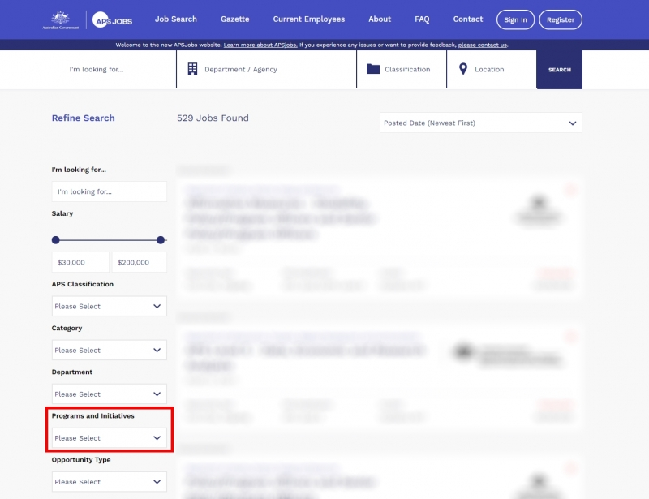

A vacancy advertised under the affirmative measure will include the following notice:

**Affirmative measure vacancy – disability employment**

The filling of this vacancy is intended to constitute an affirmative measure under Section 27 of the Australian Public Service Commissioner’s Directions 2016. This vacancy is open only to people with disability.

Agencies may also use the measure when recruiting through their temporary employment registers.

## How to apply for jobs advertised under the affirmative measure

### Follow the application information

Apply for a job by following the information the agency provides, like any other APS job application.

As well as the information on the APSjobs website, there is usually extra information on the agency's website, such as an applicant information pack. There will be a nominated contact officer, and it’s a good idea to get in touch with them if you have any questions about the job or the recruitment process.

* Prepare your application using the guidance provided in the advertisement and applicant information pack.

### Check these extra tips on applying for APS jobs

You can find general guidance on how to increase your chances of winning an APS job at [Applying for jobs in the APS](https://www.apsc.gov.au/working-aps/joining-aps).

The Australian Government’s JobAccess program also has helpful information at [Finding or changing jobs](https://www.jobaccess.gov.au/people-with-disability/available-support/151).

### Providing evidence of disability

Only people with disability or a particular type of disability are eligible for vacancies under the affirmative measure. To make sure applicants are people with disability, agencies will ask for evidence of disability.

You don’t need to include information about the type of disability – unless the vacancy is restricted to people with a particular type of disability.

You may not need to provide evidence of disability until you are shortlisted for the next stage of the application process. This means you don’t need to provide evidence unnecessarily.

Suitable evidence of a disability may be a:

* certificate or letter from a registered medical practitioner.
* letter from a Disability Employment Services or jobactive provider
* letter from a secondary or tertiary institution disability services unit in relation to a recent student.

If you need to get one of these documents, you may find it helpful to use the template below for providing evidence of eligibility for disability.

If none of these documents are available, agencies may consider accepting a statutory declaration. Contact the agency to find out what they regard as acceptable evidence.

## Definition of disability

For the purposes of the affirmative measure, ‘disability’ is defined by the Australian Bureau of Statistics in its [Survey of Disability, Ageing and Carers](http://www.abs.gov.au/ausstats/abs@.nsf/Lookup/4430.0Glossary12015).

People are considered to have a disability if they have a limitation, restriction or impairment, which has lasted, or is likely to last, for at least 6 months and restricts everyday activities.

Full details are at [Definition of disability](https://www.apsc.gov.au/working-aps/diversity-and-inclusion/disability/definition-disability).

## Privacy

Usually employees are not obliged to share information about disability with an employer unless it affects their ability to do the tasks needed to get the job done. However, for the affirmative measure, you do need to disclose that you have a disability to demonstrate you meet the eligibility requirements.

Information collected about disability is regarded as ‘sensitive information’ for the purposes of the Privacy Act 1988. This means agencies need your consent to collect or share the information.

## Accessibility and adjustments

Agencies have to provide reasonable adjustments or flexibilities in the recruitment process to applicants with disability.

For example, this could include providing:

* an Auslan interpreter for an applicant who is hearing impaired
* extra reading time during assessment activities for a person with learning difficulties
* accessible software for a person with vision impairment.

The applicant information pack should clearly state that reasonable adjustments are available if requested and include details of a contact person who can assist you. Usually, this is the nominated contact officer for the job.

Any online application and assessment processes should be fully accessible. If you have any difficulty or need alternative formats, get in touch with the contact officer.

Inform the contact officer of any reasonable adjustments you need during the application process, and make sure you let them know in advance about any adjustments you need if you’re shortlisted for further assessment (such as video interview, panel interview or assessment centre).

If you get the job, reasonable adjustments can also be made to assist you in the job.

## Contact details

### Job contact officer

The contact officer listed in the job advertisement can answer your questions.

### JobAccess Advisers

JobAccess Advisers may be able to assist with information about getting a public service job or accessing other services. This includes the Employment Assistance Fund, which can provide reasonable adjustments for job seekers and employees.

For more information:

* call JobAccess Advisers on 1800 464 800
* visit [Free support to find or keep a job](https://www.jobaccess.gov.au/people-with-disability/free-support-find-or-keep-job)
* visit [Employment Assistance Fund Guidelines](https://www.jobaccess.gov.au/employment-assistance-fund-eaf)

### RecruitAbility scheme

The RecruitAbility scheme to improve job prospects of people with disability.

For more information:

* [RecruitAbility scheme: guide for applicants](https://www.apsc.gov.au/working-aps/diversity-and-inclusion/disability/recruitability)

### Affirmative measure

For more information on the affirmative measure in Section 27 of the Australian Public Service Commissioner’s Directions 2016:

* email the APSC Diversity and Inclusion Policy Team at [diversity@apsc.gov.au](mailto:diversity@apsc.gov.au).

### DES providers

The Australian Government funds a national network of private and not-for-profit organisations to support people with disability to prepare for, find and keep a job. These organisations are known as Disability Employment Services (DES) providers.

For more information:

* visit the [Australian Government jobactive website](https://jobsearch.gov.au/serviceproviders/search?jsk=1)
* phone 1800 464 800
* use the [JobAccess online enquiry form](https://www.jobaccess.gov.au/contacts/online-enquiry-form).

**Last reviewed:**

16 July 2021

# Template for providing evidence of eligibility for disability employment affirmative measure

Name of person certifying eligibility:______________________________________________

Organisation/business name: ___________________________________________________

I am:

* a registered medical practitioner, registration number:
* employed in the disability services unit of a University/TAFE/school
* other, please describe: _____________________________________________________

I hereby certify that, according to records held in this office, [insert applicant name] meets the definition of disabilityapplicable to the Australian Public Service Affirmative Measure – Disability Employment.

Signature: __________________________________________________

Date: ______________________________________________________

## Disability definition

People are considered to have a disability if they have a limitation, restriction or impairment, which has lasted, or is likely to last, for at least 6 months and restricts everyday activities.

Full details are listed below and at [Definition of disability](https://www.apsc.gov.au/working-aps/diversity-and-inclusion/disability/definition-disability).

### Disability groups

##### **Sensory**

* loss of sight (not corrected by glasses or contact lenses)
* loss of hearing where communication is restricted, or an aid to assist with, or substitute for, hearing is used
* speech difficulties.

##### **Intellectual**

* difficulty learning or understanding things.

##### **Physical**

* shortness of breath or breathing difficulties that restrict everyday activities
* blackouts, seizures or loss of consciousness
* chronic or recurrent pain or discomfort that restricts everyday activities
* incomplete use of arms or fingers
* difficulty gripping or holding things
* incomplete use of feet or legs
* restriction in physical activities or in doing physical work
* disfigurement or deformity.

##### **Psychosocial**

* nervous or emotional condition that restricts everyday activities
* mental illness or condition requiring help or supervision
* memory problems or periods of confusion that restrict everyday activities
* social or behavioural difficulties that restrict everyday activities.

##### **Head injury, stroke or acquired brain injury**

* head injury, stroke or other acquired brain injury, with long-term effects that restrict everyday activities.

##### **Other**

* receiving treatment or medication for any other long-term conditions or ailments and still restricted in everyday activities
* any other long-term conditions resulting in a restriction in everyday activities.

**Last reviewed:**

16 July 2021