Participant Information

## 2022 APS Employee Census

This Participant Information Sheet tells you about the 2022 APS Employee Census (Census). It explains what is involved with participating and will help you decide if you want to participate. Please read this information carefully and should you have any questions about anything that you don’t understand or want to know more about, please contact your agency Census coordinator in the first instance, or alternatively the contact details below.

Participation in the Census is voluntary; there is no obligation to take part. If you choose not to participate there will be no detriment to your career. However, the more people who respond, the more representative and useful the results will be.

What is the purpose of this Census?

The purpose of this Census is to understand your views on, and experiences of working in, your agency and the broader Australian Public Service (APS).

Agencies use Census data to inform programs and planning, and for monitoring trends. This information also allows agencies to assess how well they are tracking against other agencies and the APS more generally. The responses you provide will assist the Australian Public Service Commissioner to evaluate the state of the APS. The Census results are presented on the Australian Public Service Commission website and in the annual State of the Service Report. The Census results also help the development and evaluation of strategies to build APS workforce capability now and into the future.

Who is conducting the Census?

The Australian Public Service Commission (APSC) is conducting this Census with assistance from your agency and Engine, an external service provider.

What do I need to do?

Participation involves completion of an online survey which is expected to take approximately 30 minutes. You may complete part of the Census in one session and return to it later. Each employee receives an invitation containing a unique link to the survey. Completion time is dependent upon your personal work circumstances. You may need only 20 minutes to complete the census, or it may take you around 40 minutes should you have more information you wish to convey. If you choose to exit before completing you can use the link in your email invitation to return to the survey.

Alternative response submission options (such as verbal response submission) are available if required by contacting the survey provider via email at [SupportAU@enginegroup.com](mailto:SupportAU@enginegroup.com) or on 1800 065 312.

How was I identified to participate?

You were identified by your agency to participate in the Census. The names, Australian Government Staff (AGS) numbers and email addresses of all APS employees were provided by your agency for the purpose of sending the Census to all APS employees. Only Engine, the external service provider, will be able to link your Census response with your unique identifiers such as AGS number and your email address. You can request to be removed from the list by contacting the APSC at [APSSurveys@apsc.gov.au](mailto:stateoftheservice@apsc.gov.au).

Is my participation voluntary?

Yes, your participation is completely voluntary. You can choose not to participate without having to provide a reason for doing so or experience any disadvantage as a result of your decision. With the exception of four demographic questions (gender, age, state/territory of your workplace, and actual classification), you may skip any question you do not wish to answer.

If you wish to withdraw your already recorded survey responses, you are free to do so up until the end of the survey administration period (5pm AEST, 10 June 2022) by contacting the APSC on 1800 464 926 or [APSSurveys@apsc.gov.au](mailto:stateoftheservice@apsc.gov.au). If you withdraw, your responses will not be saved or contribute to any analysis or reports.

What are the benefits of participating?

By completing this survey you have an opportunity to provide feedback to your agency and the APSC. Agencies and the APSC will use the results of this survey to inform planning and initiatives. By better understanding the views and experiences of their workforce, agencies and the APSC will be better positioned to evaluate, revise and/or improve the working conditions and environment for you and your colleagues.

What are the risks in participating?

Due to the general nature of the survey questions, it is not anticipated that you will experience any discomfort when participating in this activity. Should you feel uncomfortable at any point during the survey, you are free to not answer the relevant questions or stop the survey by closing the web page. If you require assistance, please contact the services offered by your agency’s employee assistance program. Alternatively, you can contact an external support service such as:

* Lifeline: Ph. 13 11 14; <https://www.lifeline.org.au/>
* Beyondblue: Ph. 1300 224 636; <https://www.beyondblue.org.au/>
* Mensline: Ph. 1300 789 978; <https://mensline.org.au/>
* QLife: Ph. 1800 184 527; <https://qlife.org.au/>
* Suicide Call Back Service: Ph. 1300 659 467; <https://www.suicidecallbackservice.org.au/>
* Australian Government Health Direct: <https://healthdirect.gov.au/mental-health-helplines>

Will my answers be disclosed to anyone?

The APSC and Engine report de-identified and aggregated Census results which are made available to agencies and other parties (examples are provided in Figures 1 and 2). Results are reported for groups of respondents. Groups can be formed by a combination of demographic information (such as age group, gender or classification level) and/or where the respondent works within an agency. Agencies may also publicly release reports of their APS Employee Census results. These reports will be at the whole-of-agency level. Agency level reports for 2021 may be viewed at [APS Employee Census 2021 | Australian Public Service Commission (apsc.gov.au)](https://www.apsc.gov.au/initiatives-and-programs/workforce-information/aps-employee-census-2021).

The APSC may provide agencies and external parties with de-identified datasets of results. Responses within these datasets will not be reasonably attributable to any specific individual. There are strict filters in place so that when less than 10 employees respond, no data is displayed in an agency’s online Census reporting portal. Figure 1 provides an example of how data is displayed, on the online portal, and the last two columns show that there are insufficient responses for a group. Figure 2 provides an example of how data is displayed in an agency highlights report. While there is no way to see an individual’s entire survey responses, if you are part of a group or agency that achieves a 100% response rate, and 100% of those individuals respond the same way on a single item then your response can be attributed to you.

Figure 1 Agency results by gender

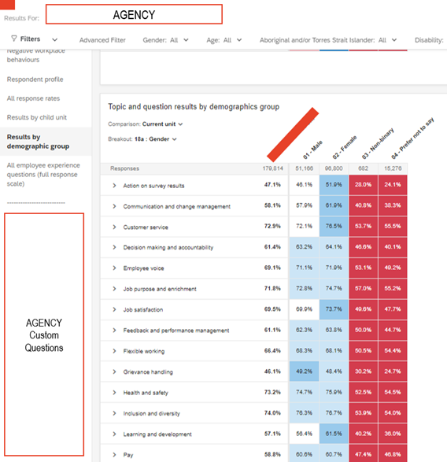

Figure 2 Agency highlights report

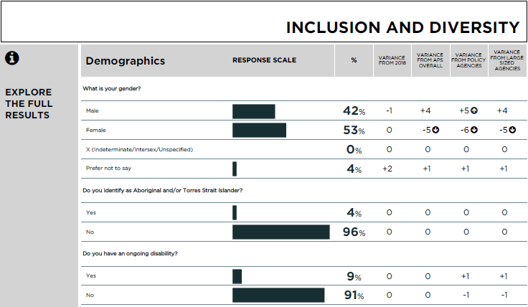

There are free-text questions throughout the Census where you can comment on specific issues. In answering these questions, please do not provide personal information about yourself or any other person, for example by including their name or position in your response. These comments will be reported verbatim (word for word, exactly as written) and made available to your agency and external parties. However, free-text comments will only be attributable to particular groups where there are 30 or more comments from members of that group. For example, if an organisation unit has less than 30 respondents the free text questions will not be shown for that work group.

How is my information stored?

Your information will be stored securely by Engine. Engine employs data management systems and a security policy which are ISO 27001 (Information Security Management System) certified. Engine use the Qualtrics survey platform to administer the Census. Employee data including email addresses are held securely within the Qualtrics survey platform.

Engine provide de-identified, individual-level survey data to the APSC, which is stored on the APSC's information and communications technology (ICT) infrastructure in accordance with the APSC's ICT security policies and practices. Access to data is restricted according to a range of end-user access-level profiles, and only staff with a need-to-know are granted access on a secure system.

Restricted aggregated datasets that ensure employees’ privacy will be available to agencies via an online reporting tool. Item-level de-identified data will be available to the wider public at data.gov.au.

In order to obtain any dataset of de-identified data, agencies and other parties will agree to store the data in a manner consistent with the Australian Privacy Principles. [The APSC Privacy Policy (Part B)](https://www.apsc.gov.au/apsc-privacy-policy-part-b), provides more detailed information about how your data is collected and maintained.

De-identified datasets will be uploaded to data.gov.au in accordance with the [Australian Government Public Data Policy](https://pmc.gov.au/public-data/public-data-policy).

De‑identification of data is undertaken in accordance with guidance provided by the [Office of the Australian Information Commissioner](https://www.oaic.gov.au/agencies-and-organisations/guides/de-identification-and-the-privacy-act).

**Where do I go if I still have questions or complaints?**

If you have any further questions or wish to make a complaint, please contact your agency Census coordinator in the first instance, alternatively, please contact the APSC on 1800 464 926 or at [APSSurveys@apsc.gov.au](mailto:stateoftheservice@apsc.gov.au).