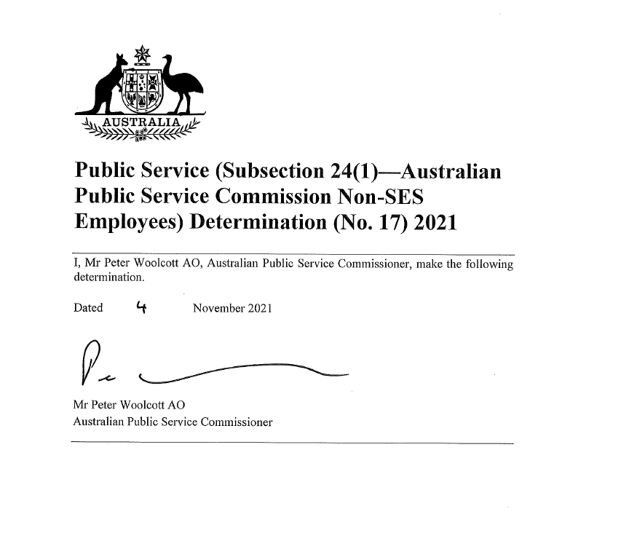

**NOTE:**

This determination has been amended as at 13 October 2022 to reflect a 3% wage increase effective 8 November 2022.

These amendments are reflected in Section 9 and Schedule 2.

This determination should be read in conjunction with the   
*Australian Public Service Commission Enterprise Agreement 2018-21*.

Contents

1 Name 1

2 Commencement 1

3 Authority 1

4 Application 1

5 Definitions 1

6 Purpose 1

7 Period of operation 1

8 First annual adjustment of salary and allowances 2

9 Second annual adjustment of salary and allowances 2

10 Third annual adjustment of salary and allowances 2

Schedule 1—First annual adjustment—Salary and allowances from Monday, 8 November 2021 4

1 Salary 4

2 Allowances 5

Schedule 2—Second annual adjustment—Salary and allowances on, 8 November 2022 6

1 Salary 6

2 Allowances 7

Schedule 3—Third annual adjustment—Salary and allowances from Wednesday, 8 November 2023 8

1 Salary 8

2 Allowances 9

1 Name

This determination is the *Public Service (Subsection 24(1)—Australian Public Service Commission Non-SES Employees) Determination (No.17) 2021*.

2 Commencement

This determination commences on the date it is signed.

3 Authority

This determination is made under subsection 24(1) of the *Public Service Act* *1999*.

4 Application

This determination applies to non‑SES employees employed in the Australian Public Service Commission under the *Public Service Act* *1999* who are covered by the Australian Public Service Commission Enterprise Agreement.

5 Definitions

In this determination:

***Australian Public Service Commission Enterprise Agreement*** means the enterprise agreement approved by the Fair Work Commission on 31 October 2018 and known as the Australian Public Service Commission Enterprise Agreement 2018-21.

6 Purpose

The purpose of this determination is to adjust employees’ salaries and allowances for which they are eligible under the terms of the Australian Public Service Commission Enterprise Agreement.

7 Period of operation

This determination is in force for the period:

(a) beginning at the start of the day this determination commences; and

(b) ending at the earlier of the following:

(i) the start of the day that an enterprise agreement made in accordance with the *Fair Work Act 2009* that covers the employees and replaces the Australian Public Service Commission Enterprise Agreement commences operation;

(ii) the start of the day that another determination under subsection 24(1) of the *Public Service Act* *1999* that applies to the employees and revokes this determination comes into force.

8 First annual adjustment of salary and allowances

(1) Employees’ salaries are adjusted by 1.9%, with effect from Monday, 8 November 2021.

(2) Each adjustment is to be calculated based on the salary immediately before the adjustment under subsection (1).

(3) First Aid, Departmental Liaison Officer and work outside standard bandwidth allowances are adjusted by the same percentage as salaries, with effect from Monday, 8 November 2021.

(4) Each adjustment of an allowance is to be calculated based on the allowance immediately before the adjustment under subsection (3).

(5) Schedule 1 has effect.

9 Second annual adjustment of salary and allowances

1. Employees’ salaries are adjusted by 3% with effect on 8 November 2022.

(2) Each adjustment is to be calculated based on the salary immediately before the adjustment under subsection (1).

(3) First Aid, Departmental Liaison Officer and work outside standard bandwidth allowances are to be adjusted by the same percentage as salaries, with effect on 8 November 2022.

(4) Each adjustment of an allowance is to be calculated based on the allowance immediately before the adjustment under subsection (3).

(5) Schedule 2 has effect.

(6) Employees who have had their salary maintained above the relevant salary range published in Column 2 of Schedule 2 for their classification (consistent with clause 38 of the Australian Public Service Commission Enterprise Agreement), will receive the adjustment under subsection (1).

1. This section and Schedule 2 have effect despite section 8 and Schedule 1.

10 Third annual adjustment of salary and allowances

1. Employees’ salaries are to be adjusted by X% with effect from Wednesday, 8 November 2023.

Note: The applicable percentage adjustment in salary will be inserted in Year 3 in line with the most recently published annual June Private Sector WPI% as described in the Public Sector Workplace Relations Policy 2020.

(2) Each adjustment is to be calculated based on the salary immediately before the adjustment under subsection (1).

(3) First Aid, Departmental Liaison Officer and work outside standard bandwidth allowances are to be adjusted by the same percentage as salaries, with effect from the Wednesday, 8 November 2023.

(4) Each adjustment of an allowance is to be calculated based on the allowance immediately before the adjustment under subsection (3).

(5) Schedule 3 is to be changed to reflect the adjustments.

Schedule 1—First annual adjustment—Salary and allowances from Monday, 8 November 2021

1 Salary

From Monday, 8 November 2021, salary for an employee covered by column 1 of an item of the following table at a pay point described in column 2 of the item is payable at the rate for that pay point (the ***new rate***) described in column 3 of the table. This is an adjustment of 1.9% under subsection 8(1) of this determination.

| Salary from Monday, 8 November 2021 | | | |
| --- | --- | --- | --- |
| Item | Column 1 Salary Pay Point | Column 2 Salary amount applicable before commencement of this determination | Column 3 Salary amount applicable from Monday, 8 November 2021 |
| 1 | EL 2.7 | $149,195 | $152,030 |
| 2 | EL 2.6 | $147,774 | $150,582 |
| 3 | EL 2.5 | $145,737 | $148,506 |
| 4 | EL 2.4 | $142,928 | $145,644 |
| 5 | EL 2.3 | $140,269 | $142,934 |
| 6 | EL 2.2 | $135,582 | $138,158 |
| 7 | EL 2.1 | $132,711 | $135,233 |
| 8 | EL 1.7 | $121,305 | $123,610 |
| 9 | EL 1.6 | $120,137 | $122,420 |
| 10 | EL 1.5 | $117,207 | $119,434 |
| 11 | EL 1.4 | $115,516 | $117,711 |
| 12 | EL 1.3 | $111,572 | $113,692 |
| 13 | EL 1.2 | $108,417 | $110,477 |
| 14 | EL 1.1 | $105,839 | $107,850 |
| 15 | APS 6.3 | $94,386 | $96,179 |
| 16 | APS 6.2 | $90,522 | $92,242 |
| 17 | APS 6.1 | $86,940 | $88,592 |
| 18 | APS 5.3 | $83,510 | $85,097 |
| 19 | APS 5.2 | $79,937 | $81,456 |
| 20 | APS 5.1 | $76,363 | $77,814 |
| 21 | APS 4.3 | $73,254 | $74,646 |
| 22 | APS 4.2 | $69,091 | $70,404 |
| 23 | APS 4.1 | $68,056 | $69,349 |
| 24 | APS 3.2 | $63,719 | $64,930 |
| 25 | APS 3.1 | $61,796 | $62,970 |
| 26 | APS 2.3 | $59,167 | $60,291 |
| 27 | APS 2.2 | $55,231 | $56,280 |
| 28 | APS 2.1 | $53,043 | $54,051 |
| 29 | APS 1.2 | $48,028 | $48,941 |
| 30 | APS 1.1 | $46,428 | $47,310 |

| Training Classification from Monday, 8 November 2021 | | | |
| --- | --- | --- | --- |
| Item | Column 1 Salary Pay Point | Column 2 Salary amount applicable before commencement of this determination | Column 3 Salary amount applicable from Monday, 8 November 2021 |
| 1 | Graduate APS | $61,796 | $62,970 |
| 2 | Trainee APS | $46,428 | $47,310 |
| 3 | Cadet APS | $31,106 | $31,697 |

2 Allowances

From Monday, 8 November 2021, an allowance described in column 1 of an item of the following table is payable at the rate (the ***new rate***) described in column 3 of the table. This is an adjustment of 1.9% under subsection 8(3) of this determination.

| Allowances from Monday, 8 November 2021 |
| --- |

| Item | Column 1 | Column 2 Rate of allowance applicable before commencement of this determination | Column 3 Rate of allowance applicable from Monday, 8 November 2021 |
| --- | --- | --- | --- |
| 1 | Payment outside standard bandwidth | $85.00 | $86.61 |
| 2 | First Aid | $26.47 | $26.97 |
| 3 | Departmental Liaison Officer | $18,223 | $18,569 |

Schedule 2—Second annual adjustment—Salary and allowances on 8 November 2022

1 Salary

On, 8 November 2022, salary for an employee covered by column 1 of an item of the following table at a pay point described in column 2 of the item is to be payable at the rate for that pay point (the ***new rate***) described in column 3 of the table. This is an adjustment of 3% under subsection 9(1).

| Salary on 8 November 2022 | | | |
| --- | --- | --- | --- |
| Item | Column 1 Salary Pay Point | Column 2 Salary amount applicable before commencement of this schedule | Column 3 Salary amount applicable on 8 November 2022 |
| 1 | EL 2.7 | $152,030 | $156,591 |
| 2 | EL 2.6 | $150,582 | $155,099 |
| 3 | EL 2.5 | $148,506 | $152,961 |
| 4 | EL 2.4 | $145,644 | $150,013 |
| 5 | EL 2.3 | $142,934 | $147,222 |
| 6 | EL 2.2 | $138,158 | $142,303 |
| 7 | EL 2.1 | $135,233 | $139,290 |
| 8 | EL 1.7 | $123,610 | $127,318 |
| 9 | EL 1.6 | $122,420 | $126,093 |
| 10 | EL 1.5 | $119,434 | $123,017 |
| 11 | EL 1.4 | $117,711 | $121,242 |
| 12 | EL 1.3 | $113,692 | $117,103 |
| 13 | EL 1.2 | $110,477 | $113,791 |
| 14 | EL 1.1 | $107,850 | $111,086 |
| 15 | APS 6.3 | $96,179 | $99,064 |
| 16 | APS 6.2 | $92,242 | $95,009 |
| 17 | APS 6.1 | $88,592 | $91,250 |
| 18 | APS 5.3 | $85,097 | $87,650 |
| 19 | APS 5.2 | $81,456 | $83,900 |
| 20 | APS 5.1 | $77,814 | $80,148 |
| 21 | APS 4.3 | $74,646 | $76,885 |
| 22 | APS 4.2 | $70,404 | $72,516 |
| 23 | APS 4.1 | $69,349 | $71,429 |
| 24 | APS 3.2 | $64,930 | $66,878 |
| 25 | APS 3.1 | $62,970 | $64,859 |
| 26 | APS 2.3 | $60,291 | $62,100 |
| 27 | APS 2.2 | $56,280 | $57,968 |
| 28 | APS 2.1 | $54,051 | $55,673 |
| 29 | APS 1.2 | $48,941 | $50,409 |
| 30 | APS 1.1 | $47,310 | $48,729 |

| Training Classification on 8 November 2022 | | | |
| --- | --- | --- | --- |
| Item | Column 1 Salary Pay Point | Column 2 Salary amount applicable before commencement of this schedule | Column 3 Salary amount applicable on 8 November 2022 |
| 1 | Graduate APS | $62,970 | $64,859 |
| 2 | Trainee APS | $47,310 | $48,729 |
| 3 | Cadet APS | $31,697 | $32,648 |

2 Allowances

On 8 November 2022, an allowance described in column 1 of an item of the following table is to be payable at the rate (the ***new rate***) described in column 3 of the table. This is an adjustment of 3% under subsection 9(1) of this determination.

| Allowances on 8 November 2022 | | | |
| --- | --- | --- | --- |
| Item | Column 1 Insert name of allowance | Column 2 Rate of allowance applicable before commencement of this schedule | Column 3 Rate of allowance applicable on 8 November 2022 |
| 1 | Payment outside standard bandwidth | $86.61 | $89.21 |
| 2 | First Aid | $26.97 | $27.78 |
| 3 | Departmental Liaison Officer | $18,569 | $19,126 |

Schedule 3—Third annual adjustment—Salary and allowances from Wednesday, 8 November 2023

1 Salary

From Wednesday, 8 November 2023, salary for an employee covered by column 1 of an item of the following table at a pay point described in column 2 of the item is to be payable at the rate for that pay point (the ***new rate***) described in column 3 of the table. This is an adjustment of X% under subsection 10(1) of this determination.

| Salary from Wednesday, 8 November 2023 | | | |
| --- | --- | --- | --- |
| Item | Column 1 Salary Pay Point | Column 2 Salary amount applicable before commencement of this schedule | Column 3 Salary amount applicable from Wednesday, 8 November 2023 |
| 1 | EL 2.7 |  |  |
| 2 | EL 2.6 |  |  |
| 3 | EL 2.5 |  |  |
| 4 | EL 2.4 |  |  |
| 5 | EL 2.3 |  |  |
| 6 | EL 2.2 |  |  |
| 7 | EL 2.1 |  |  |
| 8 | EL 1.7 |  |  |
| 9 | EL 1.6 |  |  |
| 10 | EL 1.5 |  |  |
| 11 | EL 1.4 |  |  |
| 12 | EL 1.3 |  |  |
| 13 | EL 1.2 |  |  |
| 14 | EL 1.1 |  |  |
| 15 | APS 6.3 |  |  |
| 16 | APS 6.2 |  |  |
| 17 | APS 6.1 |  |  |
| 18 | APS 5.3 |  |  |
| 19 | APS 5.2 |  |  |
| 20 | APS 5.1 |  |  |
| 21 | APS 4.3 |  |  |
| 22 | APS 4.2 |  |  |
| 23 | APS 4.1 |  |  |
| 24 | APS 3.2 |  |  |
| 25 | APS 3.1 |  |  |
| 26 | APS 2.3 |  |  |
| 27 | APS 2.2 |  |  |
| 28 | APS 2.1 |  |  |
| 29 | APS 1.2 |  |  |
| 30 | APS 1.1 |  |  |

| Training Classification from Monday, 8 November 2023 | | | |
| --- | --- | --- | --- |
| Item | Column 1 Salary Pay Point | Column 2 Salary amount applicable before commencement of this schedule | Column 3 Salary amount applicable from Wednesday, 8 November 2023 |
| 1 | Graduate APS |  |  |
| 2 | Trainee APS |  |  |
| 3 | Cadet APS |  |  |

2 Allowances

From Wednesday, 8 November 2023, an allowance described in column 1 of an item of the following table is to be payable at the rate (the ***new rate***) described in column 3 of the table. This is an adjustment of X% under subsection 10(3) of this determination.

| Allowances from Wednesday, 8 November 2023 | | | |
| --- | --- | --- | --- |
| Item | Column 1 | Column 2 Rate of allowance applicable before commencement of this schedule | Column 3 Rate of allowance applicable from Wednesday, 8 November 2023 |
| 1 | Payment outside standard bandwidth |  |  |
| 2 | First Aid |  |  |
| 3 | Departmental Liaison Officer |  |  |