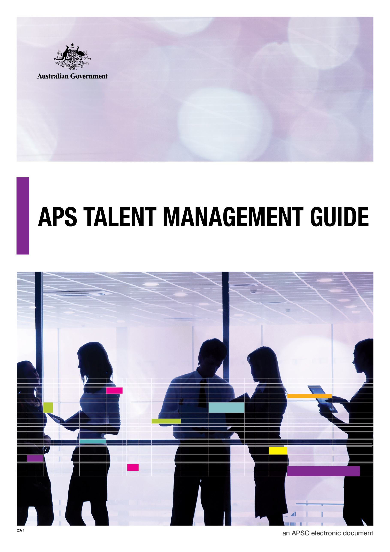

**© Commonwealth of Australia January 2015**

All material produced by the Australian Public Service Commission (the Commission), constitutes Commonwealth copyright administered by the Commission. The Commission reserves the right to set out the terms and conditions for the use of such material.

Apart from any use permitted under the Copyright Act 1968, and those explicitly granted herein, all other rights are reserved.

Contents

Part A: Talent Management Principles 1

1. What do we mean by ‘Talent’? 1

2. What is Talent Management? 1

3. Benefits of Talent Management 1

4. Principles of Talent Management 2

5. The Talent Management System 3

6. Arrangements to Manage Talent 4

Part B: Talent Management Practices 6

1. Talent Attraction and Identification 6

1.1 Attracting external talent 6

1.2 Identifying internal talent 7

1.3 Bringing performance and potential together 12

2. Talent Development 15

2.1 The role of development 15

2.2 Types of development 15

2.3 Planning for development 16

2.4 Mobility: placements and secondments 17

3. Talent Engagement 18

3.1 Why engagement is important 18

3.2 What is talent engagement? 18

3.3 Keeping talent engaged 18

3.4 Talent tracking 20

4. Talent Deployment 21

4.1 What does deployment mean? 21

4.2 The role of succession planning 21

4.3 Supporting deployment to new roles 22

5. Governance Arrangements for Managing Talent 23

5.1 The Talent Council 23

# Part A: Talent Management Principles

## 1. What do we mean by ‘Talent’?

Talent consists of those individuals with the performance and potential to make a significant difference to agency performance in the APS now, and in the longer term[1].

The concept of high potential is central to the notion of talent. It refers to the capacity of an individual to move into - and succeed in - roles of greater complexity, ambiguity and scale in the future.

Although all people have inherent talents, specific focus is given to those identified as high potential talent.

## 2. What is Talent Management?

Talent management is the systematic attraction, identification, development, engagement, retention and deployment of those individuals who are of particular value to the APS because of their high potential for the future[2].

Talent management is a key business strategy and an investment in the future capability of the APS. Taking a systematic approach to managing the career growth of high potential employees can help ensure the APS has the right people ready for critical roles now and in the future.

## 3. Benefits of Talent Management

Recent research[3] lends support for a focus on talent management. Some of the tangible business outcomes identified in the research include:

* The creation of a robust leadership bench strength that supports the organisation’s succession planning for key positions
* Improved retention and engagement of high potential employees with business critical skills
* Greater customer satisfaction and overall better market performance, compared to organisations that do not actively manage talent.

A study by the Corporate Executive Board[4] in 2014 highlighted the criticality of high potential individuals, finding that these employees are almost twice as valuable to an organisation compared with those who are not found to be high potential. This study also found that only 15% of an organisation’s highest performing employees can develop and adapt enough to succeed in more senior, complex roles.

Talent management helps to identify that 15% and ensure they are positioned to take up critical roles. It can also help to ensure the other 85% of high performing employees remain strong contributors to the agency and are in roles which support them to contribute their best.

For the APS, a systematic approach to talent management is critical to building a more agile and responsive institution that is better able to serve government as it makes progress on a range of complex issues for the nation. It makes good business sense to engage the best and brightest individuals in the work of the APS, and, through targeted career development, position them for critical roles in the future. It is the key to sustainable agency performance.

## 4. Principles of Talent Management

Three principles underpin effective talent management in the APS:

* **Talent management is owned and led by APS leaders,** who are actively engaged in the process with a view to the longer term interests of their agency and the wider APS. Senior leaders, as stewards of the APS, have a particular leadership role to play in driving effective talent management in their agency and across the APS.
* **The identification of talent is based on valid and objective assessment**, ensuring the right people are receiving the right development and focus at specific times in their career. This is consistent with the notion of merit.
* **Talent management is systematic and dynamic:**
  + The process involvesregular and active identification, planning and monitoring of high potential individuals: who they are, how they are being developed, the career ‘next steps’ that will best help them realise their potential.
  + The process also recognises that an assessment of potential may change over time depending on an individual’s circumstances or career stage. As such, potential is regularly monitored and reassessed.

## 5. The Talent Management System

In the APS, corporate and strategic workforce planning processes inform the focus for talent management. Corporate plans set the strategic direction for an agency and its key priorities and objectives[5]. Workforce planning assesses the workforce requirements to deliver on strategic priorities, including the roles that are critical to successful delivery. These roles may be generic, for example senior management or technical roles (for example chief finance officer roles).

Talent management focuses on individuals with the potential to successfully undertake these critical roles now and in the future. There are four elements to the system:

1. **Talent attraction and identification:**  Sourcing external talent or identifying internal talent with the capacity to be successful in critical roles in the future.
2. **Talent development**: Making a targeted investment in the development of talented employees to build their capability for future roles.
3. **Talent engagement:** Maintaining the engagement of talented employees with the APS, and retaining them, through career management, ongoing development and retention strategies.
4. **Talent deployment:** Actively drawing on identified talent to fill critical workforce gaps. This involves the placement of talented individuals in either short-term roles (critical projects/taskforces) or in long-term positions in line with career aspirations and business needs.

The full talent management system can be seen in Figure 1. Each step is then covered in more detail in **Part B** of this guide.

## 6. Arrangements to Manage Talent

For talent management to work effectively, it is important to have a clearly established mechanism for senior managers to come together regularly to discuss talent. This can be across the APS or within an agency. This mechanism can take the form of:

* A Talent Council or equivalent talent specific council or group
* A regular talent agenda item as part of an existing Executive Committee forum.

These types of mechanisms allow for an appropriate level of discussion of talent, ensuring decisions can be made with a view to the strategic directions of the agency, its best long-term interests and the interests of high potential individuals. Decisions about talent can also be made at a level where there is agency support for their implementation, for example, a decision to place a high potential individual in another role to broaden their skills base and experience.

Talent discussions at the senior manager level need to be supported by the Human Resource function. The HR function can provide information and advice on the identification, development, and career progression for high potential individuals. This can be supported by talent tracking and monitoring tools which are available on existing HR systems or can be procured as specialised software. Depending on the size of the talent pool being managed, a simple spreadsheet can also be an effective and low cost monitoring tool.

Further information on the arrangements for managing talent can be found in **Part B, section 5** of this guide.

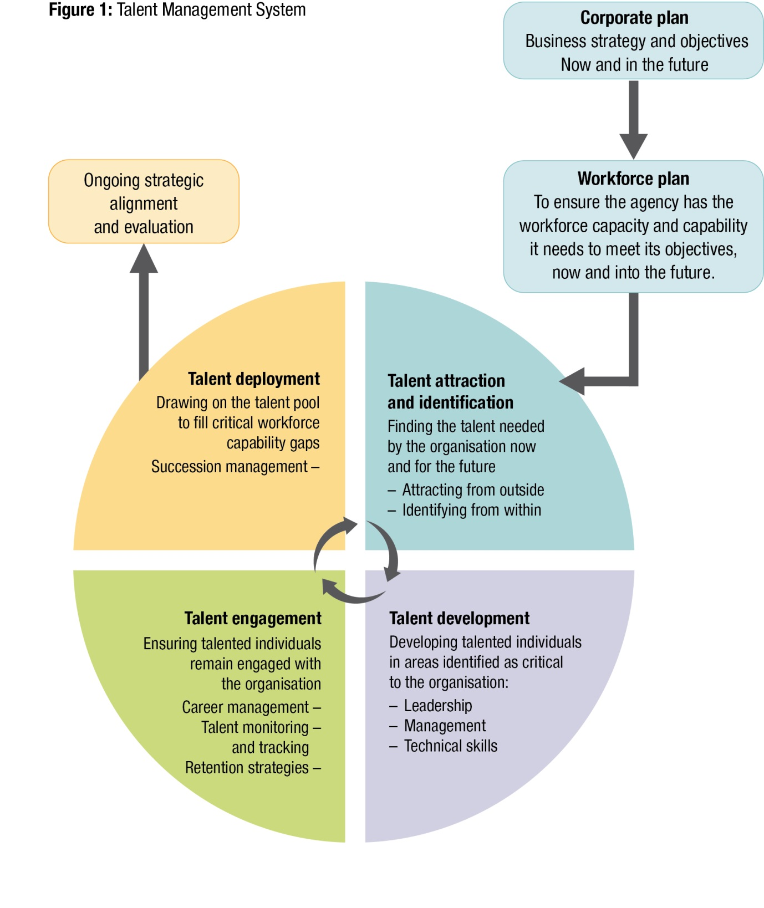

# Part B: Talent Management Practices

## 1. Talent Attraction and Identification

There are two key ways to build an agency’s pool of talented employees: recruiting external talent from the labour market or identifying talent within the agency’s existing workforce. Most organisations used a mix of both approaches to build a talent pool able to fill a range of critical roles.

### 1.1 Attracting external talent

Attracting talent means recruiting the best, brightest and most respected individuals to a career in the APS. External talent attraction aims to grow the breadth of the existing talent pool by bringing in individuals with business critical skills and experiences, fresh enthusiasm for the agency’s work and the potential for career growth. Research[6] suggests the benefits of recruiting talented employees include higher employee engagement, better retention rates and lower staffing costs through reduced absence or performance management.

The [**APS Recruitment Guidelines**](http://www.apsc.gov.au/__data/assets/pdf_file/0013/51232/recruitment-guidelines.pdf) contain information on tailoring recruitment processes to find the best employees**.** Social media and global networks are dramatically changing the way that organisations attract the most talented employees. According to recent research[7], effective talent attraction strategies that organisations should consider in the age of social media include:

* **Treating recruitment like marketing.** How an organisation is perceived matters when competing for talent. Today, 48% of candidates are trying to work out if your organisation fits with their values and 31% are looking for information on ‘culture’[8]. Attracting talent means building a strong employment brand that attracts candidates to the work of the APS.
* **Using social media to build a pool of candidates.**  Effective organisations are using social media to build a community of individuals interested in their products, their work or in the organisation itself. Members of these communities have the potential to turn into high-quality, committed employees.
* **Using referrals.** Referrals are one of the fastest growing sources for attracting talent. Research[9] shows that candidates coming from internal referrals are two to three times more likely to succeed.
* **Using data.** Consider using data from sources such as LinkedIn, Facebook and other global networks to identify quality candidates.

### 1.2 Identifying internal talent

Identifying and developing internal talent means that an agency is not reliant on the labour market to fill every critical vacancy.

**1.2.1 Why accurate identification is important**

Effective talent management relies on the systematic and objective measurement of performance *and* potential. Talented individuals are those who are high performers *with* high potential. It has been estimated that only 15% of high performers are also high potential[10].

Talent management can be unsuccessful when organisations make the mistake of focusing on the wrong people – usually those who are ‘high performers’ in a current role but not necessarily ‘high potential’ for more senior roles. This is because performance is generally easier to observe and assess than potential:

| **Performance** | **Potential** |
| --- | --- |
| An assessment of what has already happened in a past role or what is happening in a current role:   * Actual achievements * Actual behaviours | A prediction of what might happen in the future in a more complex, ambiguous, larger role:   * Likelihood of success in delivering outcomes * Likelihood of appropriate behaviours * Likelihood of surviving and thriving |

When talent is inaccurately assessed, it can result in a poor investment of time and resources in the development and engagement of an individual.

**1.2.2 Measuring Performance**

High performance is the first component in identifying talent. In assessing performance, two dimensions are important:

* **what has been delivered and the outcomes achieved**: high performers not only get things done, they get the most critical things done and achieve the desired result
* **how outcomes have been achieved**: the behaviour of high performers aligns with the APS values and reflects good management and leadership practice.

Agency performance management systems should provide a good basis for understanding current and past performance. However, if there is not an equal emphasis on **how** outcomes have been achieved, there will need to be a supplementary consideration of this dimension of performance.

***APS Values***

* ***Impartial*** *– The APS is apolitical and provides the Government with advice that is frank, honest, timely and based on the best available evidence.*
* ***Committed to Service*** *– The APS is professional, objective, innovative and efficient, and works collaboratively to achieve the best results for the Australian community and Government.*
* ***Accountable*** *– The APS is open and accountable to the Australian community under the law and within the framework of Ministerial responsibility.*
* ***Respectful*** *– The APS respects all people, including their rights and their heritage.*
* ***Ethical*** *– The APS demonstrates leadership, is trustworthy, and acts with integrity, in all that it does.*

**1.2.3 What is potential?**

The identification of potential involves making an assessment of an individual’s likely ability to be effective in a more complex and ambiguous role in the future. This is a predictive assessment and tends to be more difficult than measuring current performance.

The APS model for high potential is based on an assessment of an individual against three qualities: ability, aspiration and engagement. These qualities were first identified by the Corporate Executive Board and are now used widely by organisations in their talent identification processes[11].

Recent APS research across nineteen models for high potential identified observable indicators for each quality[12] that are meaningful in the APS context. These form the APS framework for identifying potential, as set out in Figure 2 below. A more detailed explanation of the elements of the framework is provided in Table 1 on the next page and in the [**APS Framework for High Potential**](http://www.apsc.gov.au/publications-and-media/current-publications/talent-management-guide/toolkit/aps-framework-for-high-potential).

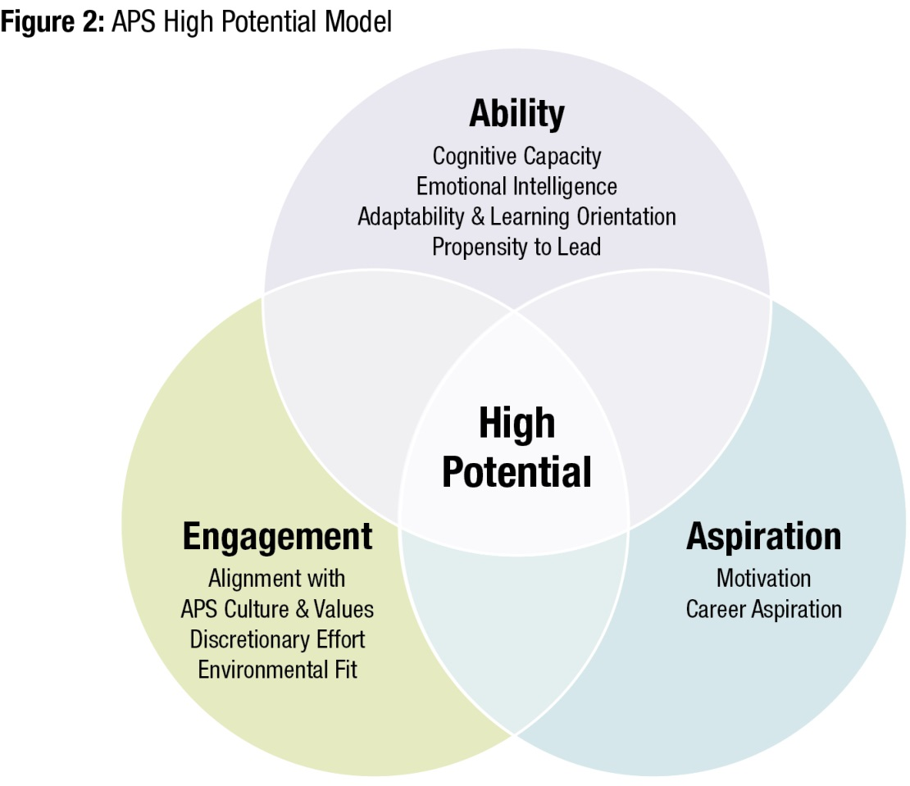

Source: *Ability, Aspiration, Engagement* based on Corporate Leadership Council, High Potential Employee Management Survey, 2005.

**1.2.4 How can potential be assessed?**

***Making an initial assessment***

An initial assessment of an individual’s potential can be made through observation against the qualities, indicators and behaviours in the APS framework, as set out in Table 1 below. A manager guide to this assessment is included in the [**Manager guide to identifying potential**](http://www.apsc.gov.au/publications-and-media/current-publications/talent-management-guide/toolkit/manager-guide-to-identifying-high-potential)**.** This kind of assessment is best made by a manager who is working closely with an individual and is able to observe their behaviours directly and engage with them about their career aspirations**.** These observations should be validated through discussion with a more senior manager or others on the management team. Drawing on multiple points of view combined with descriptions of behaviour can help to ensure personal bias is minimised.

When done well, an initial assessment offers an efficient way to gain a better understanding of the potential of individuals. It can be applied to all individuals in a segment of the workforce to screen for high potential, prior to embarking on more formal assessment processes. This may also avoid putting the wrong individuals through formal talent assessments, setting expectations which may not be met.

***Table 1: APS framework for high potential***

| **Quality** | **Indicators** | **What you may observe/hear from current performance** |
| --- | --- | --- |
| **Ability** – *capacity to grow, adapt and develop enough to handle the complex work challenges which come with more senior roles* | **Cognitive Capacity**  *Relatively fixed in an individual* | Smart; quick thinker  Makes connections  Adept at conceptualising |
| **Emotional Intelligence**  *Some scope for development* | Stable and resilient in face of pressure  Self-aware with ability to develop relationships |
| **Adaptability & Learning orientation**  *Some scope for development* | Able to translate learning to behavioural change  Inquisitive  Open to feedback  Open to new experiences and challenges (sees change as an opportunity) |
| **Propensity to lead**  *Some scope for development* | Not afraid to take the lead  Comfortable with authority  Influential and inspiring team player |
| **Engagement** – s*trong commitment to the APS with application of discretionary effort to achieve objectives* | **Alignment with APS culture & values** | Commitment to the work of the APS or agency Behaviours align with APS values |
| **Discretionary Effort** | Goes above and beyond expectations to achieve goals |
| **Environmental Fit[13]** |  |
| **Aspiration** – *motivation and desire to rise to more senior positions* | **Motivation** | Internally driven  Committed to achieving outcomes |
| **Career Aspiration** | Eager to broaden experience and take on more complex roles |

***Undertaking formal assessment***

Formal assessment can be valuable to confirm an initial assessment of high potential and understand areas for development.

There are two types of formal assessment:

* **Screening tools** – these are generally online questionnaires that can be validated with wider stakeholder input. These tools provide a quick, objective and consistent assessment.
* **In-depth assessment tools** – these are used when high selectivity is required and/or to inform development planning. These types of assessments include task simulations, behavioural interviews and personality assessments.

More information on formal assessments can be found in [the guide to formal assessment tools and methods](http://www.apsc.gov.au/publications-and-media/current-publications/talent-management-guide/toolkit/assessment-tools).

### 1.3 Bringing performance and potential together

**1.3.1 The nine-box grid**

Accurate assessment of an individual’s performance and potential is the first step in a well-targeted talent management process. However, it is only when an individual’s assessment is considered *in relation to* the assessments of other individuals across a segment of the workforce that important decisions can be made by the senior management team such as:

* Identifying likely successors for more senior/complex leadership roles
* Identifying individuals who are most likely to benefit from **targeted development**
* Identifying gaps where **strategic external recruitment** may be required
* Identifying individuals within a workforce who are **critical to retain.**

A useful tool for plotting individual assessments across a cohort is the nine-box grid, which was originally developed by McKinsey for General Electric. The full [APS nine-box grid](http://www.apsc.gov.au/publications-and-media/current-publications/talent-management-guide/toolkit/9boxgrid)  can be found in the Talent Management Toolkit.

**Figure 3:**APS Nine-Box Grid

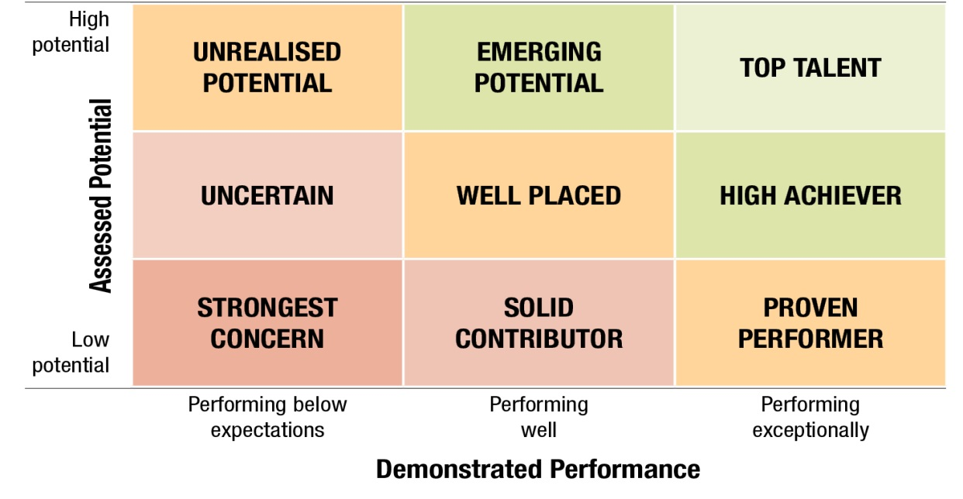

**Performance:** *An individual’s success at delivering on role objectives in current and past roles. Performance is an assessment of what a person delivers and how they deliver (within the context of the APS values).*

**Potential:** *The likelihood that an individual can work successfully and effectively in an expanded role, particularly the ability to work in an increasingly complex and ambiguous environment.*

**1.3.2 Using the grid: talented employees**

Plotting individual assessments on a nine box grid will paint a picture of a group as a whole, be it a cohort across the APS or within an agency, division or team.

It is sensible to focus **talent management discussions** on the individuals with the highest performance and potential **(top talent),** as well as those who show strong signs of reaching the top talent ranking **(emerging potentials and high achievers).** This will ensure that talent processes have a strong and single-minded focus on developing, retaining and deploying the individuals who have been identified as the most critical to future agency success. Further guidance on **developing** and **engaging** talented employees is provided later in this document. A discussion prompt for debriefing individuals identified as talent on their placement in the nine box grid and further clarifying their career goals is found in the[**Guide to career conversations**](http://www.apsc.gov.au/publications-and-media/current-publications/talent-management-guide/toolkit/guide-to-career-conversations).

**1.3.3 Using the grid: other employees**

Plotting individual assessments on the nine box grid will also highlight individuals who do not currently fall into the talent categories. These individuals would not normally be considered through talent management mechanisms. However, their placement on the grid provides useful information for managers to consider in their general workforce planning and performance management processes. The assessments can help fine-tune the management practices that will best support an individual to contribute their best.

For example, ‘proven performers’ are high performing individuals who are not rated as high potential. These are employees who may not aspire to more senior roles or have the ability to contribute at a more senior level, however their performance makes a significant contribution to the agency, they may have deep expertise and they are highly valued for their contribution at level. Agencies may wish to consider how they keep these important contributors engaged through:

* Recognising and rewarding their contribution
* Providing opportunities for professional development
* Understanding aspirations for lateral movement.

At the other end of the scale, for individuals in the ‘strongest concern’ category there is a need for firm and decisive management action. This includes accurately understanding the nature of the employee’s performance shortcomings and then taking steps to address them. In the first instance, the manager must engage the employee on the issues, providing honest and clear feedback. They then need to set goals and expectations around a return to effective performance, ensure appropriate training is provided, and monitor progress.

If performance does not improve, agency [**underperformance processes**](http://www.apsc.gov.au/publications-and-media/current-publications/managing-performance) should be commenced. This may result in reassignment of the individual to another role, reclassification or [**termination**](http://www.apsc.gov.au/publications-and-media/current-publications/terminating)**.**

A set of manager discussion prompts for each of the nine-box grid categories is provided in the [**Guide to career conversations**](http://www.apsc.gov.au/publications-and-media/current-publications/talent-management-guide/toolkit/guide-to-career-conversations).

## 2. Talent Development

### 2.1 The role of development

Although talented individuals have been assessed as having the capacity to move into roles of greater complexity, ambiguity and scale in the future, they may not yet have the full capability required for those roles.  For example, an individual may have highly developed technical skills but require stronger leadership and management skills.

As such, an important element in a talent management process is working with a high potential individual to pinpoint areas for targeted development and finding the right development option.

The notion of accelerated growth is an important consideration in high potential development. Offering opportunities that stretch the individual may get them ready for a future role faster. This can be beneficial for the agency and attractive to high potential individuals who are fast and agile learners.  However, speed of development needs to be weighed against the depth and breadth of experience required to be successful and thrive in a more senior and more complex role.

### 2.2 Types of development

An integrated approach to development based on the 70:20:10 model is likely to achieve the best developmental outcomes[14]:

* 70% of learning is gained from experience (e.g. on the job experience, tasks and problem solving)
* 20% of learning is gained through relationships (e.g. feedback and interpersonal learning)
* 10% of learning is gained through formal learning programs.

Effective development activities should be challenging and take the individual outside their comfort zone. Those identified as high potential are likely to gain real benefits from this; as keen learners, high potentials should respond well to intensive development.

To maximise learning gains, development should incorporate elements from each of these types:

| **On the job learning**  **(70%)** | **Learning through others (20%)** | **Formal learning (10%)** |
| --- | --- | --- |
| * Being part of a working group, committee, or taskforce * Taking on new responsibilities or a new project * Secondments outside the APS or with another APS agency * Representational activities | * Mentoring * Coaching * Career counselling * Manager feedback | * Academic study * APS learning programs (e.g. leadership & talent development programs) * External learning programs * eLearning |

### 2.3 Planning for development

Career and development conversations with high potential individuals are important to understand:

* Aspirations and how these relate to business need and critical roles
* Motivators, strengths & weaknesses
* Learning needs
* Development options
* Timelines, including those for monitoring and review.

These conversations should take into account development needs identified through formal or informal assessments.

Managers are best placed to conduct these conversations. Manager guides for career conversations with high potential talent can be found in the [**Guide to Career Conversations**](http://www.apsc.gov.au/publications-and-media/current-publications/talent-management-guide/toolkit/guide-to-career-conversations).

Drawing on the career conversation, an individual development plan can be constructed. The plan should build useful skills and experience based on future critical roles and the individual’s aspirations. This plan is usually fed into senior management discussions about talent so that there is clarity about an individual’s development goals and agreement to the investment being made.

More detail on development planning can be found in [**A guide to learning on the job in the APS**](http://www.apsc.gov.au/publications-and-media/current-publications/on-the-job-learning-good-practice-guide).

### 2.4 Mobility: placements and secondments

The planned movement of employees within, across and outside agencies to gain varied job experiences is an effective strategy in career and capability development.  For high potential talent, this is particularly effective, as these individuals are often looking for ‘an experience’ which provides new opportunities for career growth. Indeed, recent research indicates that high potential employees will find opportunities outside the agency if such opportunities are not provided from within[15].

When done well, the planned use of employee mobility is a cost effective means of diversifying and enhancing a high potential employee’s knowledge, experience, and skills through ‘immersion’ and ‘learning by doing’. Developmental mobility includes:

* Internal movement within an agency
* External movement between agencies
* External movement to the private sector
* External movement to a state or territory government.

Movements can be unilateral or bilateral (exchanges), however the focus of the movement should be on developing the high potential individuals’ breadth and depth of skills in areas likely to be relevant in future roles.

Agencies using mobility as part of their talent development strategy should undertake **pre-assignment planning.** This activity ensures that mobility placements will provide the targeted capability development identified in the individual’s development plan. It is also important to provide **on-assignment support** to ensure the required development is taking place.

## 3. Talent Engagement

### 3.1 Why engagement is important

Maintaining the engagement of high potential individuals is important if their skills and capabilities are to continue to be available to the APS or their agency in the future. If talented employees aren’t kept engaged, the risk of losing them is high. A Harvard Business Review study[16] found that most high performing young people with records of strong academic and workplace performance regularly and actively looked for new jobs when they were already employed.

### 3.2 What is talent engagement?

Engagement does not mean holding on to talented employees in one job role or agency; indeed, talent ‘hoarding’ is likely to have a negative effect on engagement. For high potential individuals, there three requirements for continued engagement:

* Visibility: Knowing that the APS or an agency recognises their potential and is interested in them
* Planning: Being clear about the plan for their development and their career path
* Action: Seeing things happen that will assist in their growth and career development.

### 3.3 Keeping talent engaged

Talented individuals work harder than their peers and expect their agencies to provide stimulating work that prepares them for future roles, ongoing recognition and rewarding career paths. Research[17] indicates that the following strategies in 3.3.1 to 3.3.5 can help keep talented employees engaged and committed.

**3.3.1 Keep senior leaders involved with talent**

The direct involvement of senior managers can make a significant difference to the engagement of talented individuals. Aligning high potential employees with a senior sponsor – directly or through a talent forum – can impact on all three requirements for engagement. The high potential employee will enjoy greater visibility and have access to senior level guidance about their career. Because the senior sponsor is in an influential position in the agency, they may be able to unlock barriers to the employee making progress with their career development, for example, if it is time for a change in role.

**3.3.2 Recognise talent, even when times are tough**

Being recognised is one of the most critical factors that keep talented employees engaged. Talented employees are aware that they contribute more than others. Failing to meaningfully recognise their greater contribution risks disengagement or leaving for a new employer.

In the private sector, recognition is often financial. In the APS, there are alternative ways to keep talented employees engaged through recognition. This might include offering different and more challenging development opportunities, offering special projects or mobility changes, or offering flexible working arrangements to support study or other development.

During periods where promotion or transfer opportunities are limited across the APS, agencies should carefully consider whether acting assignments or new projects are suitable for keeping high potential employees committed to the APS. Providing the best opportunities to high potential employees isn’t about creating a ‘favoured class’, but is about ensuring that the best contributors continue to offer their best and keep growing in preparation for taking on critical roles.

**3.3.3 Keep giving talented employees tough roles or projects**

Keeping high potential employees engaged means continuing to stretch them with challenging roles or projects where they are forced to quickly develop new skills. Protecting talent from experiencing tough roles is a bigger long-term risk – talent will leave in search of greater challenges or they will reach critical roles without having being tested.

Agencies should keep their talent engaged and developing by placing high potentials in the most complex, high-impact roles and projects. These challenging assignments should be linked to an individual development plan and precise development goals.

**3.3.4 Keep talent involved in business strategy**

Talented employees usually stay committed when they feel they are actively contributing to the agency’s future. Strategies include involving talent in projects to resolve important strategic challenges, allowing high potentials to serve on ‘shadow boards’ that provide genuine business advice to senior leaders, or offering private briefings on strategic challenges.

**3.3.5 Regularly test your talent’s engagement**

Organisations cannot assume that their high potential employees will remain highly engaged. Research[18] shows that one in three high potentials admits to not putting all their effort into their work, while one in five believe that their aspirations are markedly different to what their organisation has planned for them.

Agencies should regularly check the level of engagement of their high potentials and seek to understand their career aspirations. Strategies include appointing career stewards to guide career aspirations and expectations, or regularly obtaining feedback from talented employees on their satisfaction with jobs, career opportunities and work-life balance.

### 3.4 Talent tracking

Tracking and monitoring of talent can also be useful in maintaining engagement levels. There are many systems on the market that can assist with talent tracking. Care is needed in choosing a system that is simple to use and affordable.

Individual Profiles (often known as career profiles or talent profiles) are a low cost tool that can be used to track talent. These serve as an internal resume and can facilitate discussion and understanding of an individual’s experience and development needs. Individual profiles are used by HR and at senior management talent discussions to enable detailed discussion about the development, engagement and deployment of identified talent. The profiles capture past experience (both professional and academic), along with career highlights, aspirations and sought after roles. A sample [career profile template](http://www.apsc.gov.au/publications-and-media/current-publications/talent-management-guide/toolkit/career-profile) can be found in the talent management toolkit.

## 4. Talent Deployment

### 4.1 What does deployment mean?

Talent deployment is the process of drawing on identified talent to fill critical workforce gaps.  This may include placement of identified talent in short-term roles such as critical projects/taskforces or selection for long-term positions.  Successful deployment is the return on investment in a talent management system.

It is important to note that identification within the talent management system is not a guarantee of promotion. Rather the aim is to give the agency a pool of talented individuals with the skills, abilities and experience for critical future business roles.  A merit-based selection system then determines the best person for the role.

### 4.2 The role of succession planning

Succession planning involves understanding the critical roles within an agency, the current occupants of those roles and their likely career moves, and the pool of available talent who could fill the roles in the future.

Succession planning works alongside the talent management system and potential successors from the talent pool are considered in terms of:

* Skills and experience (what does the high potential individual offer this role?)
* Aspirations (how does this role fit with their aspirations?)
* Required development (what development might they need to fill this role successfully?)
* Timing (are they an immediate successor, or do they need time before consideration?)
* Risks (what would be the risk of putting this person in the role?).

Succession plans should be kept confidential and only senior staff should be party to the discussion and information.  A [succession plan template](http://www.apsc.gov.au/publications-and-media/current-publications/talent-management-guide/toolkit/successionplan) can be found in the talent management toolkit.

### 4.3 Supporting deployment to new roles

Setting up the high potential employee for success in taking on a new role is important. Even when a talented employee has been developed and positioned for a more complex or senior role, they will still experience a period of transition.  This will involve quickly getting across a broader scope of work and responsibility. It will also involve letting go of their previous role and associated high level of competence in that role.

Consideration should be given to the benefit of a mentor or coach to support in this transition period.

For some talented individuals, successful deployment into a more senior role may fully realise their potential. As such, they may not continue to be actively considered in talent management processes. For others, there may still be room for development and growth for roles of even greater complexity in the future. It is important to continue monitoring and tracking these individuals as part of talent processes.

## 5. Governance Arrangements for Managing Talent

### 5.1 The Talent Council

A Talent Council or equivalent works to ensure the talent strategy connects with the business strategy. The benefits of holding Talent Council discussions regularly include:

* Involvement of business leaders in talent and succession management strategy and decisions, ensuring connection with business strategy.
* Development plans are regularly reviewed to ensure relevance to a future critical role.
* Career movement of talent can be mapped to potential for future critical roles.
* Leaders are held accountable for follow through.

Talent Councils usually have a strong focus on succession to ensure that the development planned for each individual meets a specific business need. An [example ’terms of reference’](http://www.apsc.gov.au/publications-and-media/current-publications/talent-management-guide/toolkit/talentcouncil) document can be found in the toolkit.

**5.1.1 Council membership**

The size of a Talent Council will vary depending on the size of an agency. A typical Talent Council would usually comprise 4-6 senior executives who:

* are more senior (by one or two levels) than the cohort under discussion
* represent a range of functions across the agency
* bring varied skills and experience.

A senior HR representative would usually be a council member. The Talent Co-ordinator attends to record the discussion and provide Secretariat functions.

**5.1.2 Meeting frequency and agendas**

Typically, Talent Councils meet on a biannual or quarterly basis. Large agencies managing bigger talent pools may meet more frequently.

The Council’s agenda will vary depending on current priorities and the maturity of agency talent management processes. When a Talent Council is established, early Council meetings should be used to discuss all high potential staff in the talent pool. As the council transitions to routine operations, its agenda may focus on a specific role with succession concerns or on a review of select staff in the high potential pool. The structure of a talent council discussion usually includes:

* Review of select high potential staff
* Potential future role fit
* Required and planned development
* Possible role moves / secondments
* Potential projects meeting agency need and individual development plan
* Plan for monitoring development outcomes
* Agency succession planning

Council members should be provided with Career Profiles and Development Plans for the high potential employees under discussion. They should also be provided with any Talent Assessments or other data such as 360o feedback.

1. Adapted from Chartered Institute of Personnel and Development, [*Talent management: an overview*](http://www.cipd.co.uk/hr-resources/factsheets/talent-management-overview.aspx), viewed 29 May 2015, <<http://www.cipd.co.uk/hr-resources/factsheets/talent-management-overview.aspx>>
2. IBID
3. Sharkey, L.D & Eccher, P.H. (2011). Optimising Talent. What every leader and manager needs to know to sustain the ultimate workforce. Charlotte, N.C: Information Age Publishing Inc.
4. Burke, Schmidt & Griffin (2014). Improving the Odds of Success for High-Potential Programs – Georgia, USA. Talent Report. CEB SHLL Talent Measurement
5. Section 35, *Public Governance, Performance and Accountability Act 2013*
6. Barry, L., Bohdal-Spiegelhoff, U., Erickson, R. & Lamoureux, K., “Talent acquisition revisited” in Schwartz, J., Bersin, J. & Pelster, B. (eds) (2014). Global Human Capital Trends 2014: Engaging the 21st Century Workforce. Deloitte University Press.
7. IBID.
8. Bersin, J. (2015).Predictions for 2015: Redesigning the Organization for a Rapidly Changing World. Deloitte Development LLC.
9. IBID
10. Burke, Schmidt & Griffin (2014). Improving the Odds of Success for High-Potential Programs –Georgia, USA. Talent Report. CEB SHLL Talent Measurement
11. CEB, High-Potential Employee Management Survey, Arlington VA, 2005
12. People Measures Pty Ltd. (2015). Defining & Predicting High Potential. Research paper 2015
13. May be important for some agencies or some functions (i.e. a person’s ability to work in different locations for an agency with an international presence; professional qualifications in a specific field)
14. Lombardo, M; Eichinger, R (1996). The Career Architect Development Planner (1st ed.) Minneapolis: Liminger.p.iv.
15. Bersin, Josh (2015). Predictions for 2015. Redesigning the Organization for a Rapidly Changing World. Research Report
16. Hamori, M., Cao, J. and Koyuncu, B. (2012). Why young managers are in a nonstop job hunt. Harvard Business Review: The Magazine. July-August 2012
17. Martin, J & Schmidt, C. (2010). How to keep your top talent. Harvard Business Review. May 1010.
18. IBID