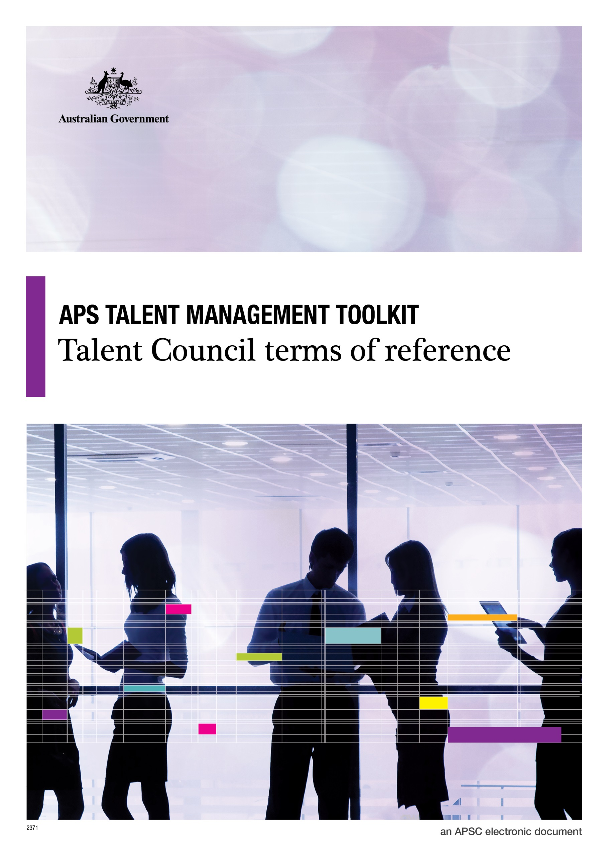
© Commonwealth of Australia January 2015
All material produced by the Australian Public Service Commission (the Commission), constitutes Commonwealth copyright administered by the Commission. The Commission reserves the right to set out the terms and conditions for the use of such material.
Apart from any use permitted under the Copyright Act 1968, and those explicitly granted herein, all other rights are reserved.

Talent Management Toolkit
Example Terms of Refererence
For talent management to work effectively, it is important to have a clearly established mechanism for senior managers to come together regularly to discuss talent. This can be across the APS or within an agency. This mechanism can take the form of:

- A Talent Council or equivalent talent specific group
- A regular talent agenda item as a part of an existing Executive Committee forum

The attached Terms of Reference are an example only and can be changed and/or modified as suits the relevant council or board.

Talent Council Terms of Reference

Chair:
Deputy Chair:
Council Manager:
Council Secretariat:
Reporting Line:

Example Terms of Reference
Purpose/ Objectives:
The Talent Council is to be an advisory body to the XXX, on matters relating to talent management within the department [and succession] as set out in these Terms of Reference.
Scope:
The Talent Council in providing advice on matters relating to talent management is to:
- identify critical business roles and align with potential successors;
- ensure talent development is aligned with organisational needs and objectives;
- identify and recommend staff with the potential to fulfil more complex leadership roles;
- work towards increased senior exposure of identified talent.
Key Activities and Deliverables:
The Talent Council is responsible for providing advice on matters overseeing talent management and will:
- moderate and agree on potential assessments;
- monitor the allocation of development opportunities for participants and ensure they align with organisational objectives as well as individuals goals and interests;
- identify potential candidates for secondment and potential secondment opportunities across the department or across departments;
- consider regular reports on program status;
- provide advice to the XXX Committee on matters relating to succession and talent management; and
- provide advice and make recommendations on strategic talent management issues to the XXXX.

The Talent Council will also make recommendations to the XXXX of significant leadership development opportunities for selected officers.
Performance Measures:
- Implementation of the Talent Management Strategy.
- The provision of timely and well informed strategic advice in relation to talent management within the department.
- Strengthened availability of potential role ready successors to more senior business critical positions.
- Progress will be reported to XXXX on a regular basis.
A review of the Council’s performance will be conducted annually to assess the quality of the work of the Council against the Terms of Reference, standards, controls, key performance indicators and targets. This annual assessment will be provided to XXXX.
Key Stakeholders:
Membership Responsibilities:
The Talent Council members will:
- promote building capability and capacity to identify, nurture and build talent;
- contribute their individual operational and positional expertise and interests to the discussion, and develop outcomes that best meet the Talent Council objectives;
- ensure that selection processes are rigorous, transparent and merit based;
- actively support Council decisions and promulgate these messages to their respective colleagues, where appropriate; and
- build a shared understanding within the Council of program operations and delivery.
Relevant assistance and support tools will be provided to Council members to enable them to meet these responsibilities.
Meeting Protocols:
- The Council will meet [monthly/quarterly etc]. Additional meetings may be called by the Chair as and when required.
- Proxies will only be able to attend Council meetings with approval from the Chair.
- A record of outcomes will be reviewed by the Chair and distributed within ten working days of the Council meeting.
- For items requiring immediate attention that fall outside the scheduled meeting timeframe, the Chair to determine appropriate actions.

Membership:
Chair
Deputy Chair

Terms of Reference taken from materials provided by the Australian Taxation Office

