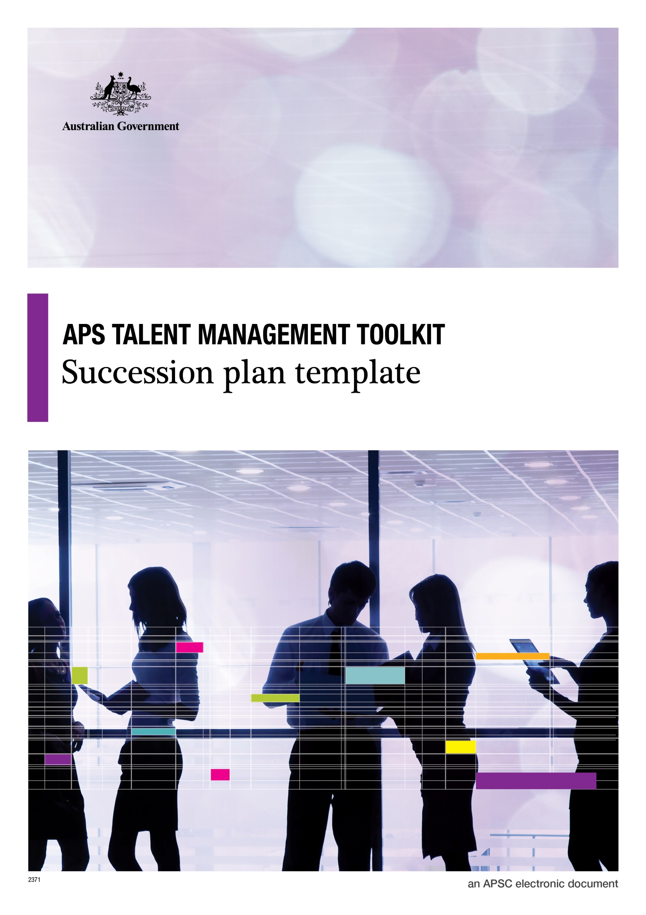

**© Commonwealth of Australia January 2015**

All material produced by the Australian Public Service Commission (the Commission), constitutes Commonwealth copyright administered by the Commission. The Commission reserves the right to set out the terms and conditions for the use of such material.

Apart from any use permitted under the Copyright Act 1968, and those explicitly granted herein, all other rights are reserved.

**Talent Management Toolkit**

**Succession Plan Template**

Succession planning involves understanding the critical roles within an agency, the current occupants of those roles and their likely career moves, and the pool of available (or developing) talent who could potentially fill the roles in the future.

Succession planning works alongside the talent management system and potential successors from the talent pool are considered in terms of:

* Skills and experience (what does the high potential individual offer this role?)
* Aspirations (how does this role fit with their aspirations?)
* Required development (what development might they need to fill this role successfully?)
* Timing (are they an immediate successor, or do they need time before consideration?)
* Risks (what would be the risk of putting this person in the role?)

Succession plans should be confidential and only senior staff should be party to the discussion and information.

Placement on a succession plan is not a guarantee of future position – regular recruitment processes will apply.