

**© Commonwealth of Australia January 2015**

All material produced by the Australian Public Service Commission (the Commission), constitutes Commonwealth copyright administered by the Commission. The Commission reserves the right to set out the terms and conditions for the use of such material.

Apart from any use permitted under the Copyright Act 1968, and those explicitly granted herein, all other rights are reserved.

Unless otherwise noted, all material in this publication, except the Commission logo or badge, the Commonwealth Coat of Arms, and any material protected by a trademark is licensed under the Creative Commons BY NC ND Attribution Non-Commercial Use No Derivatives 4.0 Australia Licence.

Creative Commons BY NC ND Attribution Non-Commercial Use No Derivatives 4.0 Australia Licence

Details of this licence are available at: <<http://creativecommons.org/licenses/by-nc-nd/4.0/legalcode>>

**Attributing Commission works**

Use of Commonwealth material licensed under the Creative Commons 4.0 BY NC ND requires the following:

* Attribution: You must give appropriate credit, provide a link to the license, and indicate if changes were made. You may do so in any reasonable manner, but not in any way that suggests the licensor endorses you or your use.
* Non Commercial: You may not use the material for commercial purposes.
* No Derivatives: If you remix, transform, or build upon the material, you may not distribute the modified material.

**Enquiries**For enquiries concerning reproduction and rights in Commission products and services, please contact <[communications@apsc.gov.au](mailto:communications@apsc.gov.au)>

**Making an initial assessment**

An initial assessment of an individual’s potential can be made through observation against the qualities, indicators and behaviours set out in the [APS Framework for High Potential](http://www.apsc.gov.au/publications-and-media/current-publications/talent-management-guide/supporting-guidance/aps-framework-for-high-potentialhttp:/www.apsc.gov.au/publications-and-media/current-publications/talent-management-guide/supporting-guidance/aps-framework-for-high-potential)which defines potential as a combination of ability, aspiration and engagement[1] as demonstrated below **.** This kind of assessment is best made by a manager who is working closely with an individual and is able to observe their behaviours directly and engage with them about their career aspirations.

An initial manager assessment offers an efficient way to gain a better understanding of individual potential prior to investing in formal assessment. It may also avoid putting the wrong individuals through a formal assessment process, setting expectations which may not be met.

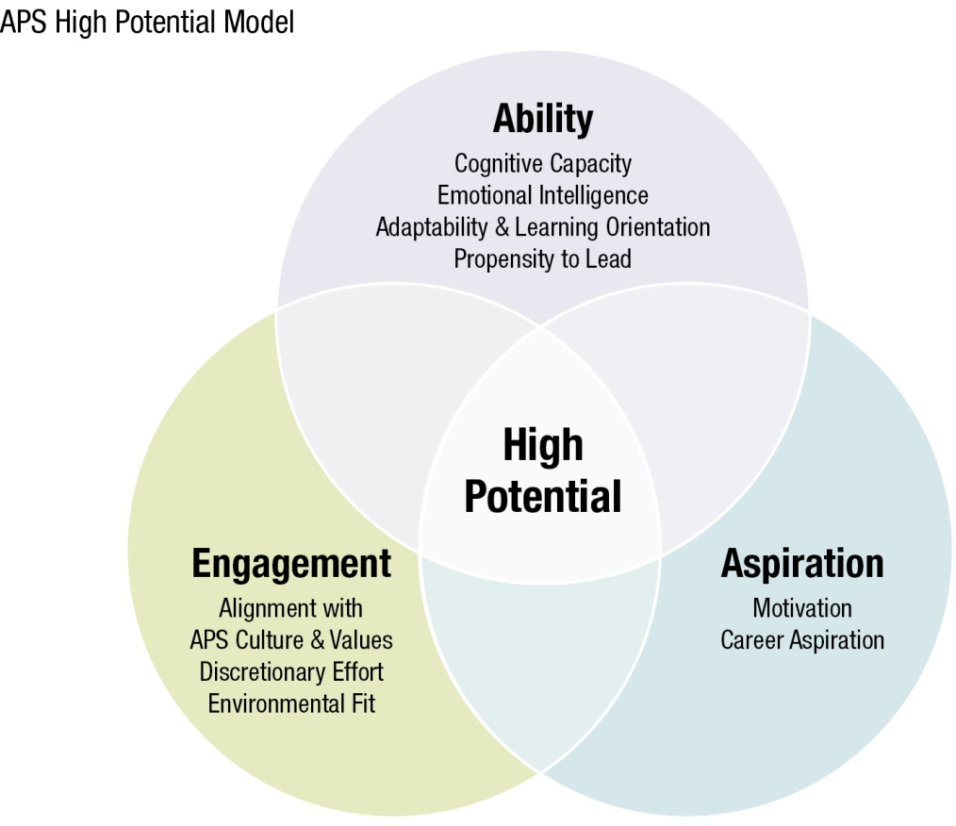

**Undertaking formal assessment**

Formal assessment can be valuable in confirming an initial assessment of high potential and in understanding areas for development.

**Manager Guide to Identifying Potential**

*An initial potential rating can be given to individuals based on demonstration of indicators below. Demonstration of each indicator can be rated by regularity (1=rarely, 5=always) with an average used for overall assessment of potential.*

**1=Rarely 2 = Occasionally 3 = Regularly 4= Consistently 5 = Always**

**ABILITY**

| **How consistently do they demonstrate the following?** | **1-5** |
| --- | --- |
| **Cognitive Capacity**   * Takes in and processes new information quickly * Makes connections and sees patterns * Grasps new concepts through formulating ideas and hypotheses * Applies theory to complex tasks |  |
| **Emotional Intelligence**   * Emotional stability and resilience * Self-awareness * Builds good relationships * Willingness to collaborate * Empathy |  |
| **Adaptability & Learning**   * An interest in learning * Openness to feedback * Versatility * Adaptability * Translates learning to behavioural change and action |  |
| **Propensity to Lead**   * Comfort with holding authority * Propensity to set direction * Uses influence * Develops and inspires others |  |

**ASPIRATION**

| **How consistently do they demonstrate the following?** | **1-5** |
| --- | --- |
| **Motivation**   * Commitment to goals * Sees goals to completion * Take calculated risks in the interest of achieving outcomes * Achieves in a variety of contexts and settings |  |
| **Career Aspiration**   * Expresses a desire to progress their career * Preparedness to take on greater responsibility * Preparedness to step into new or complex assignments in order to learn * Ambition |  |

**ENGAGEMENT**

| **How consistently do they demonstrate the following?** | **1-5** |
| --- | --- |
| **Alignment with APS Culture and Values**   * Commitment to serve the government of the day * Integrity, role modelling the APS values * Ability to work effectively in the agency and APS context * Personal maturity * Authenticity |  |
| **Discretionary Effort**   * Willingness to go above and beyond expectations to achieve goal |  |

**Average Score /5 =**

|  |  |  |  |
| --- | --- | --- | --- |
| **Average Rating** | **1-2** | **3** | **4-5** |
| **Assessment of Potential** | **Low Potential** | **Medium Potential** | **High Potential** |

1. CEB, High-Potential Employee Management Survey, Arlington VA, 2005