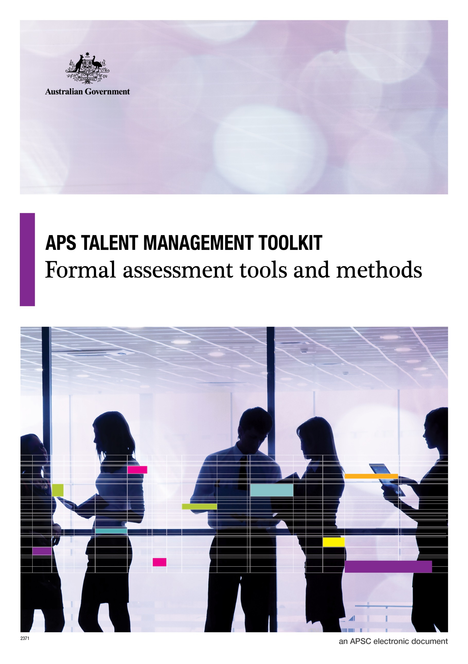

**© Commonwealth of Australia January 2015**

All material produced by the Australian Public Service Commission (the Commission), constitutes Commonwealth copyright administered by the Commission. The Commission reserves the right to set out the terms and conditions for the use of such material.

Apart from any use permitted under the Copyright Act 1968, and those explicitly granted herein, all other rights are reserved.

**Talent Management Toolkit**

# Formal Assessment Tools and Methods

An initial assessment of an individual’s potential can be made through observation against the qualities, indicators and behaviours in the APS framework, as set out in the [*APS framework for high potential*](http://www.apsc.gov.au/publications-and-media/current-publications/talent-management-guide/toolkit/aps-framework-for-high-potential) . This assessment is best made by a manager who is working closely with an individual and is able to observe their behaviours directly and engage with them about their career aspirations.

Formal assessment can be a valuable next step to confirm an initial assessment of high potential and understand areas for development.

The attached guide to formal assessment methods presents a small sample of assessments available on the market and is in no way a complete offering.

**Screening tools:** Online questionnaires completed by a manager and validated with broader stakeholder input – providing a quick, objective and consistent assessment of candidates.

**Detailed assessment**: These are done when high selectivity and risk avoidance is required (e.g. Investing in sending someone on a development program). Detailed assessments are also often done to assist with development planning where an otherwise high performing individual can get a better sense of where they need to develop to step into more complex roles.

| Ability | |  |  |
| --- | --- | --- | --- |
| Factor | Tools | Factor | Tools |
| Cognitive capacity | **Screening**:   * Lominger ‘Voices’ 360 assessment – Korn Ferry * Learning Agility (manager rating) – Korn Ferry * Via Edge (self-report) – Korn Ferry * Judgement, Drive, Influencing (JDI) - YSC * High Potential Identification Questionnaire (HPIQ) – People Measures   **Detailed assessment**:   * Cognitive ability testing (e.g. SHL verify, Saville aptitude testing) * Behavioural interview * Simulation (e.g. strategic analysis or presentation) | Adaptability and learning orientation | **Screening**:   * Lominger ‘Voices’ 360 assessment – Korn Ferry * Learning agility (manager rating) – Korn Ferry * Via Edge (self-report) – Korn Ferry * HPIQ – People Measures   **Detailed assessment:**   * Behavioural interview * Personality questionnaire |
| Emotional intelligence | **Screening**:   * Lominger ‘Voices’ 360 assessment – Korn Ferry * Learning agility (manager rating) – Korn Ferry * Via Edge (self-report) – Korn Ferry * JDI model – YSC * HPIQ – People Measures   **Detailed assessment**:   * Personality questionnaire (e.g. Saville Wave Professional Styles, Occupational Personality Questionnaire, Hogan Personality Inventory) * Behavioural interviews * Simulation (e.g. role play) * Emotional capital report - RocheMartin | Propensity to lead | **Screening**:   * JDI model – YSC * HPIQ – People Measures   **Detailed assessment:**   * Behavioural interview * Personality questionnaire |

| Aspiration | | Engagement | |
| --- | --- | --- | --- |
| Factor | Tools | Factor | Tools |
| Motivation | **Detailed assessment:**   * Behavioural interview * Personality Questionnaires (e.g. Saville Wave Professional Styles, Occupational Personality Questionnaire, Hogan Personality Inventory) | Alignment with APS culture and values | **Detailed assessment:**   * Bespoke values questionnaire * Bespoke manager rating questionnaire * Interview |
| Career aspiration | **Detailed assessment:**   * Bespoke career aspiration questionnaire (possibly administered online) * Interview on career aspirations | Environmental fit | **Detailed assessment:**   * Bespoke environmental fit questionnaire * Interview |

## Glossary of Methods:

**Behavioural Interview**: A behavioural interview is focused on discovering how an individual acted in specific employment-related situations. This uses past performance in the workplace to predict future performance. Instead of asking how an individual ‘would’ behave, the interviewer will ask how they ‘did’ behave.

**Personality Questionnaire**: A standardized series of questions or tasks, used to describe or evaluate a subject's personality characteristics. Questionnaires typically focus on describing a person’s preferred or typical style of operating compared to a large group. It is an effective way of identifying where people direct their energy and attention in work situations.

**Bespoke Questionnaires**: These are questionnaires written or adapted for a specific user or purpose. They may contain some “off the shelf” or standardised content. However their main purpose is to ask questions which are particularly relevant to the APS and the agency needs or context.

**Simulation exercise**: A simulation exercise gives people the opportunity to demonstrate their skills in a simulated environment which approximates the real world in which they would do the work. The classic simulation is an orchestra audition whereby a player is invited to perform for the panel so that their skills can be observed and evaluated. In work settings, the most common simulations that are used are analysis and presentation exercises and role plays. In an analysis and presentation exercise, people will be given a file or brief to read through which provides a broad problem and some data to analyse. They are then invited to present their recommendations to a panel acting as a board or client of some sort. Through this people can demonstrate the depth and quality of their thinking (e.g. strategic or analytical), their presentation skills and their ability to think on their feet when asked questions.