

**© Commonwealth of Australia January 2015**

All material produced by the Australian Public Service Commission (the Commission), constitutes Commonwealth copyright administered by the Commission. The Commission reserves the right to set out the terms and conditions for the use of such material.

Apart from any use permitted under the Copyright Act 1968, and those explicitly granted herein, all other rights are reserved.

Unless otherwise noted, all material in this publication, except the Commission logo or badge, the Commonwealth Coat of Arms, and any material protected by a trademark is licensed under the Creative Commons BY NC ND Attribution Non-Commercial Use No Derivatives 4.0 Australia Licence.

Licensed under the Creative Commons BY NC ND Attribution Non-Commercial Use No Derivatives 4.0 Australia Licence.

Details of this licence are available at: <<http://creativecommons.org/licenses/by-nc-nd/4.0/legalcode>>

**Attributing Commission works**

Use of Commonwealth material licensed under the Creative Commons 4.0 BY NC ND requires the following:

* Attribution: You must give appropriate credit, provide a link to the license, and indicate if changes were made. You may do so in any reasonable manner, but not in any way that suggests the licensor endorses you or your use.
* Non Commercial: You may not use the material for commercial purposes.
* No Derivatives: If you remix, transform, or build upon the material, you may not distribute the modified material.

**Enquiries**For enquiries concerning reproduction and rights in Commission products and services, please contact <[communications@apsc.gov.au](mailto:communications@apsc.gov.au)>

Assessing potential is broadly recognised as one of the more difficult elements of talent management to get right. Clear identification of potential is critical in understanding someone’s likely ability to thrive in a more complex and ambiguous environment. The Corporate Leadership Council found that there are three qualities that define high potential: Ability, Aspiration and Engagement[1]. On the basis of research across 19 models on the identification of potential[2], the three qualities can be further broken down as:

* **Ability** identifies candidates who have the ability to grow, adapt and develop enough to handle the more complex work challenges which come with more senior roles. This includes cognitive capacity, emotional intelligence, adaptability & learning orientation and propensity to lead.
* **Aspiration** identifies candidates who have the motivation to do what it takes to rise to more senior positions. This includes motivation and career aspiration.
* **Engagement** identifies candidates who are more likely to stay with the organisation once they have succeeded to more senior roles, mitigating ‘flight risk’. This includes culture, values, discretionary effort and environmental fit.

The model below is used in the assessment of potential in the APS at an individual level. High potential is the capacity to move into roles of greater complexity, ambiguity and scale and is demonstrated where all three qualities (ability, engagement, aspiration) overlap, when consistent high performance is already taken into account.

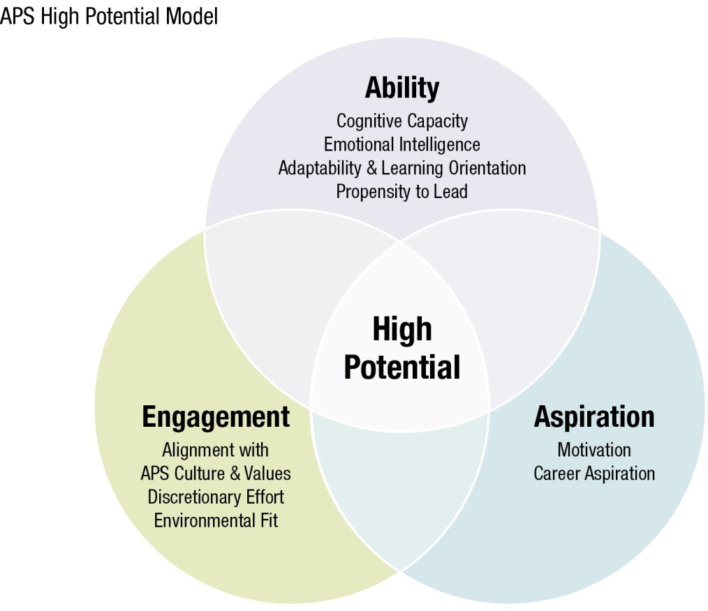

| **Ability** *(Strong foundation & capacity for growth)* | Cognitive Capacity *(consistent and stable, unlikely to change)*  Cognitive capacity is the strongest predictor of potential as it demonstrates the ability to think through and deal with increasingly complex problems and situations. Cognitive capacity includes being able to:   * take in and process new information quickly * make connections & see patterns * grasp new concepts; formulate ideas and hypotheses * apply theory to complex tasks  Emotional Intelligence *(consistent and stable, some elements can be developed)*  Emotional Intelligence is the ability to manage oneself and work effectively with others. This is critical to success in increasingly ambiguous and contested environments and is an important indicator of potential. Emotional intelligence is indicated through:   * emotional stability and resilience * self-awareness * ability to develop personal relationships * willingness to collaborate * empathy  Adaptability & Learning Orientation *(consistent and stable, some elements can be developed)*  Adaptability and learning orientation facilitate growth and development. This is an important element in an individual’s openness to new roles and experiences, and the likelihood of being able to successfully adjust. It is a combination of mental and behavioural flexibility:   * an interest in learning * openness to feedback * versatility * adaptability * ability to translate learning to behavioural change and action  Propensity to Lead *(consistent and stable, some elements can be developed)*  The propensity to lead is an important indicator of likely success in more senior and broader roles. It is the degree of comfort with taking charge, holding authority and empowering others:   * setting direction * using influence * developing and inspiring others |
| --- | --- |
| **Aspiration** *(Willingness & desire to take on more responsibility)* | Motivation Motivation facilitates growth and development. It is the energy, ambition and drive to succeed, demonstrated through the ability to:   * commit to a goal and see it through * take risks * consistently achieve in a variety of contexts and settings  Career Aspiration Aspiration is the desire to progress into broader and more complex roles, demonstrated through:   * career ambition * preparedness to take on greater responsibility   preparedness to step into new or complex assignments in order to learn. |
| **Engagement** *(Career alignment)* | Alignment with APS culture and values Alignment of individual values and behaviours with the culture and values of the APS is an important requirement for future success within the APS. This is demonstrated through:   * commitment to serve the government of the day * acting with integrity and as a role model for the APS values * being able to work effectively in the agency and APS context * personal maturity * authenticity  Discretionary Effort Discretionary effort is the willingness to go above and beyond expectations to achieve a goal. It indicates a high degree of engagement with the work of the agency or of the APS. Environmental Fit Environmental fit will vary from agency to agency depending on specific functional requirements such as:   * Operational requirements * Professional requirements |

1. CEB, High-Potential Employee Management Survey, Arlington VA, 2005
2. People Measures (2015) Defining & Predicting High Potential