 

# **Work arrangements**

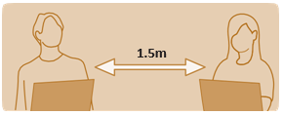

## Keep your distance

Workstations to be positioned 1.5 metres apart.

## Physical barriers

Consider presence of physical barriers between desks less than 1.5 metres apart.



## Reduce the spread

**Frequently sanitise all high touch surfaces:** desk, keyboard, mouse etc.



## Change start and finish time

Stagger work times and consider alternative working arrangements (working from home).



## Avoid peak travel

Stagger start and finish times to avoid peak travel times, consider alternative transport if public transport is affected.